Q.1 Write a command that puts the following values, in their given order, into the
salespeople table: city – San Jose, name – Blanco, comm – NULL, snum – 1100.
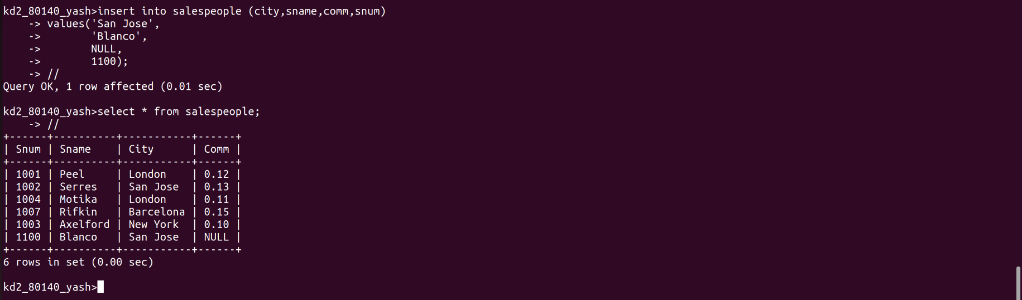

Q.2 Write a command that removes all orders from customer Clemens from the
Orders table.

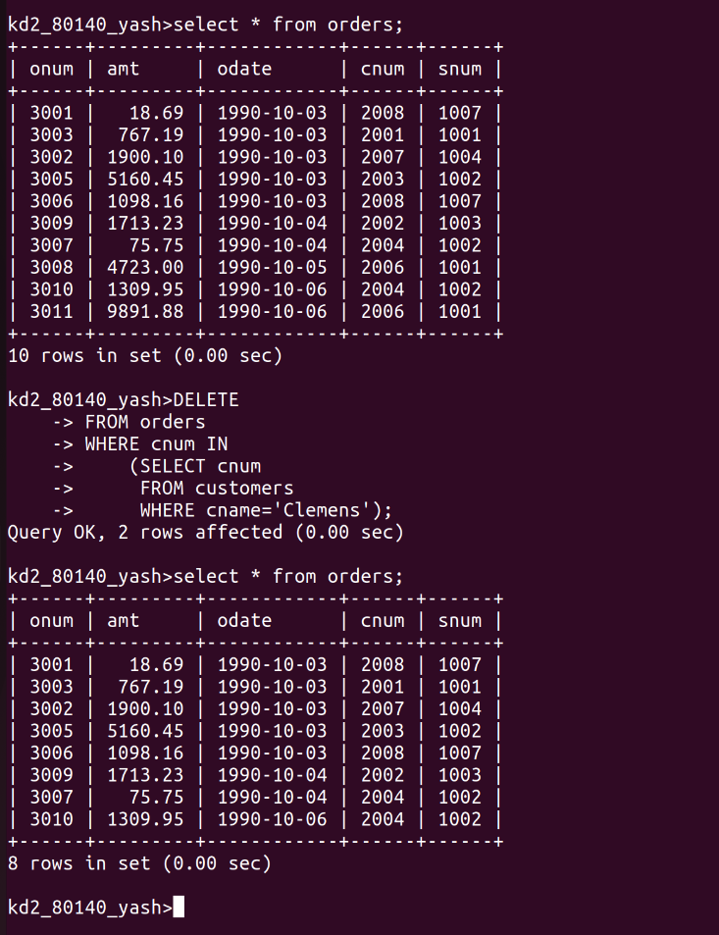

Q.3 Write a command that increases the rating of all customers in Rome by 100.

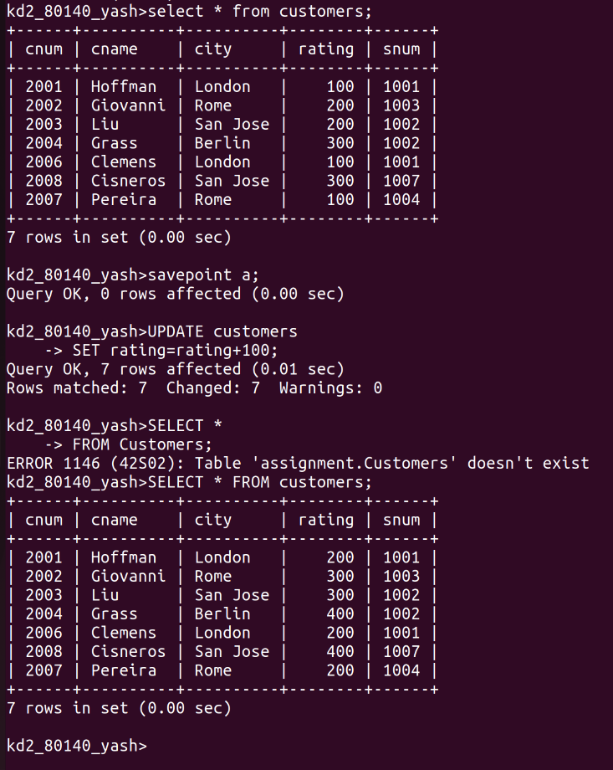

Q.4 Salesperson Serres has left the company. Assign her customers to Motika.
