Q.1 Write a query that lists each order number followed by the name of the customer who made the order.

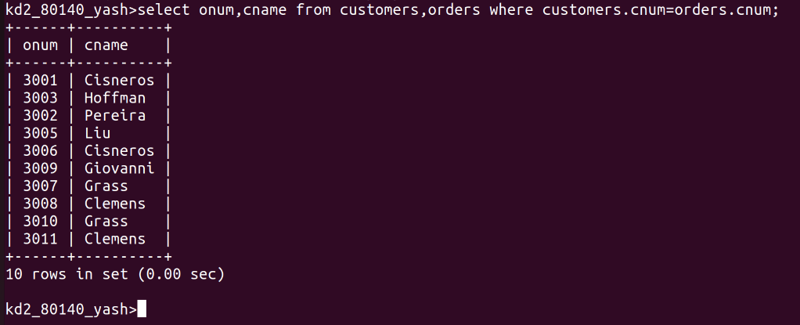
Q.2 Write a query that gives the names of both the

salesperson and the customer for each order along

with the order number.

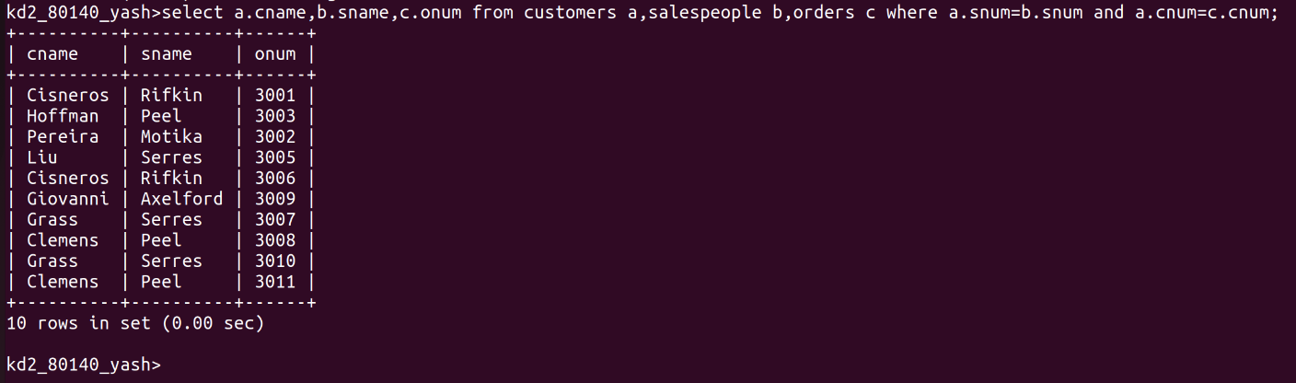
Q.3 Write a query that produces all customers serviced by salespeople with a commission above 12%. Output the customer's name, the salesperson's name, and the salesperson's rate of commission.

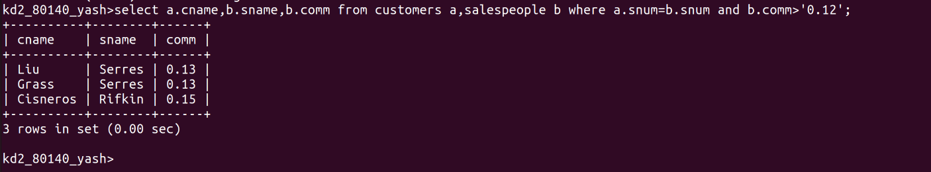

Q.4 Write a query that calculates the amount of the salespersons commission on each other by a customer with a rating above 100

