ASSIGNMENT = 12

1) WRITE A QUERY THAT SELECT ALL CUSTOMERS WHOSE RATING ARE EQUAL TO OR GREATER THAN ANY OF SERRES

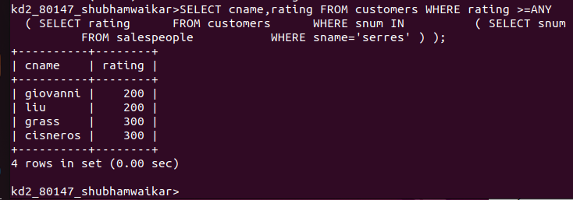

2) WRITE A QUERY USING ANY OR ALL THAT WILL FIND ALL SALESPEOPLE WHO HAVE NO CUSTOMERS LOCATED IN THEIR CITY

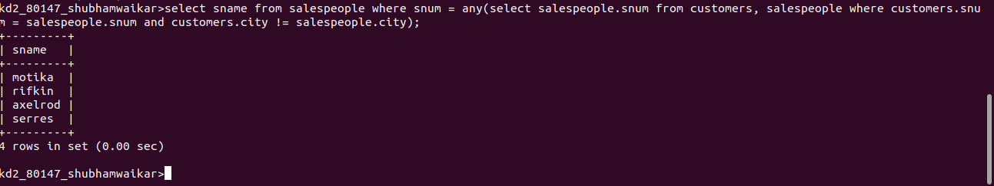

3) WRITE A QUERY THAT SELECT ALL ORDERS FOR AMOUNTS GREATER THAN ANY FOR THE CUSTOMERS IN LONDON



4)WRITE ABOVE QUERY USING MIN OR MAX

FOR MIN =

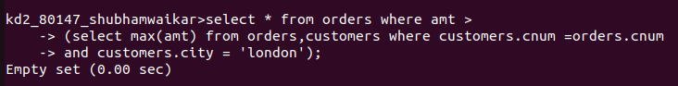

FOR MAX =

