SQL ASSINGMENT 15

1)Assume there is a table called Multicust, with all of the same column definitions as Salespeople. Write a command that inserts all salespeople with more than one customer into this table.
Sol --
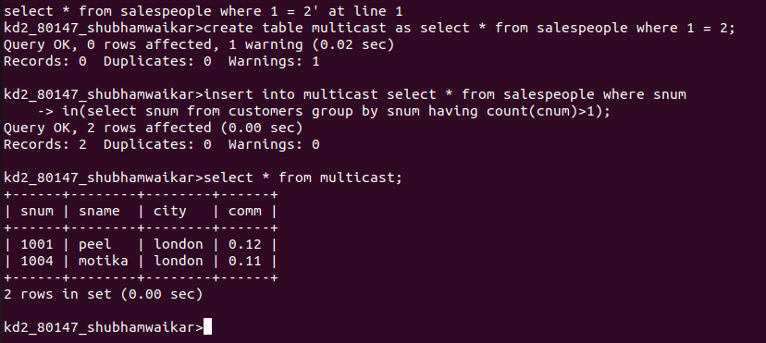

----------------------------------------------------------------------------------------------------------------------------------------------------------------

2)Write a command that deletes all customers with no current orders.
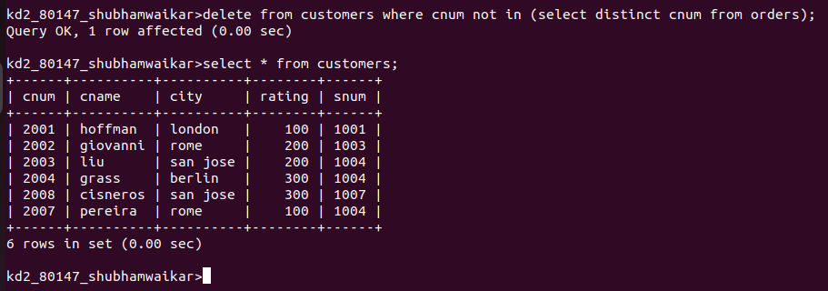
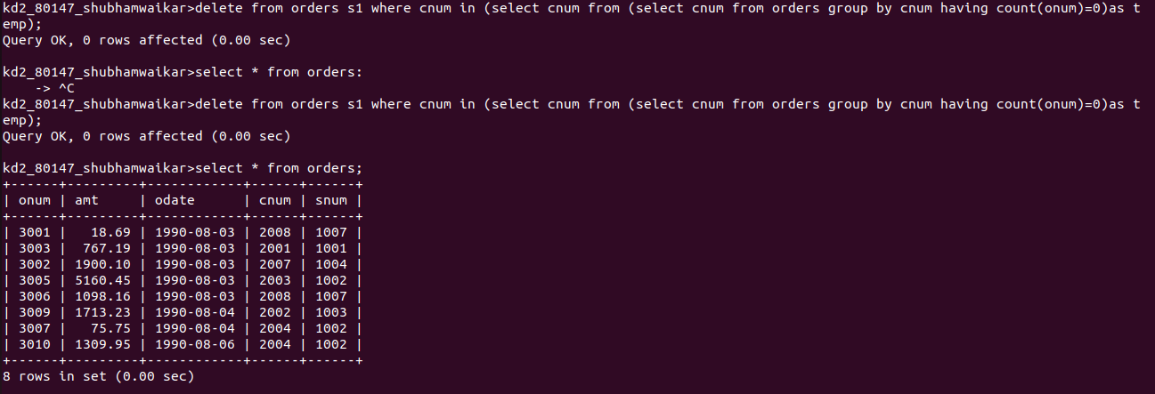

----------------------------------------------------------------------------------------------------------------------------------------------------------------

3)Write a command that increases by 20% the commisions of all salespeople with total orders above Rs. 3000.
Sol--

