ASSIGNMENT = 8

1) Assume each salesperson has a 12% commission. Write a query on the orders table that will produc the order number, the salesperson number, and t amount of the salesperson's commission for that order.

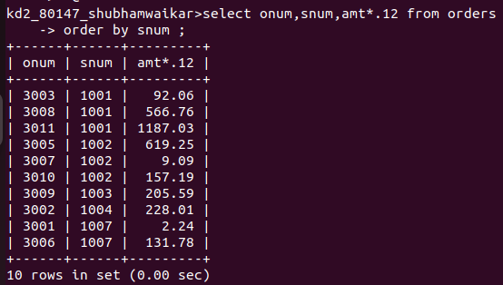

2) Write a query on the Customers table that will find the highest rating in each city. Put the butput in this form:

For the city (city), the highest rating is

(rating).
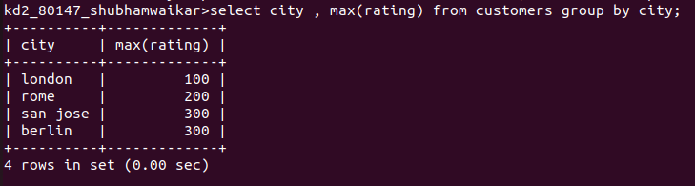
3) Write a query that lists customers in descending order of rating. Output the rating field first, followed by the customer's name and number.

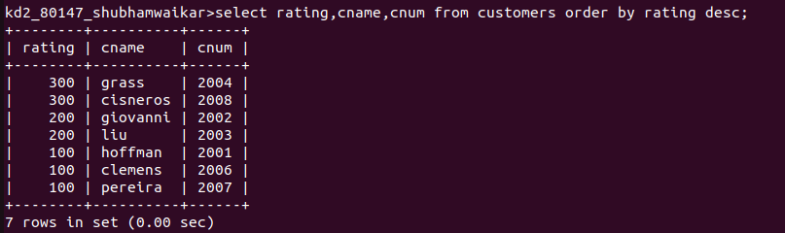
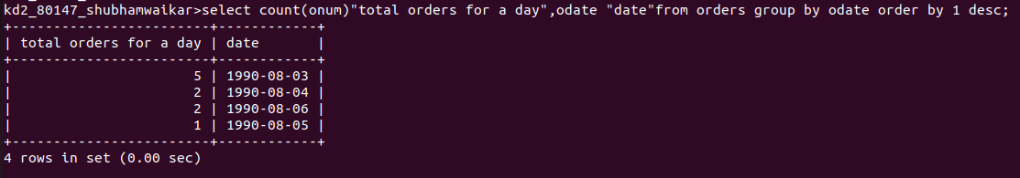

4) Write a query that totals the orders for each day and places the results in descending order.

