ASSIGNMENT = 5

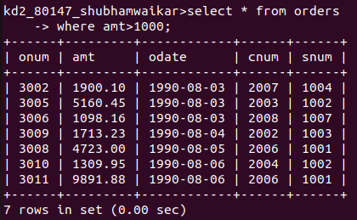
1) WRITE A QUERY THAT WILL GIVE YOU ALL ORDERS FOR MORE THAN RS 1000.

2) WRITE A QUERY THAT WILL GIVE YOU THE NAMES AND CITIES OF ALL SALESPEOPLE IN LONDON WITH A COMMISION ABOVE .10

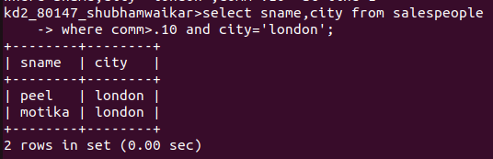

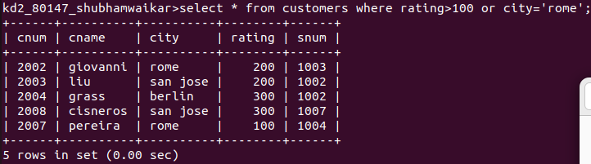
3) WRITE A QUERY ON THE CUSTOMERS TABLE WHOSE OUTPUT WILL EXCLUDEE ALL CUSTOMERS WITH RATING <=100, UNLESS THEY ARE LOCATED IN ROME
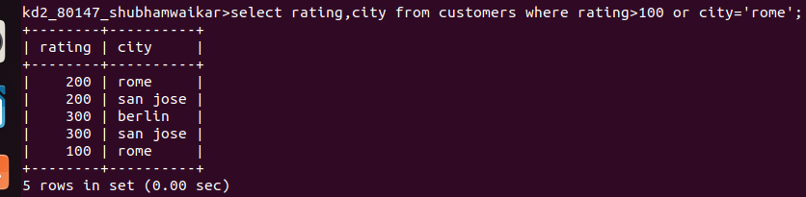

4) WHAT WILL BE THE OUTPUT FROM THE FOLLOWING QUERY
SELECT * FROM ORDERS
WHERE (AMT <1000 OR
NOT (ODATE = ‘1990=10=03’ AND CNUM >2003));

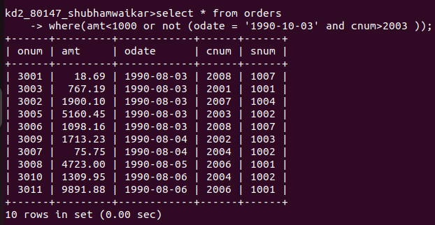

5) WHAT WILL BE THE OUTPUT OF THE FOLLOWING QUERY

SELECT * FROM ORDERS
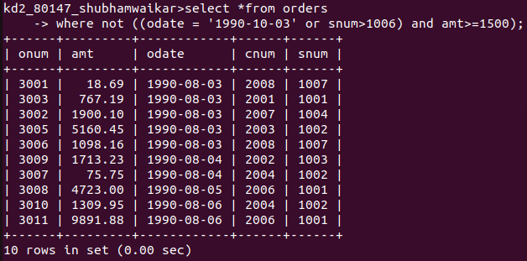
WHERE NOT (( ODATE = ‘1990-10-03’ OR SSNUM >1006) AND AMT>=1500);

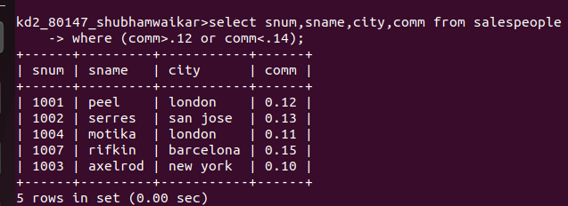
6) What is a simpler way to write this query? Select snum, sname, city, comm From Salespeople (comm>.12 OR comm <.14);

