ASSIGNMENT = 7

Summarizing Data with Aggregate Functions.

1) Write a query that counts all orders for October 3.

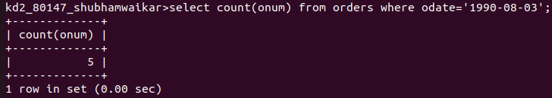

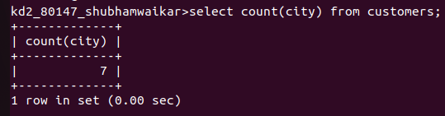
2) Write a query that counts the number of lifferent non-NULL city values in the Customers table.#Write a query that selects each customer's mallest order.

3) Write a query that select each customers smallest order

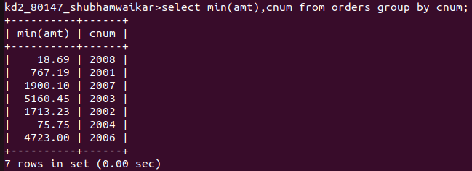
4) Write a query that selects the first customer, alphabetical order, whose name begins with G.



5) Write a query that selects the highest rating
in each city.

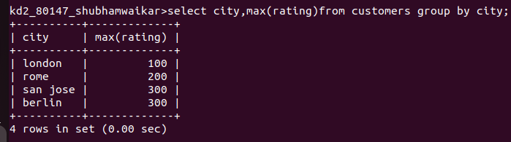

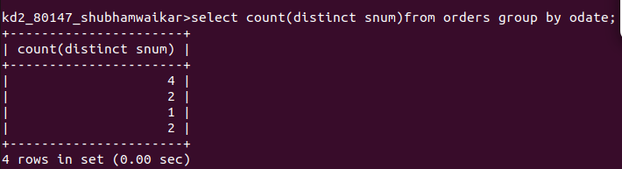
6) write a query that counts the number alespeople registering orders for each day. (Ita salesperson has more than one order on a givenday, e or she should be counted only once.).

