ASSIGNMENT = 14

1) Write a command that puts the following values, in their given order, into the salespeople table: city San Jose, name - Blanco, comm NULL, cnum - 1100.

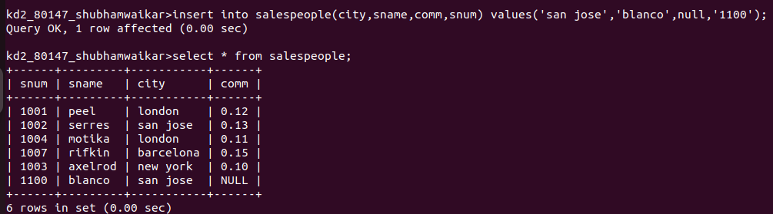

2) Write a command that removes all orders from From Salespeote
customer Clemens from the Orders table.

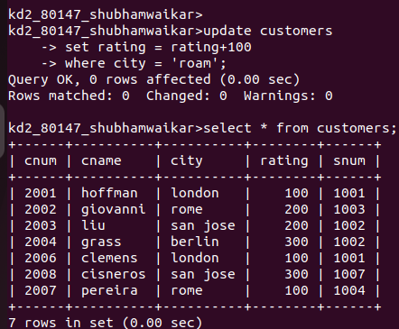
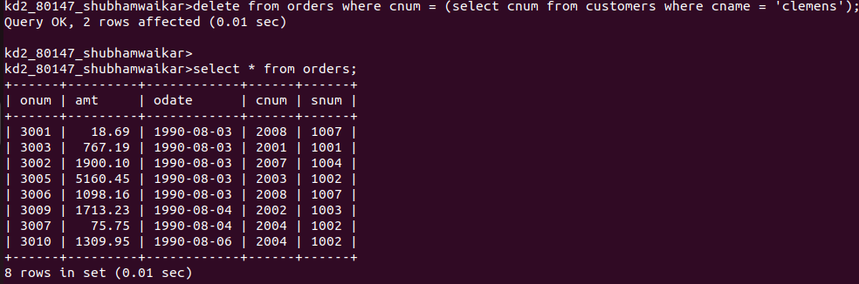

3) Write a command that increases the rating of all customers in Rome by 100.

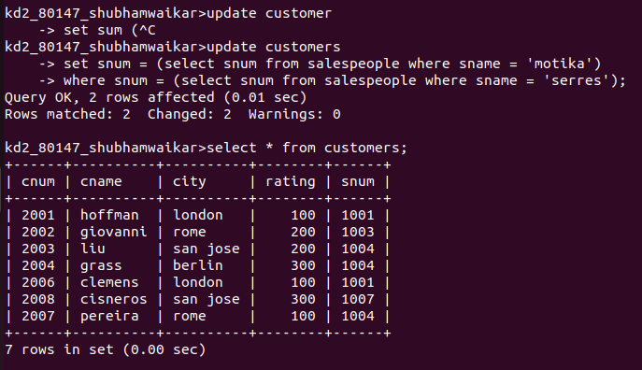
4) Salesperson Serres has left the company. Assign her customers to Motika.

