ASSIGNMENT =6

Using Special Operators in Conditions.

1) Write two different queries that would produce all orders taken on October 3rd or 4th, 1990.

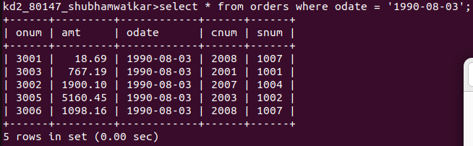

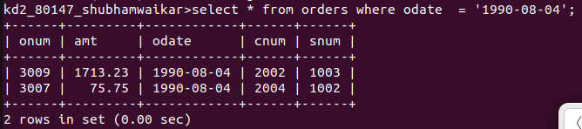

2) Write a query that selects all of the customers

Serviced by Peel or Motika. (Hint: the snum field

relates the two tables to one another).

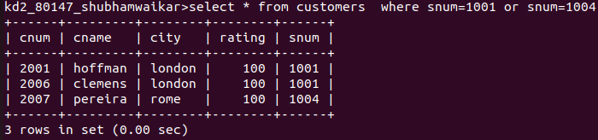

3) Write a query that will produce all the customers whose names begin with a letter from 'A' to 'G'

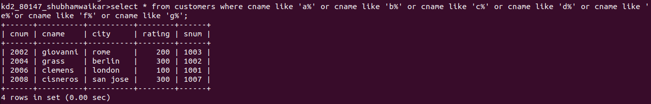

4) Write a query that selects all customers whose names begin with the letter 'C'.

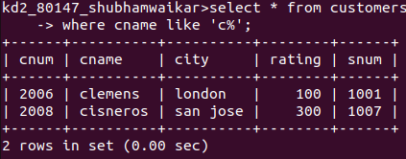

5) Write a query that selects all orders except

those with zeroes or NULLS in the amt field.

