ASSIGNMENT =4

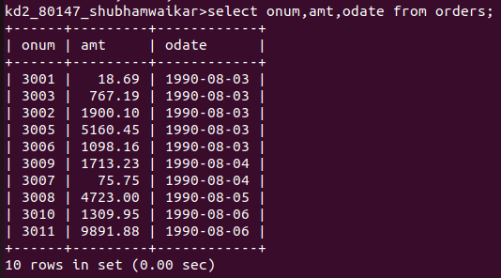
1) WRITE A SELECT COMMAND THAT PRODUCES THE ORDER NUMBER , AMOUNT , AND DATE FOR ALL ROWS IN THE ORDERS TABLE .

2) WRITE A QUERY THAT PRODUCES ALL ROWS FROM THE CUSTOMERS TABLE FOR WHICH THE SALESPERSION NUMBER 1001.

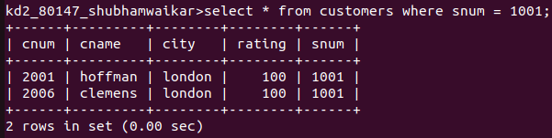

3)WRITE A QUERY THAT DISPLAY THE SALESPEOPLE TABLE WITH THE COLUMNS IN THE FOLLOWING ORDER ;CITY, SNAME, SNUM, COMM.
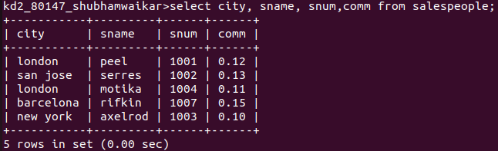

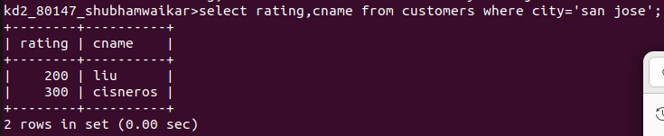
4) WRITE A SELECT COMMAND THAT PRODUCES THE RATING FOLLOWED BY THE NAME OF EACH CUSTOMER IN SAN JOSE.

