Assignment – 15

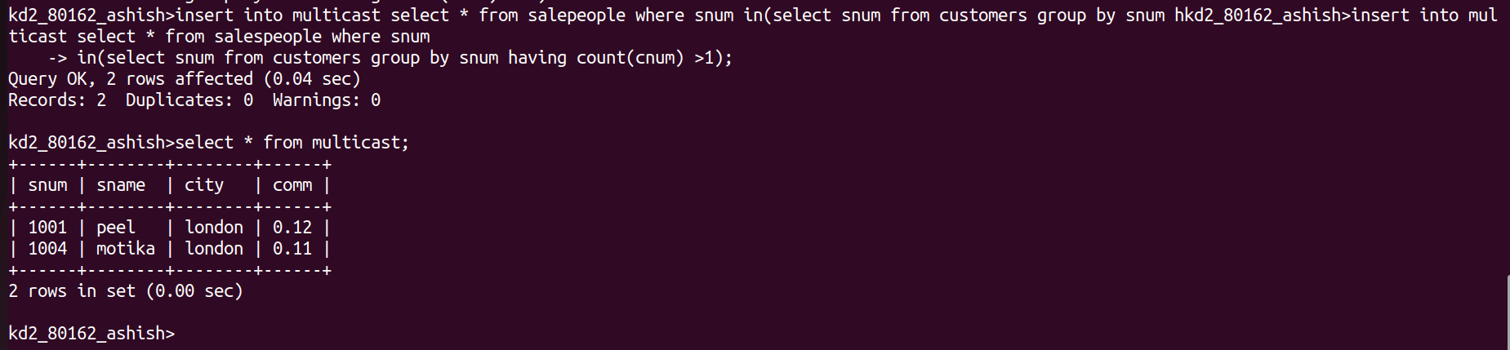
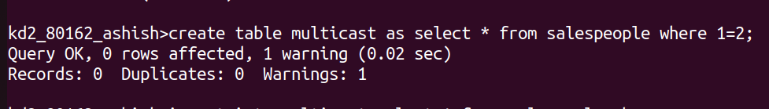
1) Assume there is a table called Multicust, with all of the same column definitions
as Salespeople. Write a command that inserts all salespeople with more than one
customer into this table.

2) Write a command that deletes all customers with no current orders.
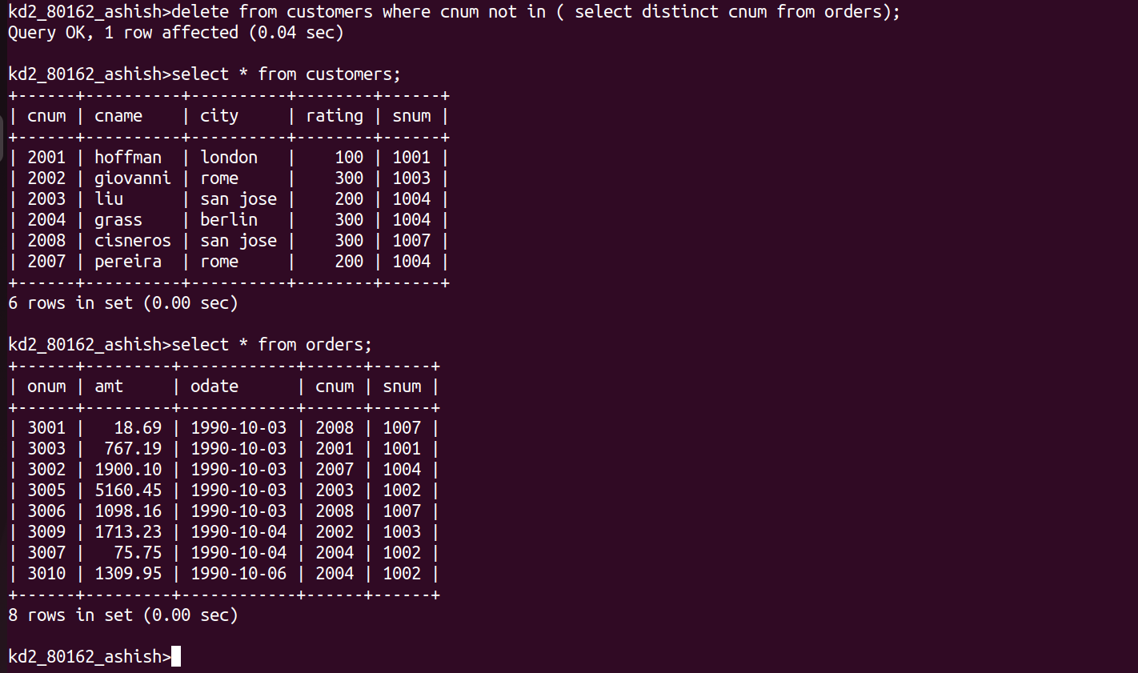

3) Write a command that increases by twenty percent the commissions of all
salespeople with total current orders above Rs. 3,000.

