Assignment No.04

Q.01)Write a Select Command that Produces the order number,amount,and date for all rows in the order table.
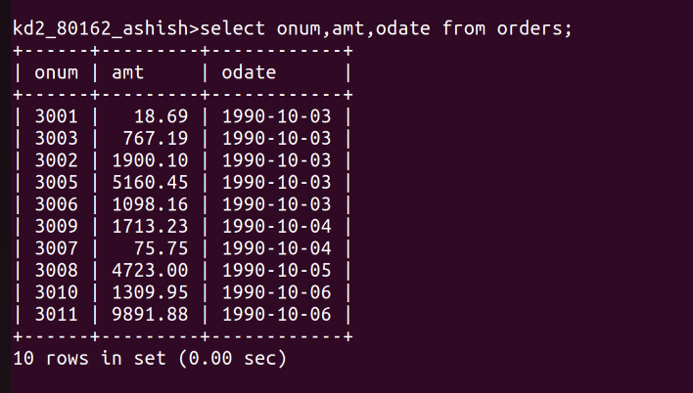
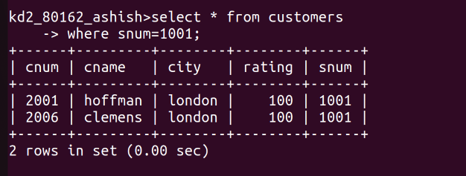
Q.02)Write a query that produces all rows from the customers table for which the salesperson’s number is 1001

Q.03)Write a query that displays the salespeople table with the columns in the following order:city,sname,snum,comm.

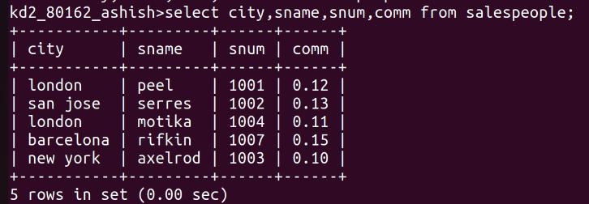

Q.04)Write a select command that produces the rating followed by the name of each customer in san jose.

