Assignment no.07

Q.01)Write a query that counts all orders for october 3
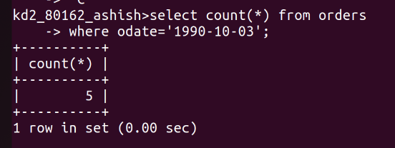
Q.02)Write a query that counts the number of different non null city values in the customers table

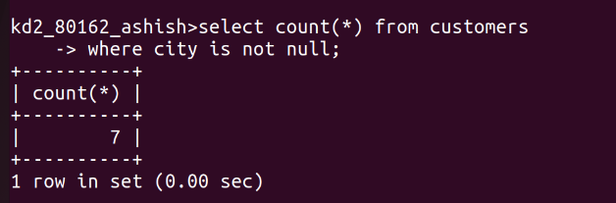
Q.03)Write a Query that selects each customer’s samllest order.

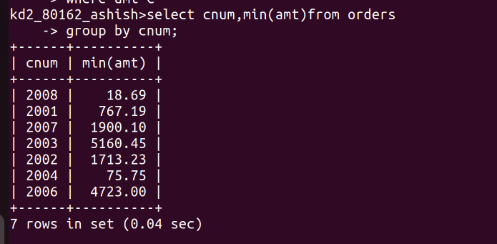
Q.4)Write a query that selects the first customer,in alphabetical order,whose name begins with g.

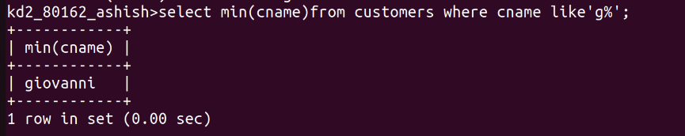
Q.5)Write a query that selects the highest rating in each city.
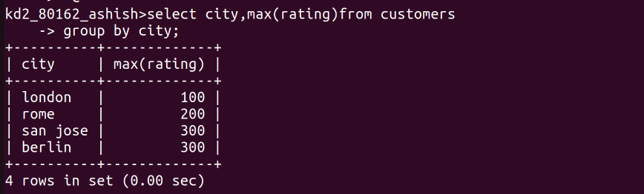
Q.6) Write a qyery that counts the number of salespeople registering orders for each day.(if a salesperson has more than one order on givenday,he or she should be counted only once.
