Assignment No.05

Q.01)Write a query that will give you all orders for more than Rs.1000.

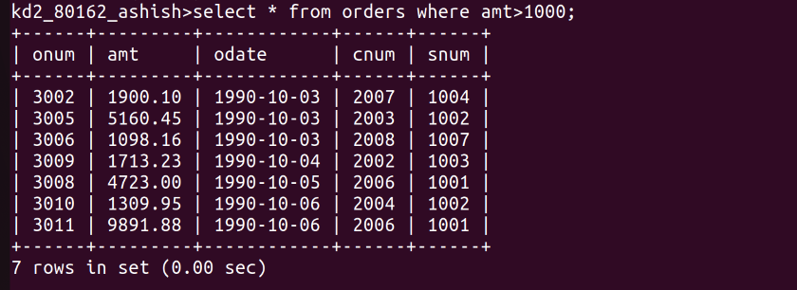
Q.02)Write a query that will give you the names and cities of all salespeople in london with a commission above .10.
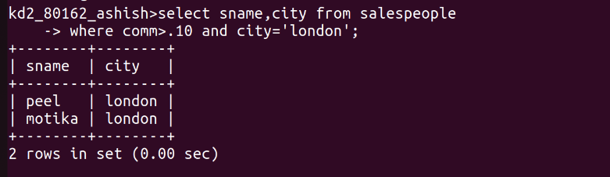
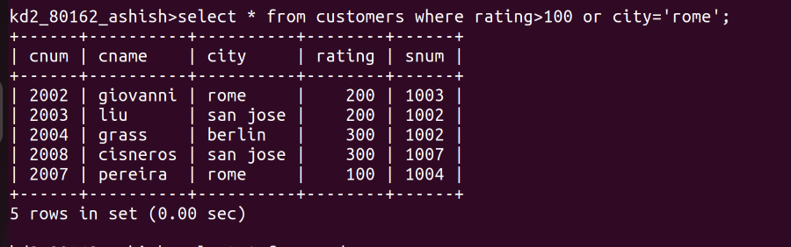
Q.03)Write a Query on the customers table whose output will exclude all customers with a rating <=100,unless they are located in rome.

Q.04)What will be the output from the following query?
Select * from orders
where ( amt<1000 or
Not (odate =’1990-10-03’
And cnum >2003));
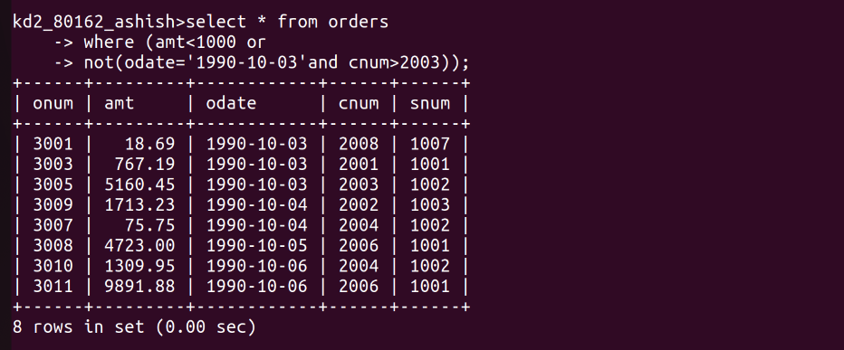
Q.05)What will be the output of the following query?
Select * from Orders
where Not((odate=’1990-10-03’ or snum
>1006)AND amt >=1500);
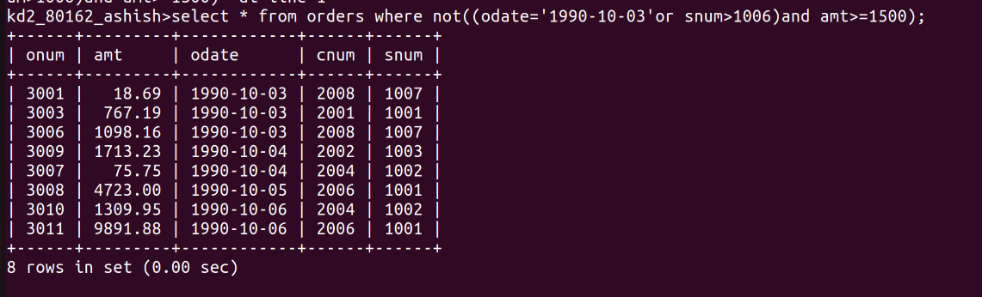
Q.06)What is a simpler way to write this query?
Select snum,sname,city,comm from salespeople where
(comm>.12 OR comm<.14)
