Assignment no.08

Q.1)Assume each salesperson has a %12 commission write a query on the orders table that will produce the order number,the salesperson number,and the amount of the salesperson’s commission for that order
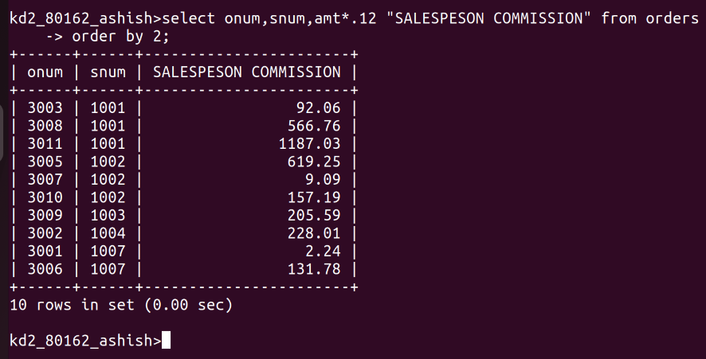
Q.2)Write a query on the customers table that will find the highest rating in each city.put the output in this form:
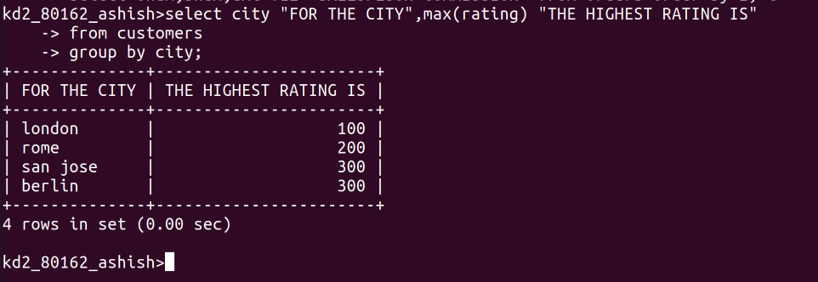
Q.3)Write a query that lists customers in descending order of rating.output the rating field ,followed by the customer’s name and number
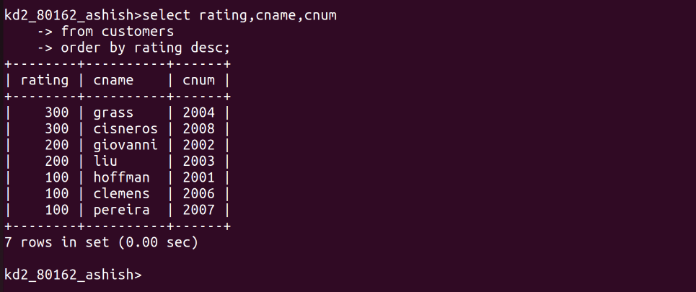
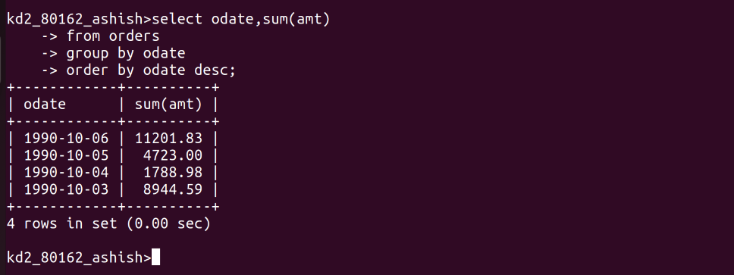
Q.4)Write a Query that totals the orders for each day places the results in descending order

