Assignment no.09

1) Write a query that lists each order number followed by the name of the customer
who made the order.

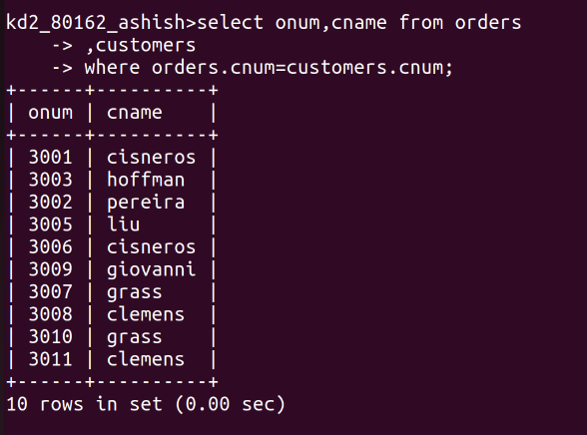
2) Write a query that gives the names of both the salesperson and the customer for
each order along with the order number.

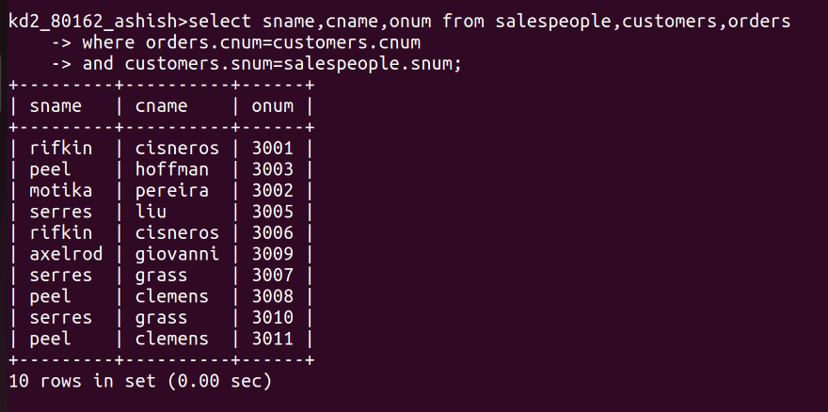
3) Write a query that produces all customers serviced by salespeople with a
commission above 12%. Output the customer’s name, the salesperson’s name,
and the salesperson’s rate of commission.
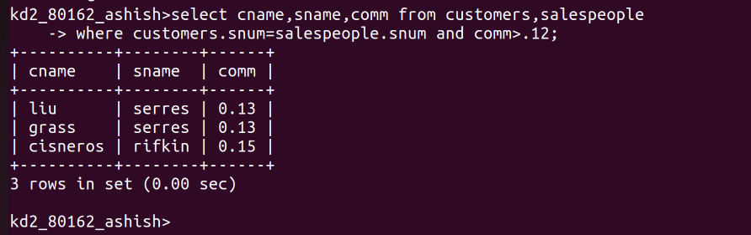

4) Write a query that calculates the amount of the salesperson’s commission on each
order by a customer with a rating above 100.


