Ques1

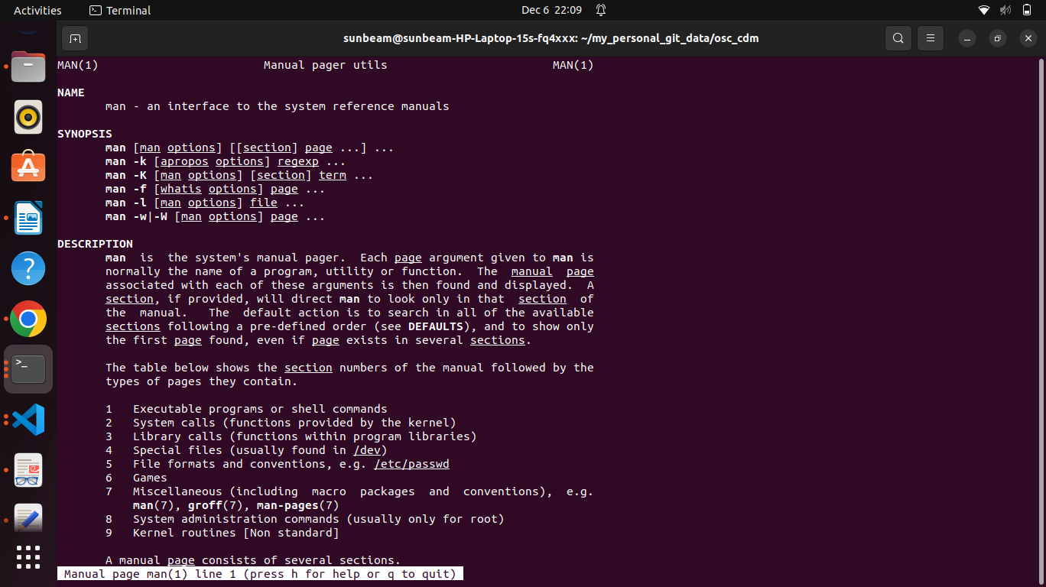
Ques 2:

Ques3:
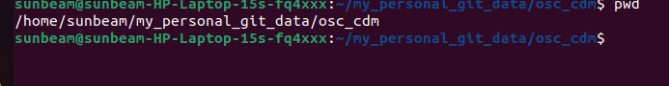
Ques4:

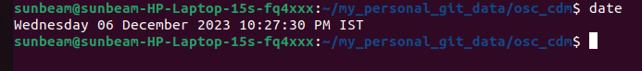

Ques6:
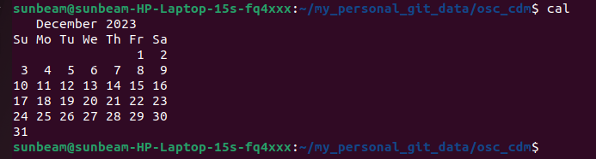

Ques7:
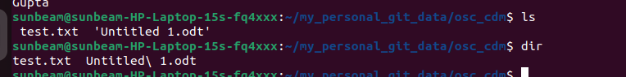

Ques 8:

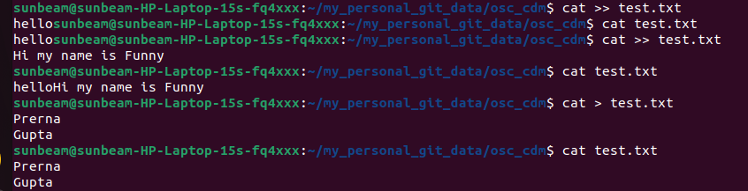
Ques 9:

Ques 10.

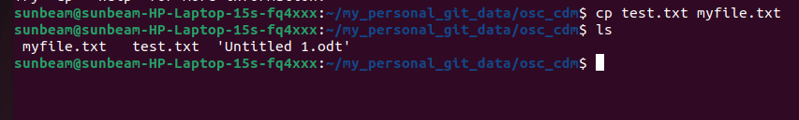

Ques 11.
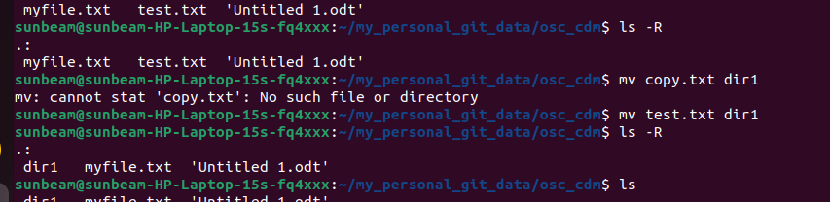

Ques 12.

Ques 13.
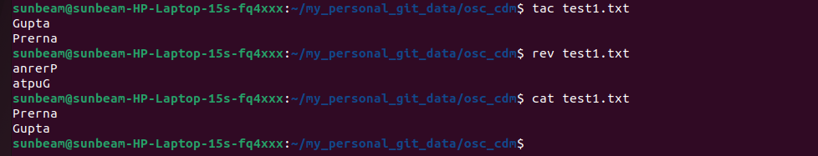

Ques 14.

Ques 15.
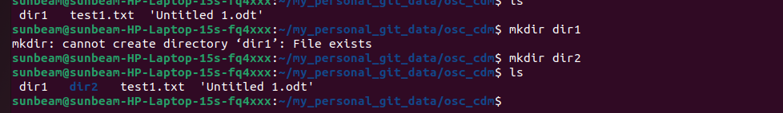

Ques16:
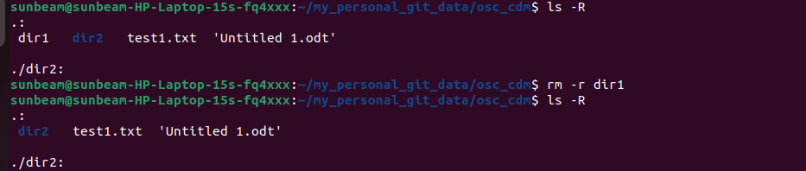

Ques 17:

Ques 18:
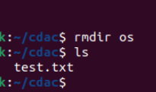

Ques19:

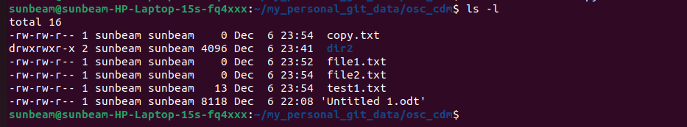

Ques 20:
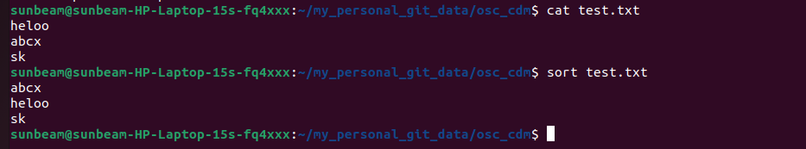

Ques 21:
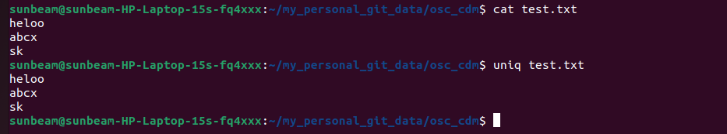

Ques22:
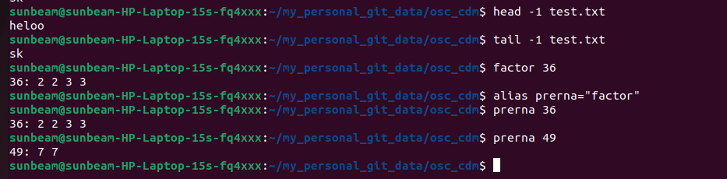

Ques23:

Ques24:

Ques25:

Ques26:
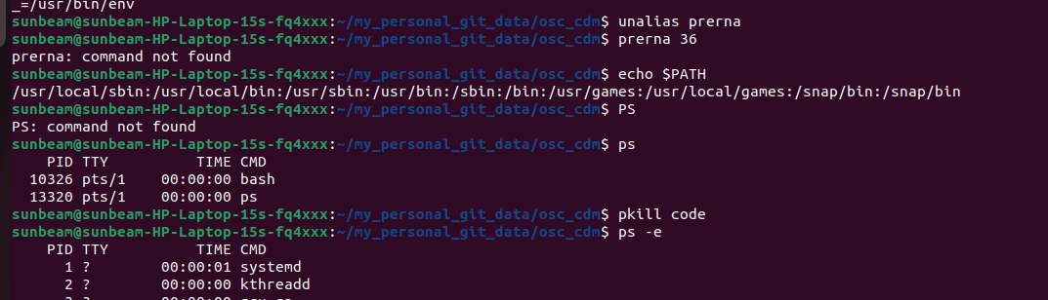

Ques27:

Ques28:

Ques29:

Ques30:
