Name: Prerna Gupta
Kd2-80175

Section A
1>sed 's/ /\n/g' file1.txt
2>grep -oP '\b\d{5}\b' file2.txt
3>echo "Welcome to Mississippi. I love Mississippi" | sed 's/\(.\)\1/Misisippi/g'
4>echo "3.5 * 2.7" | bc
5>grep -o -i 'is' file3.txt | wc -l
6>grep -v 'demo' file3.txt
7>cat >> file3.txt(to add)
answer -> grep "^L" file3.txt
8>done in test.sh file
command->vim test.sh
->bash test.sh

Section B:

1)git init

2)vim file4.txt
git add .
git commit -m "added by master"

3)git branch branch1
git checkout branch1
vim file5.txt
git add .
git commit -m"added by branch1"

4)git checkout master
git branch branch2
git checkout branch2
vim file5.txt
git add .
git commit -m"added by branch2"

5)
git checkout master
git merge branch1
git merge branch2

6)git log --oneline --graph --decorate –all
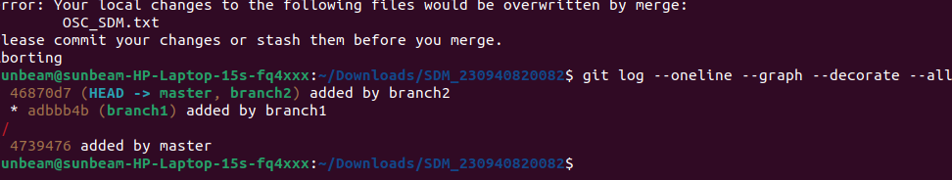

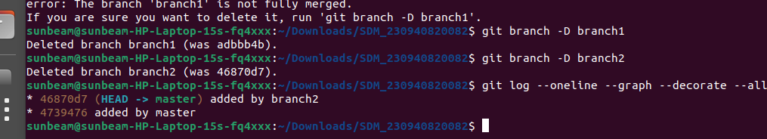
7:

8:
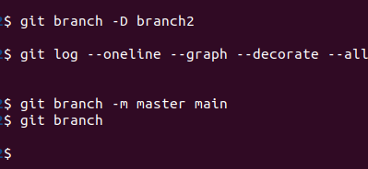

9:

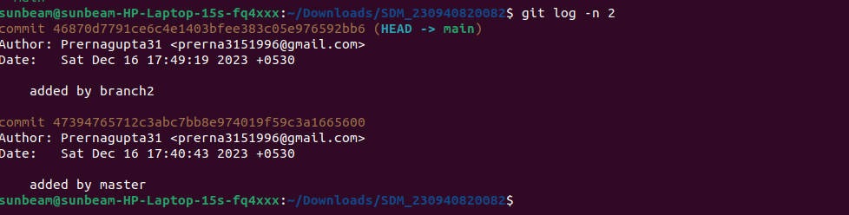
10:

git diff

SECTION3

1)
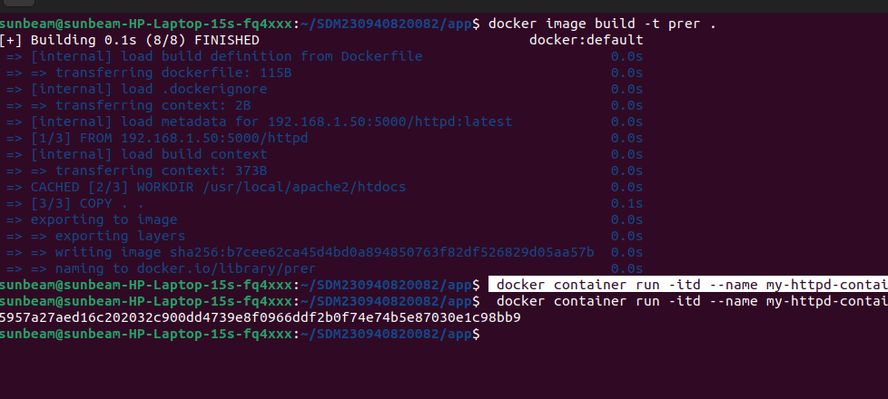

do dd
doddocker build -t my-httpd-container .cker build -t my-httpd-container .
doc docker build -t my-httpd-container .ker build -t my-httpd-container .

2)docker container run -itd --name mysql -p 3307:3306 -e MYSQL_ROOT_PASSWORD=root mysql

