ASSIGNMENT 12
Using the operators IN, ANY, and ALL.
Q1.Write a query that selects all customers whose ratings are equal to or greater
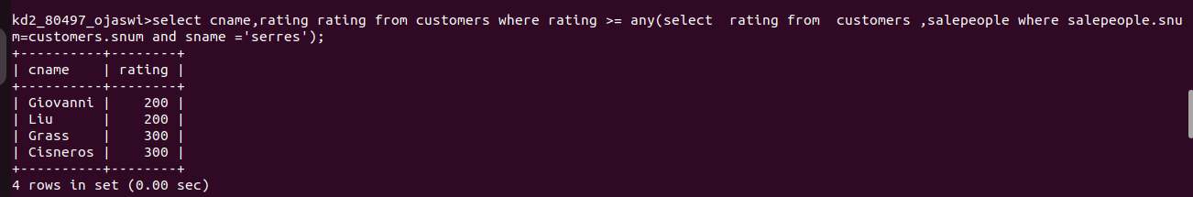
Serres.

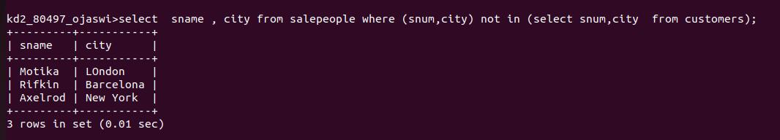
2) Write a query using ANY or ALL that will find all salespeople who have no customers located in their city.

3) write a query that selects all orders for amounts greater than any for the customers in London.
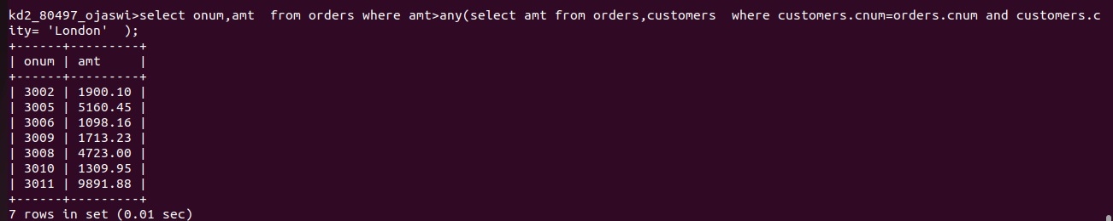
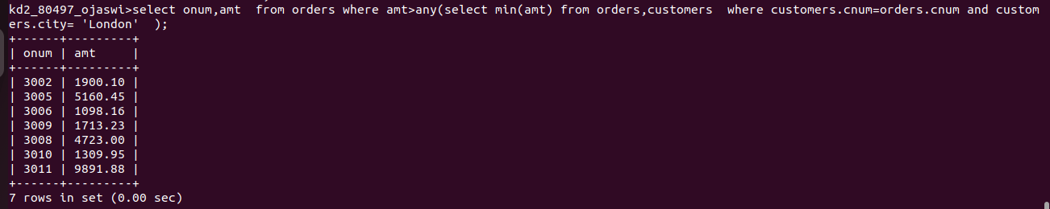
4) Write the above query using MIN or MAX.

