ASSIGNMENT 10

Q1. Write a query that produces all pairs of salespeople who are living in the same city . Exclude combinations of salespeople with themselves as well as duplicate rows with order reserved
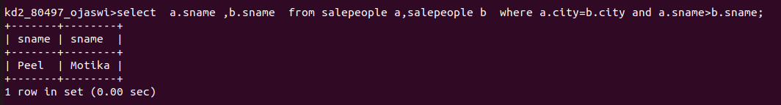
Q2. Write a query that produces the names and cities of all customers with the same ratings as Hoffman.
