SQL Assignnment 5

Q.1 Write a query that will give you all orders for more than RS 1000.
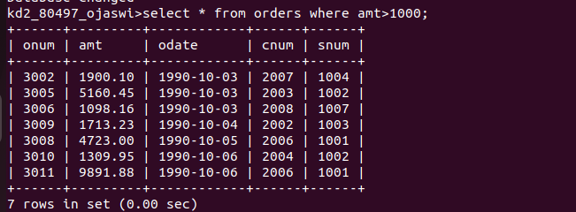

Q.2 Write a query that will give you the names and cities of all salespeople in london with commission above .10

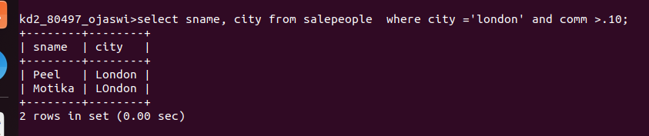

Q.3 Write a query on the customers table whose output will exclude all customers with rating <=100,unless they are located in rome.
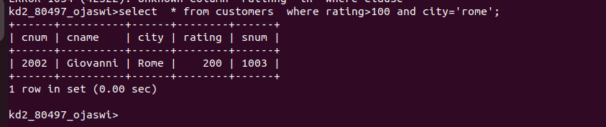

Q.4 What will be the output from the following query.
Select * from Orders where (amt < 1000 OR NOT (odate = ‘1990-10-03’
AND cnum > 2003));

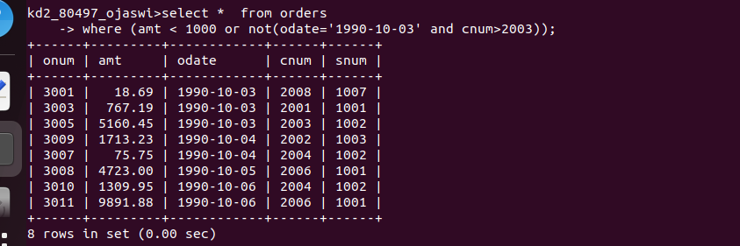

Q.5 What will be the output from the following query.
Select * from Orders where NOT ((odate =’1990-10-03’ OR snum > 1006) AND amt >= 1500)

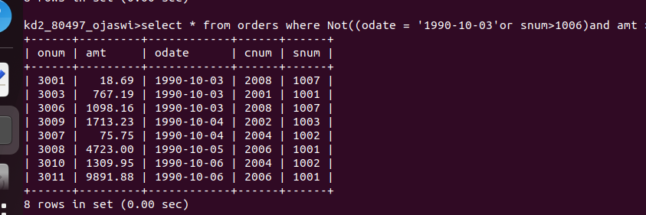

Q.6 What is a simpler way to write this query?
Select snum ,sname, city, comm from Salespeople where (comm > .12 OR
comm <.14);

