ASSIGNMENT 14

Q1. Write command that puts the following values , their given order , into the salepeople table: city_san jose , name_ blanco , comm – null ,cnum-1100.
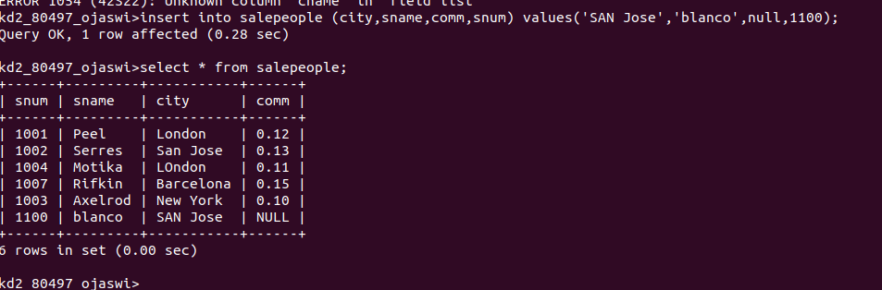

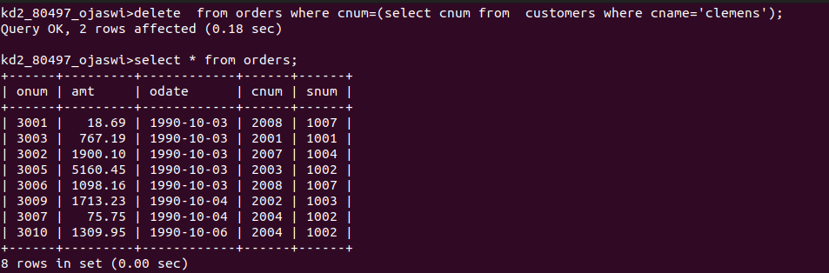
Q2. Write a command that removes all orders from customer clemens fom the orders table.

Q3.Write a command that increases the rating of all customers in rome by 100.
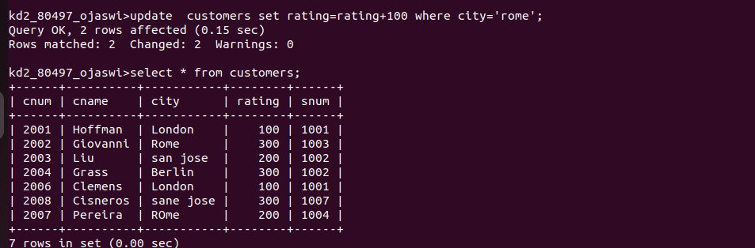
Q4.Salesperson serres has left the company .Assign her customers to motika.
