ASSSIGNMENT 9

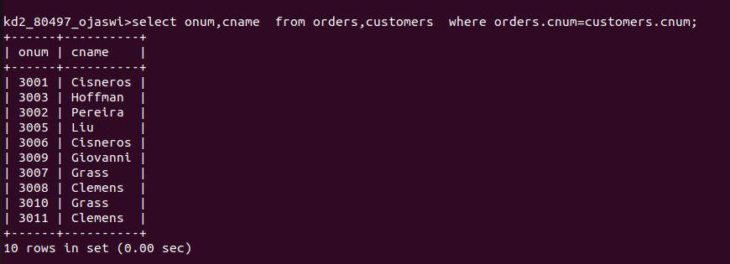
Q1.Write a query that lists each order number followed by the name of the customer who made the order.

Q2.Write aquery that gives the names of both the salesperson and the customers for each order along with the order number.
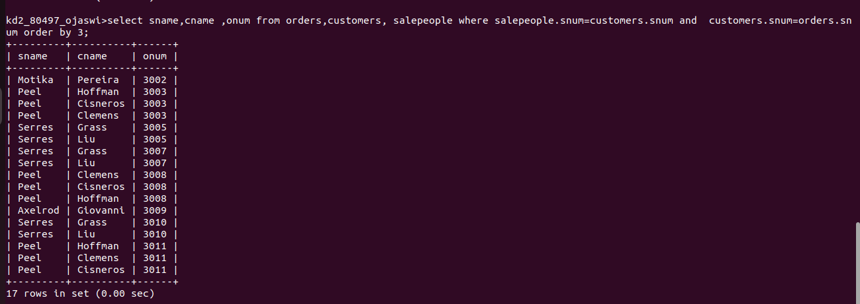

Q3.Write a query that produces all customers seviced by salespeople with a commission above 12%.output The customer’s name , the saleperson’s name,and the saleperson’s rate of commision

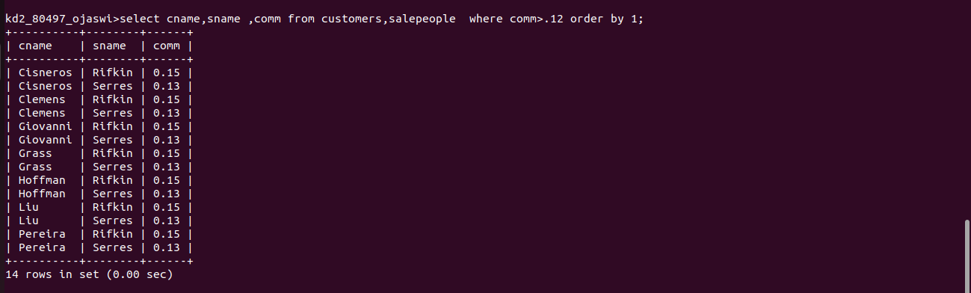

Q4 .Write a query that calculates the amount of the salespersons commisssion on each order by a customers with arating above 100.
