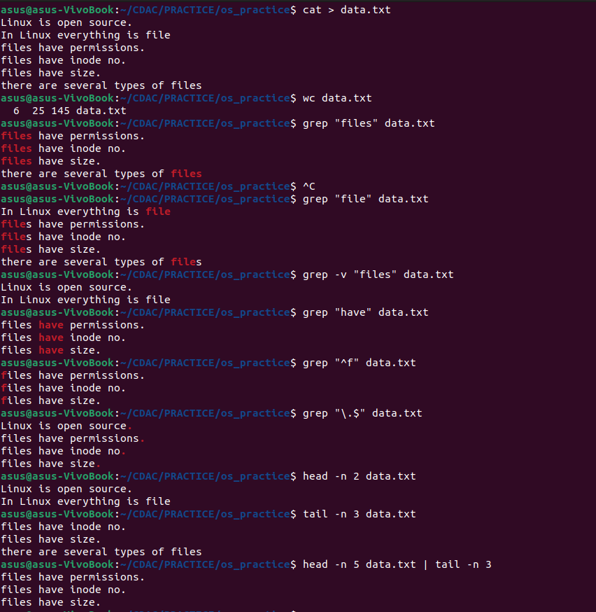
4_Linux_Commands_assignment_IV

