Q 1 - count the no. of words ,characters and lines from above 2 file.(man wc)

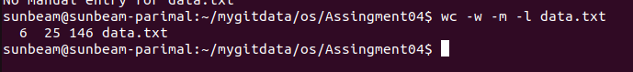

Q 2 - list the lines having word "files" (man grep)

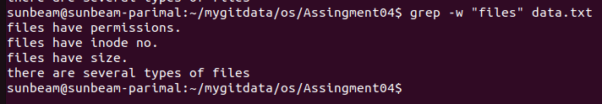

Q 3 - list the lines having word "file" (man grep)

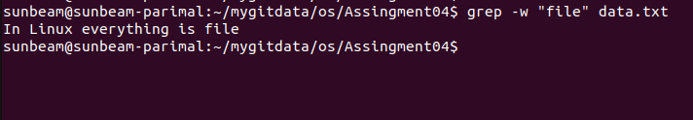

Q 4 - list the lines which don't have word "files" (man grep)

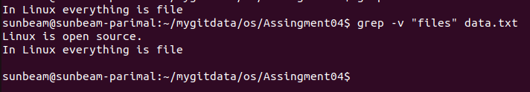

Q 5- list the lines having word "have" . (man grep)

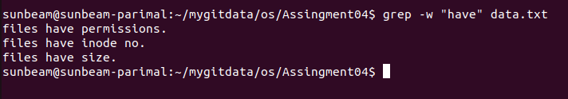
_

Q 6-list the lines starts with letter "f" (man grep)

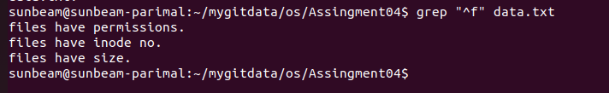

Q 7- list the lines ends with "." (man grep)

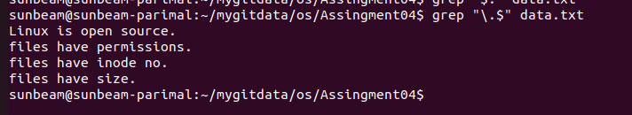

Q 8 - list only first two lines.(man head)

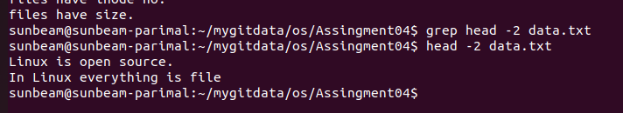

Q 9 - list only last three lines.(man tail)

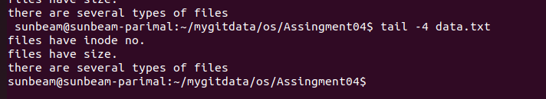

Q 10 - list line no.3,4 and 5 . (man head and tail)

