**EV Market**

**Problem Statement:**

1. To analyse the Electric Vehicle market in India using Segmentation analysis and come up with a  feasible strategy to enter the market, targeting the segments most likely to use Electric vehicles.
2. To decide which vehicle/customer space it will be develop its EVs.

**Introduction:**

The global electric vehicle (EV) market is developing at a rapid pace. According to EV volumes, overall electric vehicle reached a global share of 8.3% (including battery electric vehicles [BEVs] and Plug- in hybrid electric vehicles [PHEVs]) in 2021 from 4.2% in 2020 with 6.75 million vehicles on the road. This is an increase of 108% as of 2020. EVs are gaining attention across the globe as they help reduce emissions and depletion of natural resources. The Indian EV market is also evolving fast as close to 0.32 million vehicles were sold in 2021, up 168% YoY. Ongoing electric vehicle adoption in India is based on the Paris agreement to reduce carbon emissions, to improve the air quality in urban areas and reduce oil imports.

**Data Sources:**

1. <https://data.gov.in/>
2. <https://www.kaggle.com/datasets/kkhandekar/electric-vehicles-india>
3. <https://ev-database.org/>

**Data Preprocessing:**

1. Importing Libraries like request and beautifulsoup to scrape the data from site.
2. Importing Libraries like Pandas, Numpy, seaborne to manipulate and analyzed the data.

**Profiling and Describing segments:**

* Year (2019-20) Wise Statistic

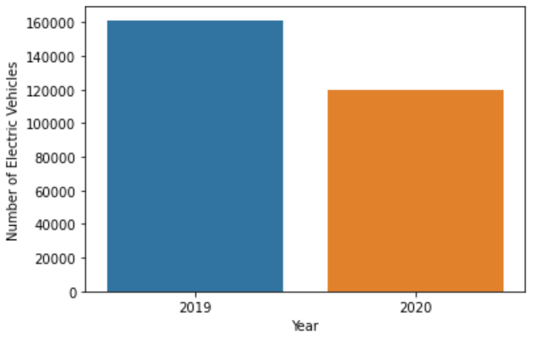

Number of vehicle sold was highest in year 2019 as compared to 2020.

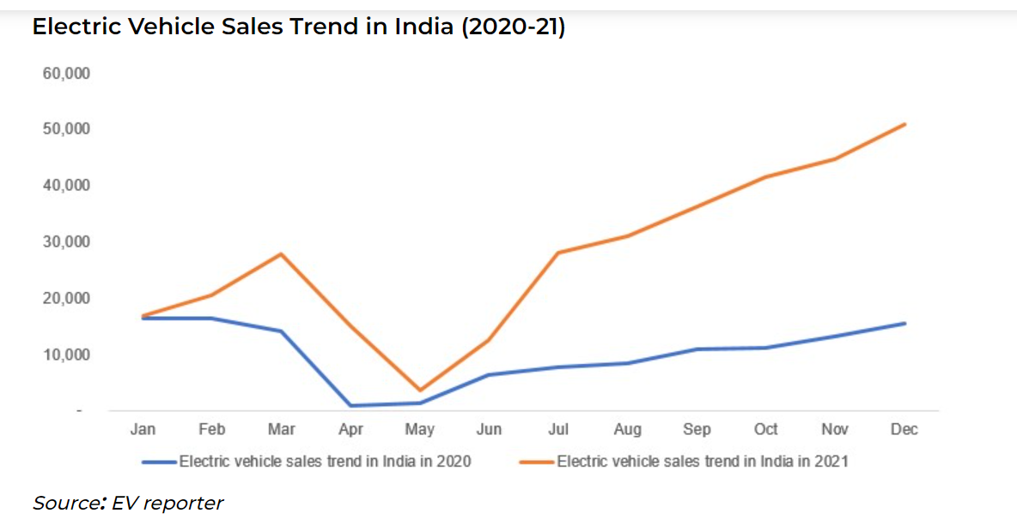

The sales of electric vehicle has increased in year 2021.

**Geographical Segment**

* Total Number of Electric Vehicle Sales State Wise

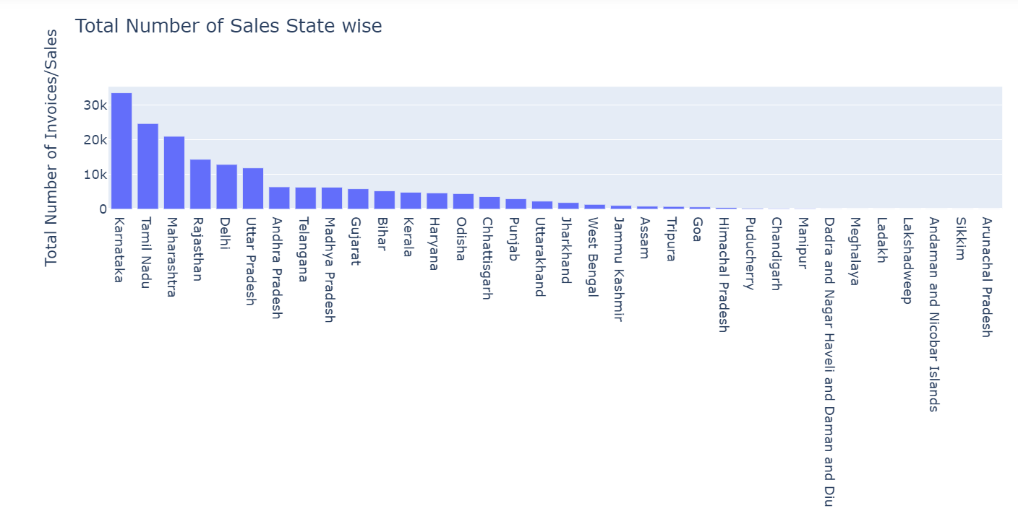

Top 5 State with highest number of Sales are:

1. Karnataka

2. Tamil Nadu

3. Maharashtra

4. Rajasthan

5. Delhi

* Number of active vehicle:

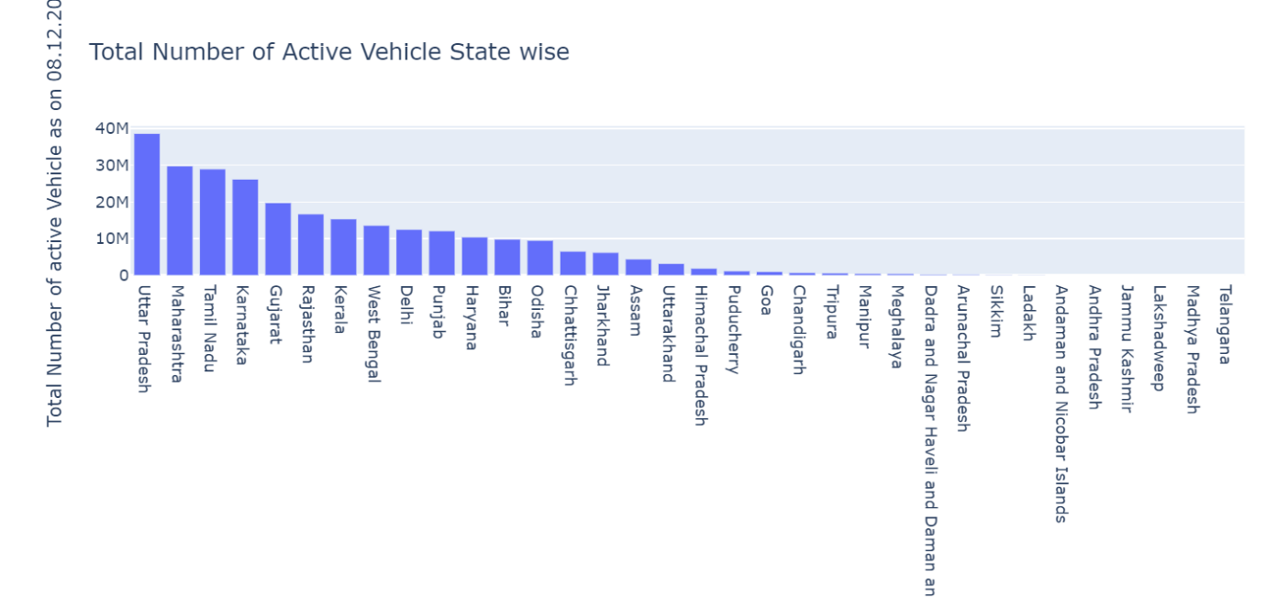

Top 5 State with highest number of active vehicle:

1. Uttar Pradesh

2. Maharashtra

3. Tamil Nadu

4. Karnataka

5. Gujarat

* Number of active Electric Vehicle:

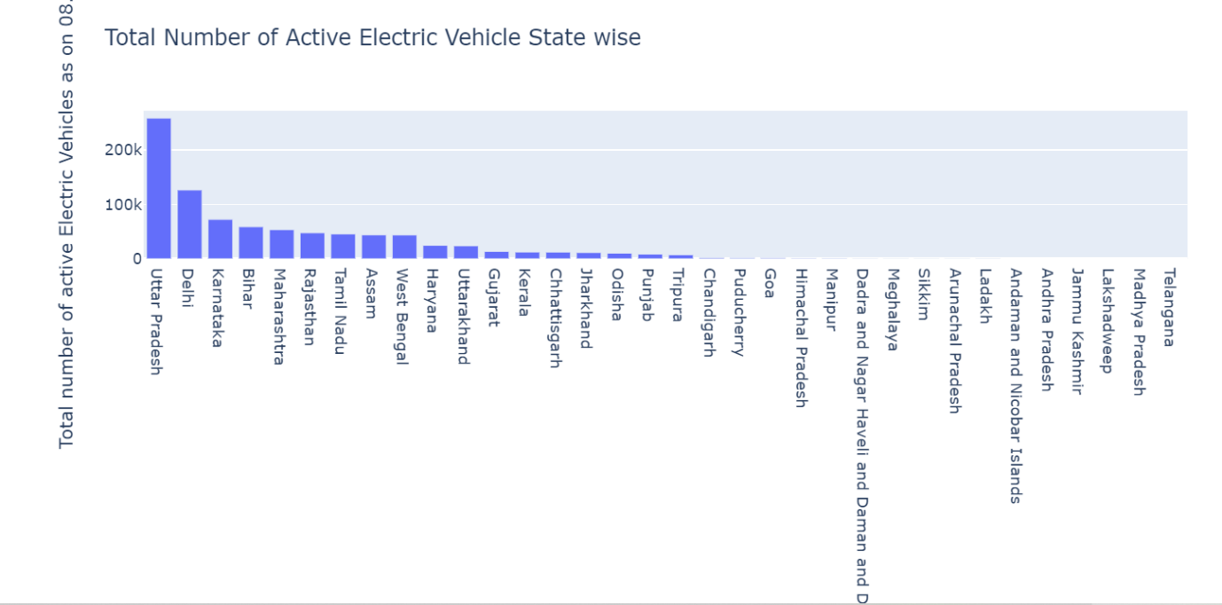

Top 5 State with highest number of active Electric Vehicle:

1. Uttar Pradesh

2. Delhi

3. Karnataka

4. Bihar

5. Maharashtra

* Highest Category of EV sold

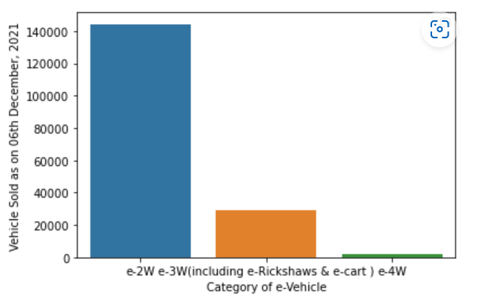

Number of vehicle sold is highest for category e-2W. Next highest category is e-3W.

* Charging station Vs. State Wise

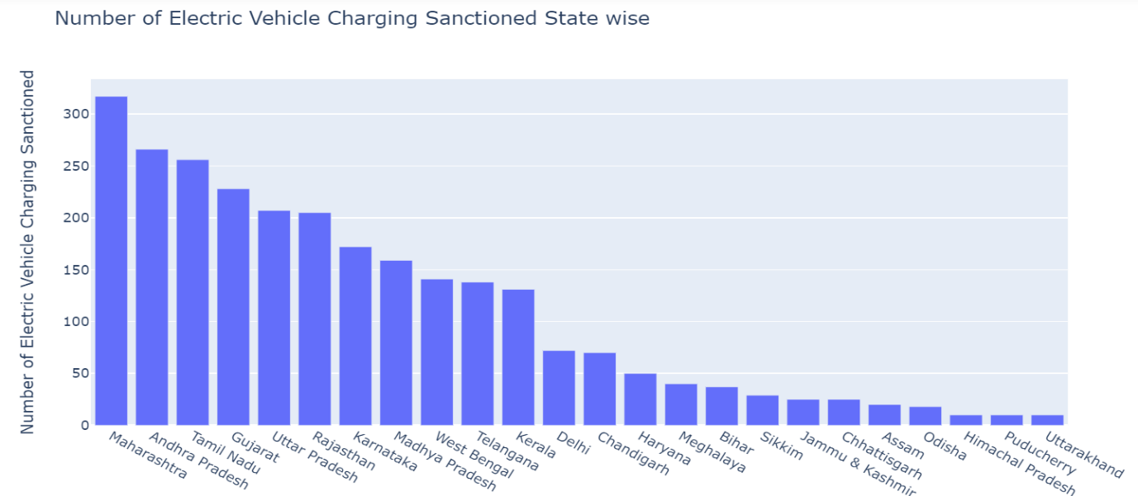

Top 5 states having higher number of charging station are:

1. Maharashtra

2. Andhra Pradesh

3. Tamil Nadu

4. Gujarat

5. Uttar Pradesh

* Charging Stations Vs. Highways

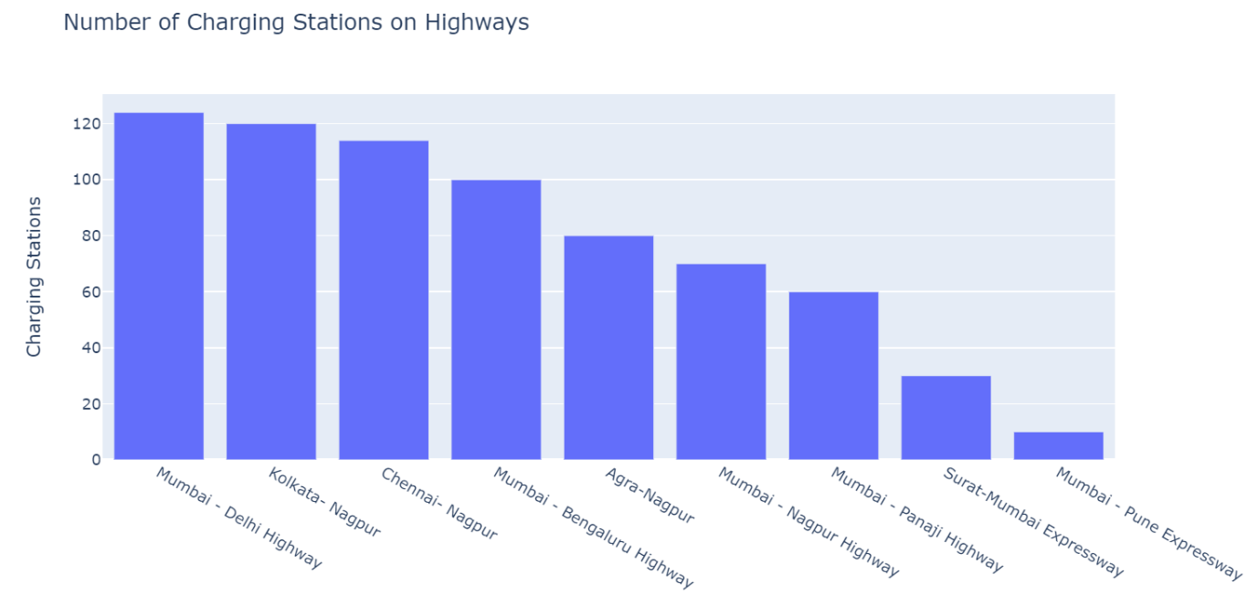

Top 5 Highways are:

1. Mumbai - Delhi Highway
2. Kolkata- Nagpur
3. Chennai- Nagpur
4. Mumbai - Bengaluru Highway
5. Agra-Nagpur

Electric Vehicle in India

Dataset used: <https://www.kaggle.com/datasets/kkhandekar/electric-vehicles-india>

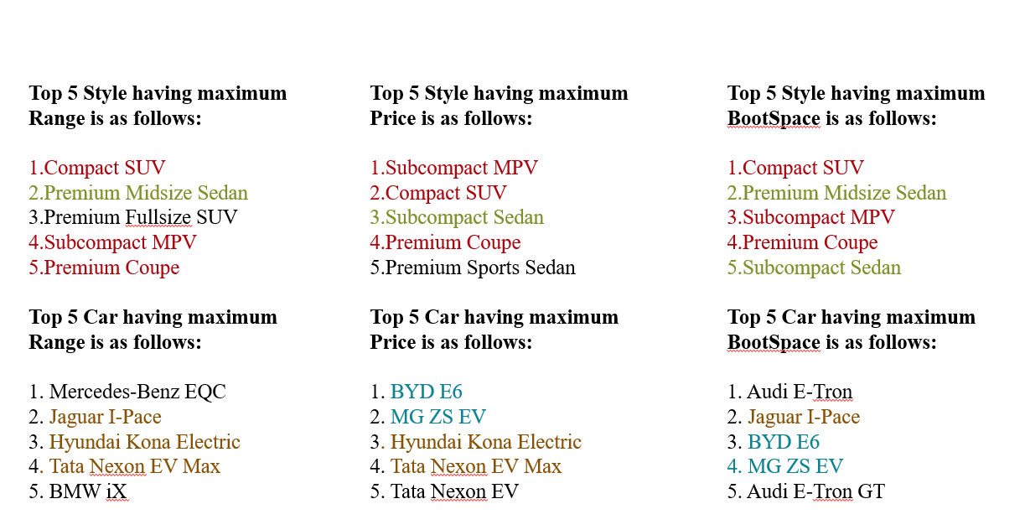

Electric Vehicle in UK, Germany, Netherlands

Why are we using Electric vehicle data of UK, Germany, Netherlands?

As we have to analyze the Electric Vehicle market in India using Segmentation analysis and come up with a feasible strategy to enter the market, targeting the segments most likely to use Electric vehicles.

Hence we need to analyze data of electric vehicle of UK, Germany, Netherlands so that we can launch the vehicle which is most commonly used there in terms of battery, acceleration, top speed, range, efficiency, fastcharge speed.

Dataset Used:

The data used here for analysis is scraped from the following site to extract the data.

Site used for scraping is: https://ev-database.org/

Extracted Data Look Like:

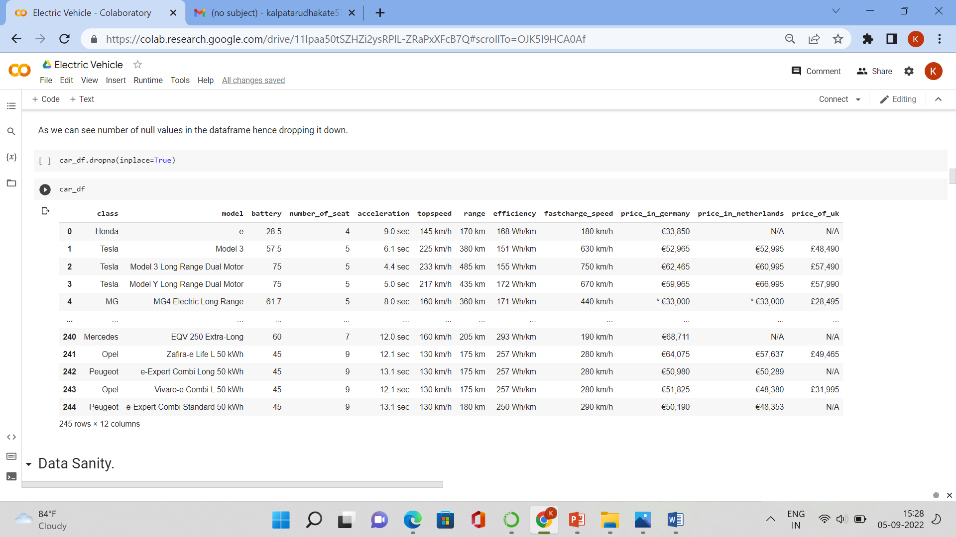



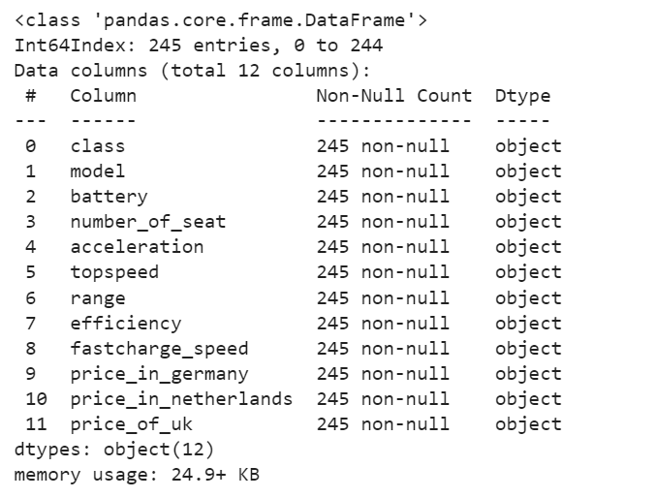

We can see that all the variable has dtype 'Object'. Hence to get insights about the data we need to convert certain variable dtype into 'int64'.

Correlation of Variables:

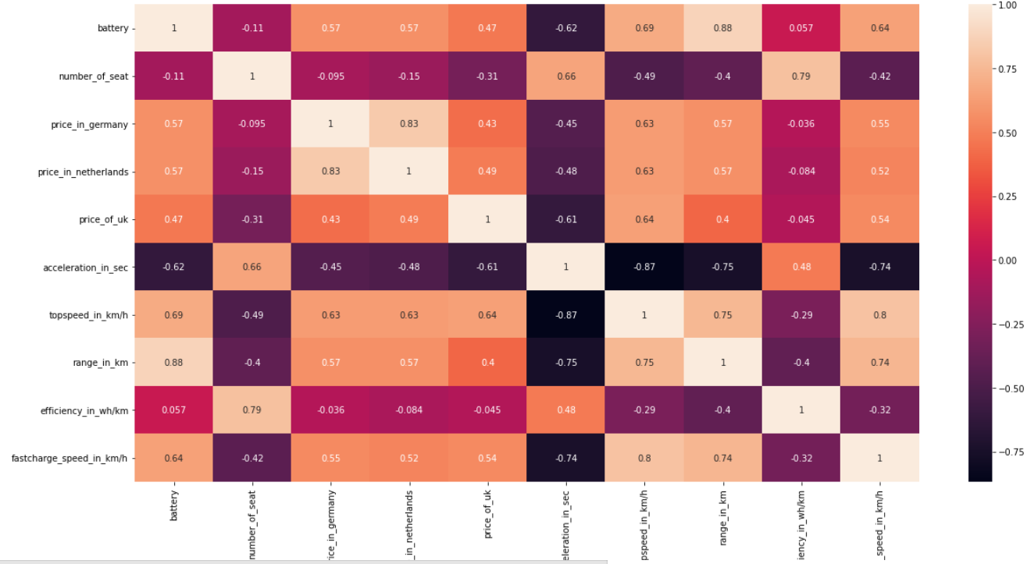

1. We can see that Variable name Battery is highly correlated with Fast charge speed, top speed and range.
2. Variable Name Efficiency is highly correlated with Number of seat.
3. Also we can see that Fast charge speed is highly correlated to Top speed and range.

* Efficiency Ranking of Electric Cars.

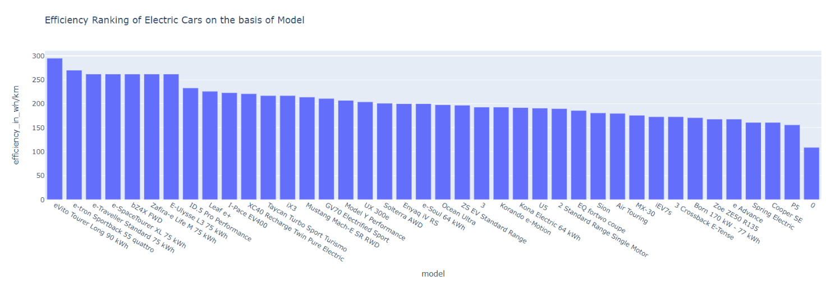

We can see that in Top 5 model in Efficiency ranking are:

1. eVito Tourer Extra-Long 90 kWh.
2. e-tron Sportback 55 quattro.
3. e-Traveller Standard 75 kWh.
4. e-SpaceTourer XL 75 kWh.
5. bZ4X FWD.

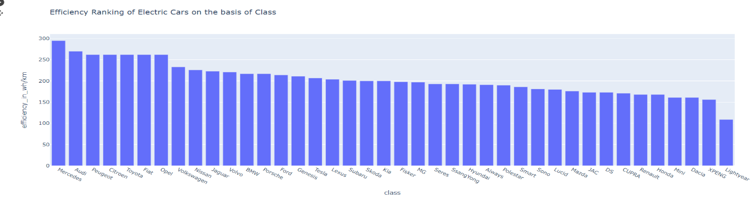

# We can see that in Top 5 class in Efficiency ranking are :

1. Mercedes.
2. Audi.
3. Peugeot.
4. Citroen.
5. Toyota.

# Battery Ranking of Electric Cars.

# C:\Users\91899\Pictures\Screenshots\Screenshot (96).png

We can see that in Top 5 Model in Battery ranking are :

1. Air Touring.
2. evito Tourer Long 90 kWh.
3. iX3.
4. Ocean Ultra.
5. Model Y Performance.

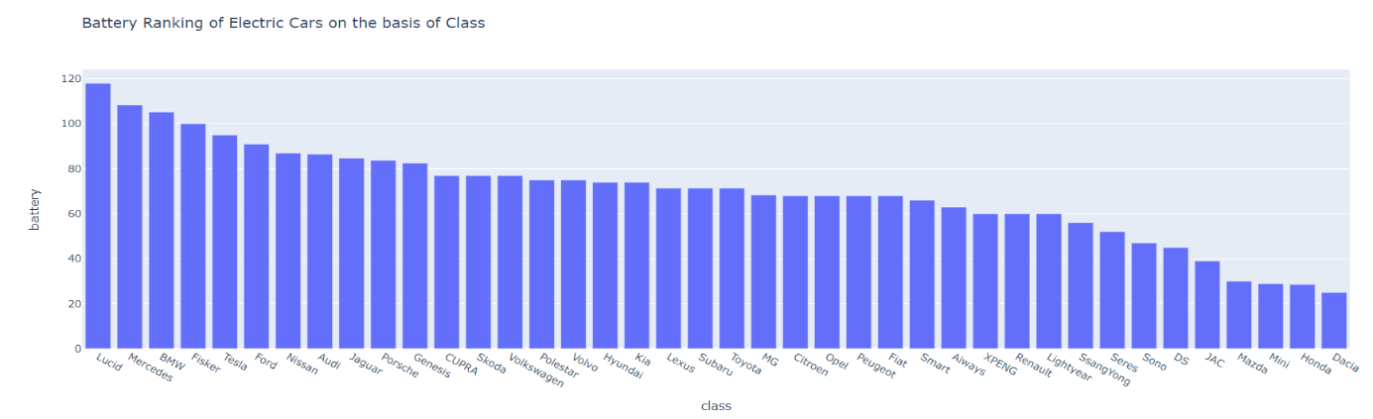

We can see that in Top 5 Model in Battery ranking are :

1. Lucid.
2. Mercedes.
3. BMW.
4. Fisker.
5. Tesla.

# Range Ranking of Electric Cars.

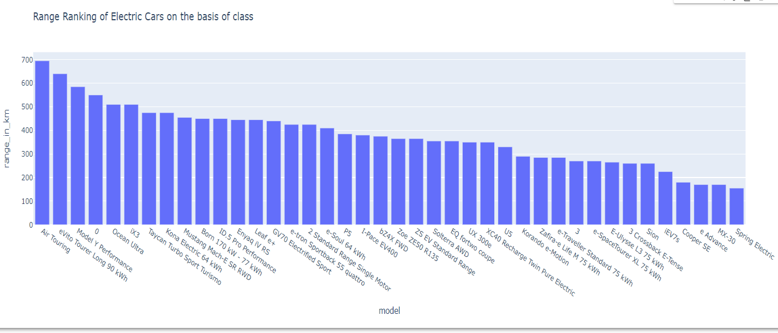

We can see that in Top 5 Model in Range ranking are :

1. Air Touring.

2. evito Tourer Long 90 kWh.

3. Model Y Performance.

4. 0.

5. Ocean Ultra.

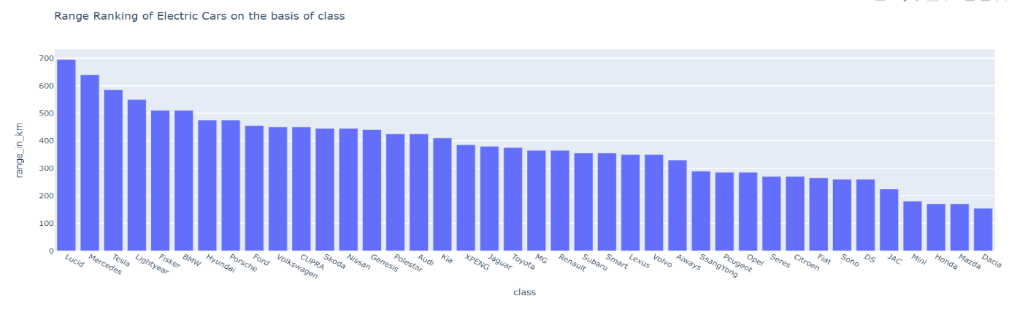

We can see that in Top 5 class in Range ranking are :

1. Lucid.

2. Mercedes.

3. Tesla.

4. Lightyear.

5. Fisker.

* Top Speed Ranking of Electric Cars

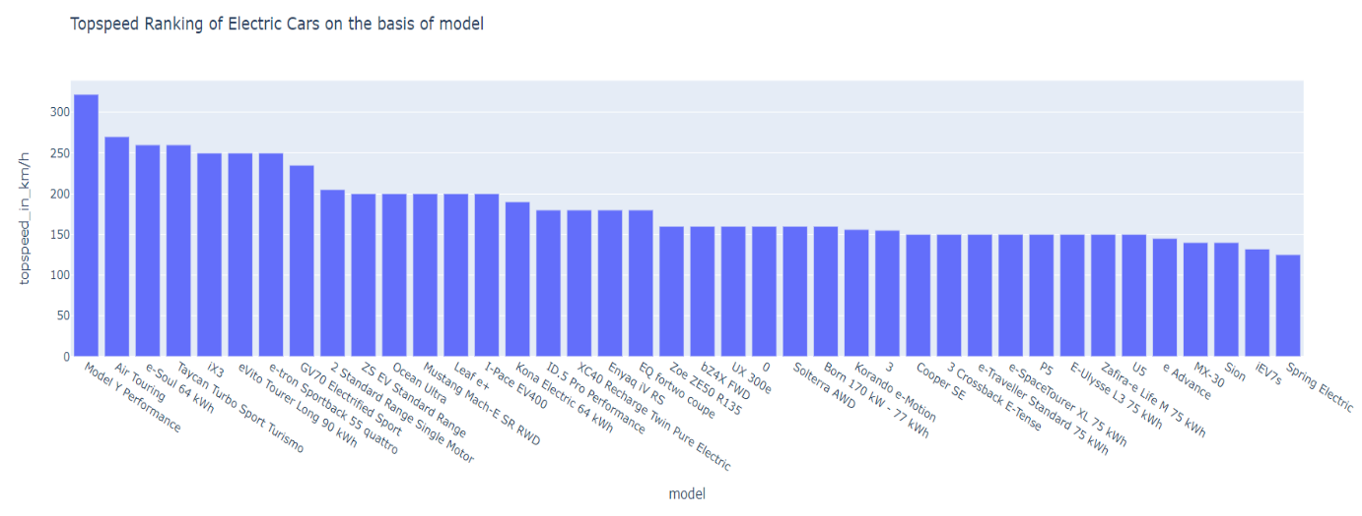

We can see that in Top 5 model in Topspeed ranking are :

1. Model Y Performance.

2. Air Touring.

3. e-soul 64 kWh.

4. Taycan Turbo Sport Turismo.

5. iX3.

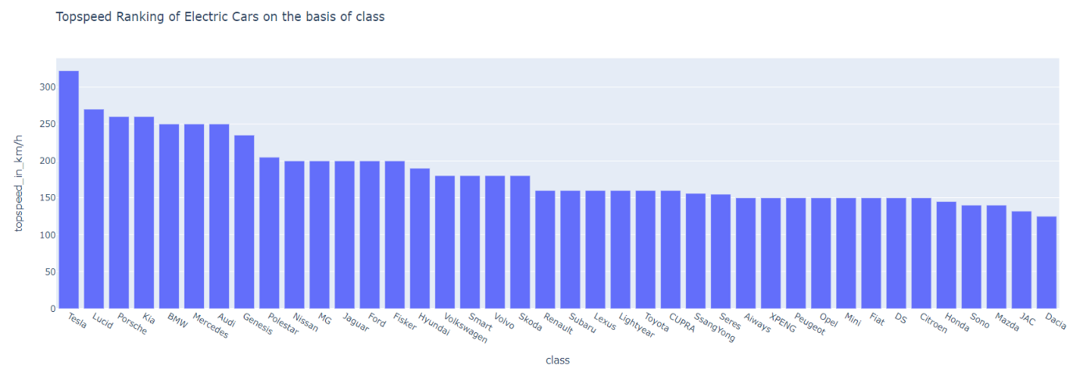

We can see that in Top 5 class in Battery ranking are :

1. Tesla.

2. Lucid.

3. Porsche.

4. Kia.

5. BMW.

* Acceleration Ranking of Electric Cars

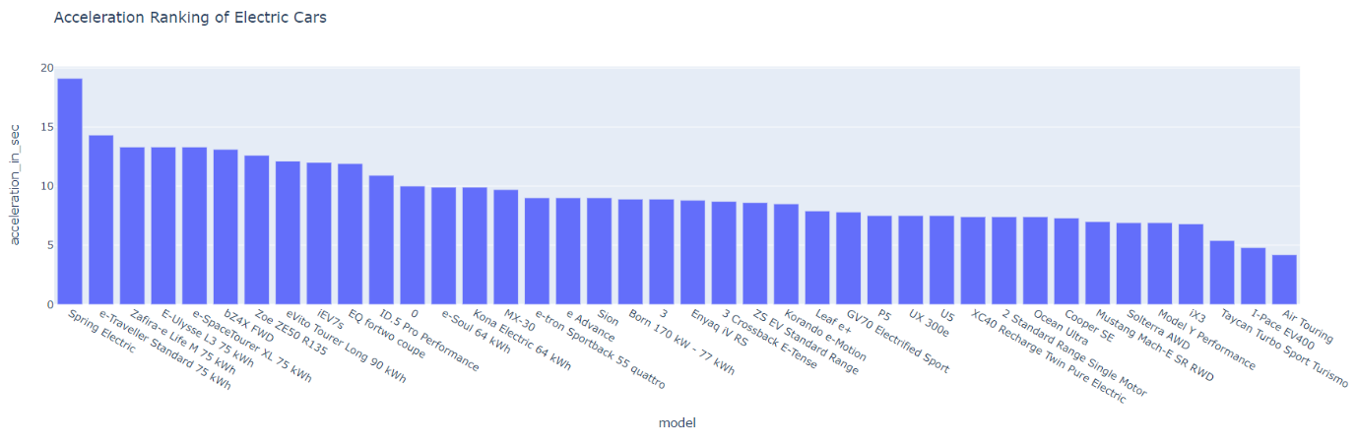

We can see that in Top 5 model in Acceleration ranking are :

1. Spring Electric.

2. e-Traveller Standard 75 kWh.

3. Zafira-e Life M 75 kWh.

4. E-Ulysse L3 75 kWh.

5. e-SpaceTourer XL 75 kWh.

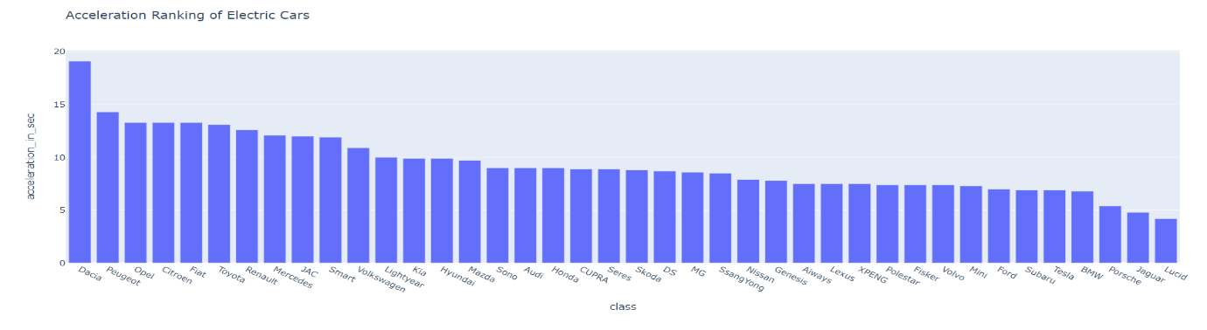

We can see that in Top 5 class in Acceleration ranking are :

1. Dacia.

2. Peugeot.

3. Opel.

4. Citroen.

5. Fiat.

* Fast charge Speed Ranking of Electric Cars

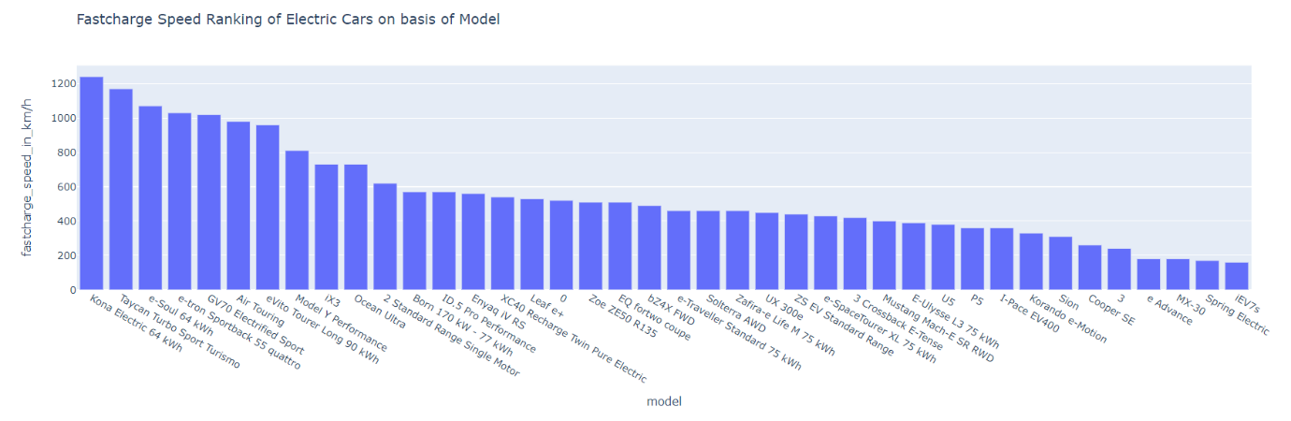

We can see that in Top 5 class in Acceleration ranking are :

1. Kona Electric 64 kWh.

2. Taycan Turbo Sport Turismo.

3. e-soul 64 kWh.

4. e-tron Sportback 55 quattro.

5. GV70 Electrified Sport.

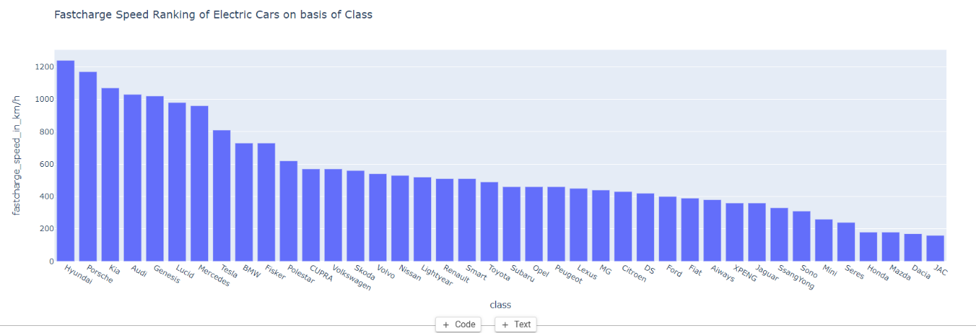

We can see that in Top 5 class in Acceleration ranking are :

1. Hyundai.

2. Porsche.

3. Kia.

4. Audi.

5. Genesis.

**Summary**

1. Based on geographical segment analysis we can see that Uttar Pradesh is highest in electric vehicle sales. Apart from Uttar Pradesh we have Maharashtra, Bihar, Karnataka, and Delhi having higher sale in electric vehicle.
2. The top 5 states having higher charging station are Maharashtra, Andhra Pradesh, Tamil Nadu, Gujarat, Uttar Pradesh.
3. Most commonly used class of electric vehicle is Compact SUV, Subcompact MPV and Premium Coupe.
4. Most commonly used models are Jaguar I-Pace, Hyundai Kona Electric, Tata Nexon EV Max, BYD E6, MG ZS EV
5. Based on Last segment which was electric vehicle in UK, Germany, Netherland we can see that based on efficiency, Battery, Range, Top speed, Fastcharge Speed and acceleration common class of car which is purchased by consumers are Lucid, Tesla, BMW, Fisker, Kia, Mercedes Peugot and Citroen.
6. Also most common model used are eVito Tourer Extra-Long 90 kWh, e-tron Sportback 55 quattro, IX3,Ocean Ultra, Air Touring, Model Y Performance.

**Conclusion:**

Based upon the analysis we can conclude that Maharashtra, Gujarat, Andhra Pradesh, Tamil Nadu, Uttar Pradesh are the state where we can increase the market of Electric Vehicles. Also we can launch e-2 vehicle which are at high sales according to analysis. Also we can launch Jaguar I-Pace, Hyundai Kona Electric, Tata Nexon EV Max, BYD E6, MG ZS EV. Apart from this we can launch new model like eVito Tourer Extra-Long 90 kWh, e-tron Sportback 55 quattro, IX3,Ocean Ultra, Air Touring, Model Y Performance for increasing market profit.

**Github Link:**

<https://github.com/kd251995/Electric_Vehicle>