**2nd PROJECT STUDY TASK**

**Submitted by: Kalpataru Dhakate**

**Batch-20-22-S-B**

**Summary of Market Segmentation.**

**Chapter 1**

**Market Segmentation**

**Notes:**

* 1. **Strategic and Tactical Marketing**

Purpose: To match the genuine needs and desires of consumers with the offers of suppliers particularly suited to satisfy those needs and desires, benefits consumers and suppliers, and drives an organisation’s marketing planning process.

Marketing planning is series of activities leading to the setting of marketing objectives and the formulation of plans to achieving them. Two components are a **strategic and a tactical** marketing plan.

The strategic explain long term goals of organisation like where the organisation want to go and why whereas tactical explains this long term goals in a detail each step to reach.

The strategic marketing plan typically identifies consumer needs and desires, strengths and weaknesses internal to the organisation, and external opportunities and threats the organisation may face.

A SWOT analysis means org strength, weakness, opportunity, threats. It outline 2 side first what supplier suitably offer to consumer and second consumer needs and desire. The need and desire is basically investigate by market research, interview, and experimental research.

Next step targeting and segmenting, Positioning of organisation ---- critical decision of long term as it cannot be reversed.

Next step market segment --- covers 4 step development and modification of product, determination of price, willingness to pay, place serving best for distribution of product, Promotion.

The combination of good strategic marketing and good tactical marketing leads to the best possible outcome.

* 1. **Definitions of Market Segmentation**

Tyne and Drayton 1987: Market segmentation is a decision-making tool for the marketing manager in the crucial task of selecting a target market for a given product and designing an appropriate marketing mix.

Market segmentation lies at the heart of successful marketing (McDonald 2010), tools such as segmentation have the largest impact on marketing decisions (Roberts et al. 2014).

* 1. **The Benefits of Market Segmentation**

Where they stand, and where they want to be in future.

What they are particularly good at compared to competitors, and make an effort to gain insights into what consumers want.

Think and rethink, and leads to critical new insights and perspectives.

Better understanding of differences between consumers, which improves the match of organisational strengths and consumer needs.

Micro marketing or hyper-segmentation

Finer segmentation where each consumer represents their own market segment.

Effective in sales management (Maier and Saunders 1990) because it allows direct sales efforts to be targeted at groups of consumers rather than each consumer individually.

**Chapter 2**

**Market Segmentation Analysis**

**2.1 The Layers of Market Segmentation Analysis**

The process of grouping consumers into naturally existing or artificially created segments of consumers who share similar product preferences or characteristics.

Collecting good data is critical step in market segment analysis.

Steps:

Deciding to segment, defining the ideal segment, selecting (the) target segment(s), developing a customised marketing mix, assessing effectiveness and monitoring marketing changes.

Collecting good data, exploring data, profiling segments helps to select target segments, describing segments.

Extracting market segments.

Third layer includes non- technical tasks -- organisational implementation issues, and do not sequentially follow the first and the second layer.

**2.2 Approaches to Market Segmentation Analysis**

**2.2.1 Based on Organisational Constraints**

Dibb and Simkin (2008) distinguish three approaches -- the quantitative survey-based approach, the creation of segments from existing consumer classifications, and the emergence of segments from qualitative research.

Segment revolution (more radical approach) and segment evolution (less radical approach).

Segment revolution or quantitative survey-based segmentation approach:

The key assumption underlying this approach is that the organisation conducting market segmentation analysis is willing and able to start from scratch; to forget entirely about how its marketing was conducted in the past, and commence the segmentation process with a genuinely open mind.

Creating segments from currently targeted sectors and segments:

This approach – representing segment evolution rather than revolution – is one of refining and sharpening segment focus. While informed by data and possibly also market research, it is typically achieved by intra-organisational work shopping.

Exploratory research pointing to segments:

The continuous tracking of the nature of market segments in large streams of data flowing in on a continuous basis can be used to check on an ongoing basis whether market structure has changed in ways which make it necessary to adapt the segmentation strategy to ensure organisational survival and prosperity.

**2.2.2 Based on the Choice of (the) Segmentation Variable(s)**

More technical way of systematising segmentation approaches.

Unidimensional or multidimensional.

Unidimensional is called priori -- decision about what characterises each segment is made in advance, before any data analysis is conducted. (Mazanec 2000), convenience-group -- segments are chosen for the convenience of serving them. (Lilien and Rangaswamy 2003) or commonsense market segmentation -- apply their common sense to choose their target segment. (Dolnicar 2004).

Proactive approach, which exploits multiple segmentation variables, is referred to as a posteriori (Mazanec 2000), cluster based (Wind 1978; Green 1977) or post hoc segmentation (Myers and Tauber 1977) -- market segments is not known until after the data analysis has been conducted.

Data-driven segmentation (Dolnicar 2004) -- segmentation solution is determined through data analysis, that data analysis creates the solution.

**2.3 Data Structure and Data-Driven Market Segmentation Approaches**

Dolnicar and Leisch (2010) distinguish three possible conceptual approaches to data-driven market segmentation: natural, reproducible or constructive segmentation.

The term natural segmentation reflects the traditional view that distinct market segments exist in the data, and that the aim of market segmentation analysis is to find them.

The term reproducible segmentation refers to the case where natural market segments do not exist in the data. But the data are not entirely unstructured either. Rather, the data contain some structure – other than cluster structure – making it possible to generate the same segmentation solution repeatedly.

The term constructive segmentation refers to the case where neither cluster structure nor any other data structure exists, which would enable the data analyst to reproduce similar segmentation solutions repeatedly across replications.

**2.4 Market Segmentation Analysis Step-by-Step**

Step 1: Deciding (not) to segment, adv. and disadvantage.

Step 2: specify characteristics of their ideal market segment.

Step 3: data collection.

Step 4: Exploring data.

Step 5: Extracting segments

Step 6: Profiling segments.

Step 7: Describing segments.

Step 8: Selecting (the) target segment(s).

Step 9: Customising the marketing mix.

Step 10: Evaluation and monitoring.

**Chapter 3**

**Step 1: Deciding (not) to Segment**

The key implication is that the organisation needs to commit to the segmentation strategy on the long term.

The commitment to market segmentation goes hand in hand with the willingness and ability of the organisation to make substantial changes (McDonald and Dunbar 1995) and investments.

Potentially required changes include the development of new products, the modification of existing products, changes in pricing and distribution channels used to sell the product, as well as all communications with the market.

Croft (1994) recommends -- to maximise the benefits of market segmentation – organisations need to organise around market segment.

**3.2 Implementation Barriers**

Senior management

McDonald and Dunbar (1995, p. 158) state: There can be no doubt that unless the chief executive sees the need for a segmentation review, understands the process and shows an active interest in it, it is virtually impossible for a senior marketing executive to implement the conclusions in a meaningful way.

Also prevent market segmentation to be successfully implemented by not making enough resources available.

Organisational culture.

Lack of market or consumer orientation, resistance to change and new ideas, lack of creative thinking, bad communication and lack of sharing of information and insights across organisational units, short-term thinking, unwillingness to make changes and office politics.

Lack of training.

The lack of a qualified data manager and analyst in the organisation.

Objective restrictions faced by the organisation.

**Chapter 4**

**Step 2: Specifying the Ideal Target Segment**

**4.1 Segment Evaluation Criteria**

Knock-out criteria –

Essential, non-negotiable features of segments that the organisation would consider targeting.

The segment must be homogeneous, distinct, large enough, matching the strengths of the organisation, identifiable, reachable.

Attractiveness criteria –

Evaluate the relative attractiveness of the remaining market segments.

Each market segment is rated; it can be more or less attractive with respect to a specific criterion.

The attractiveness across all criteria determines whether a market segment is selected as a target segment in Step 8 of market segmentation analysis.

**Chapter 5**

**Step 3: Collecting Data**

**5.1 Segmentation Variables**

Empirical data forms the basis of both common-sense and data-driven market segmentation.

Descriptor variables -- socio-demographics, information about media behaviour.

**5.2 Segmentation Criteria**

Geographic, socio- demographic, psychographic (beliefs, interests, preferences, aspirations, or benefits sought when purchasing a product,) and behavioural.

5.3 Data from Survey Studies, Data from Internal Sources, Data from Experimental Studies.

**Report of Task.**

**Task: Step 4: Exploring Data.**

For detail of codes kindly visit the following github Link.

**Link:** [**https://github.com/kd251995/Feynn_Lab_Task**](https://github.com/kd251995/Feynn_Lab_Task)

**My Findings are:**

1. The shape of given dataset was fund to be (1453, 15) whereas number of rows: 1453 and number of columns: 15.
2. We can see that all the variable except 'Age' has dtype 'Object' whereas Age has dtype 'Int64'.
3. There was no null value in the given dataset.
4. We can see that variable name Like has 11 unique value whereas variable name ‘VisitFrequency’ has 6 unique values. Others have two unique value which is yes and No.
5. We can see that almost frequency of male and female visiting is similar at 'Every three months', 'once a week', 'once a month', 'once a year', 'more than once a week'. Also we can see that average age of both male and female visitors is around 44-45.

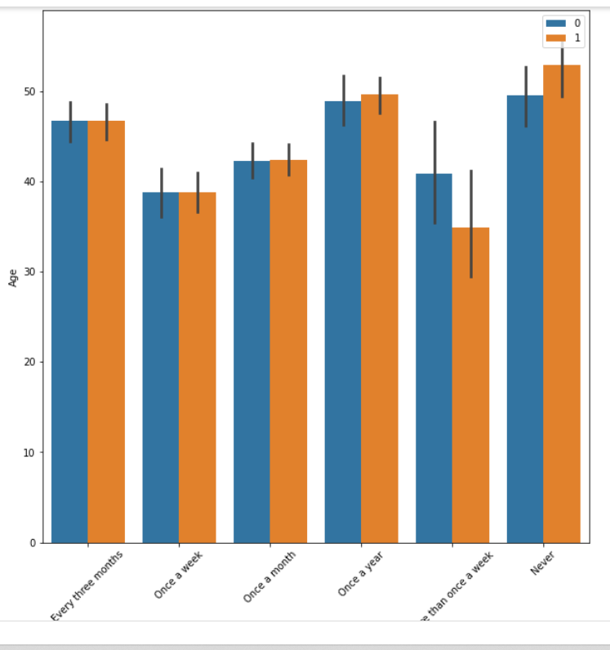

1. We can see that highest number of people visit once a month.

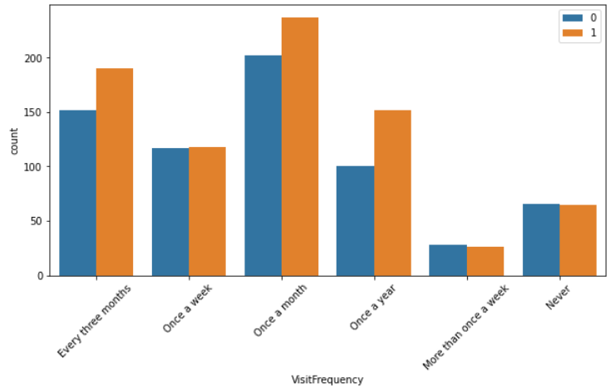

1. We can see that Adults, Youths, seniors do not visit more than once a week. Also they visit highest in once in month and in three months. There are visitors who have not visited at all.

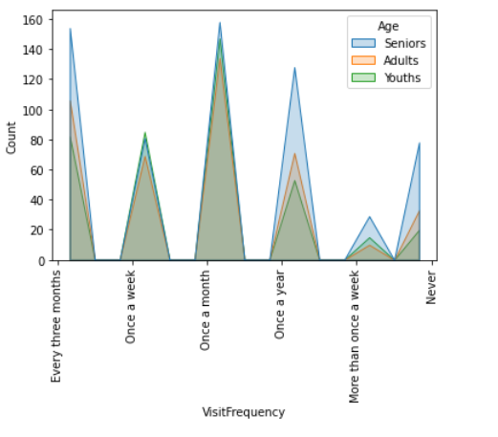

1. We can see that the count of Senior Visitor is highest as compared to Adults and Youths.

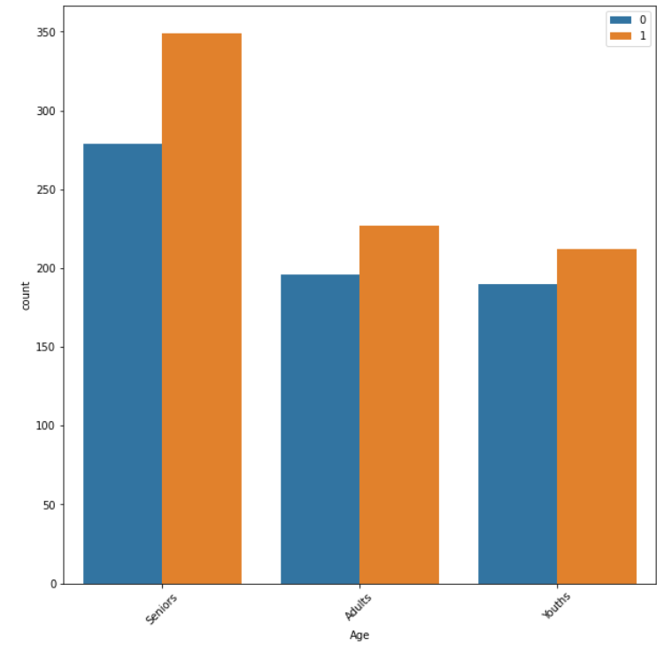

1. From above two plots we can see that Female are the frequent visitor having tasty food which are not expensive. Also we can see male also have same taste as female.

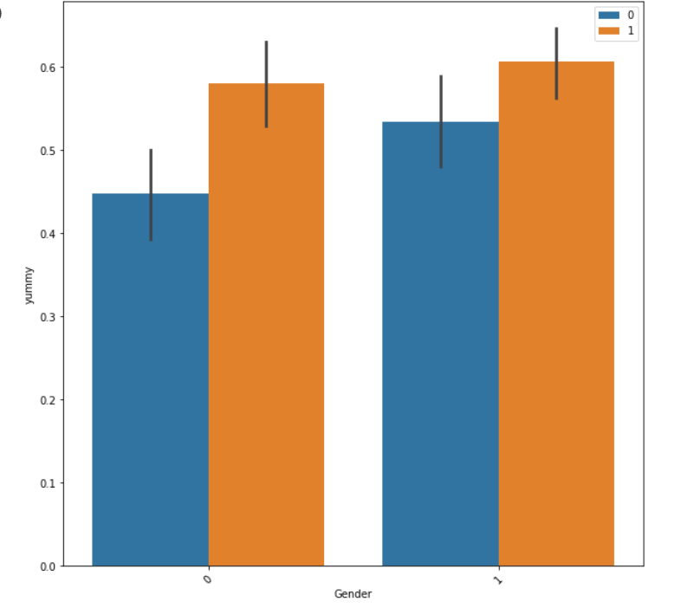

1. We can see that maximum number of people who liked the food visited only once in a year.

