Assignment 4

Question 1:
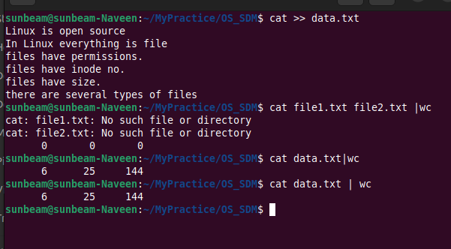
Question 2:
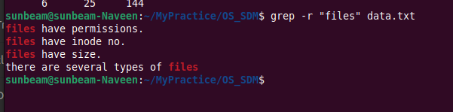
Question 3:
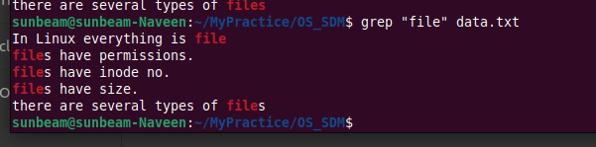
Question 4:
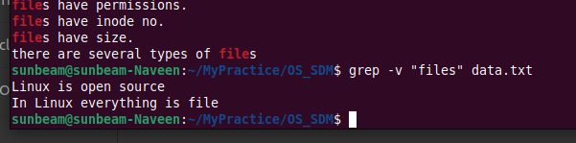
Question 5:
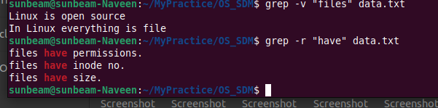
Question 6:
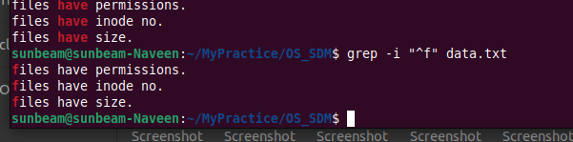
Question 7:
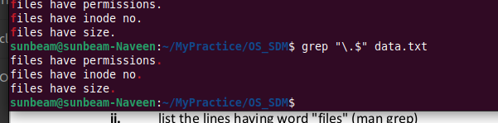
Question 8:
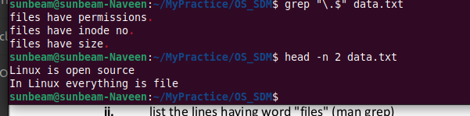
Question 9:
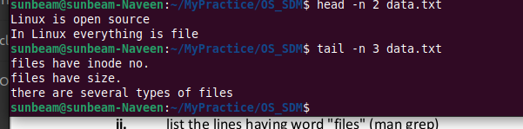
Question 10:

