Assignment 1
1.man->
2.uname->



3.pwd->
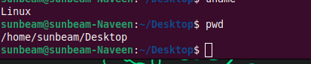

4.hostname->
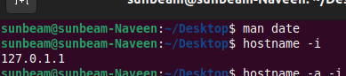

5.date->
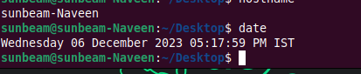

6.cal->

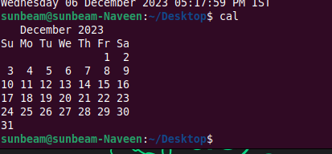

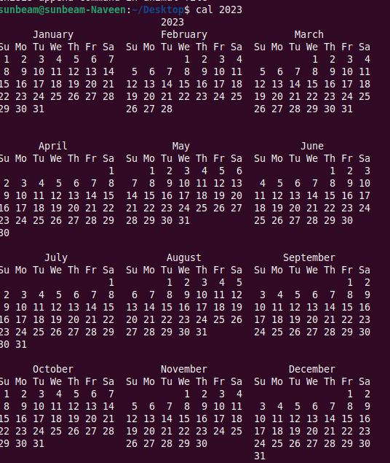

7.ls dir

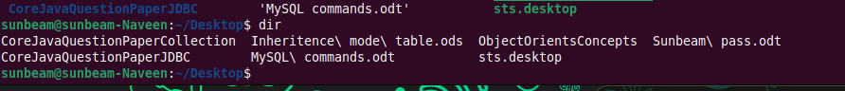

8.cat

9.cat >>

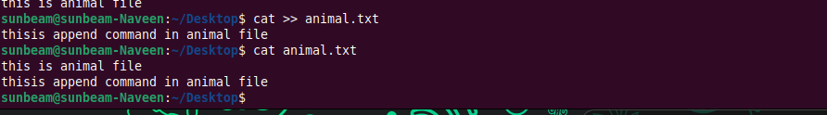

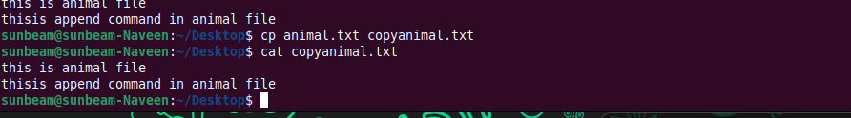
10.cp

11.mv

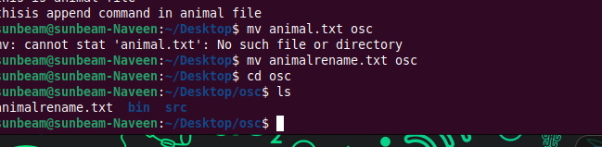

12.mv
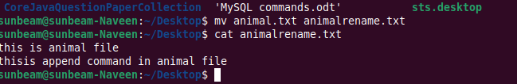
13.tac, rev

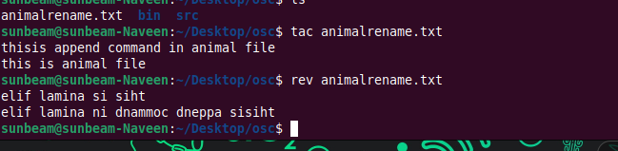
14.wc
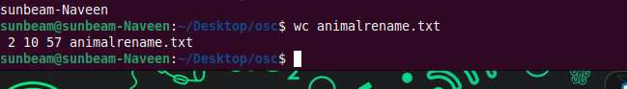

15.mkdir

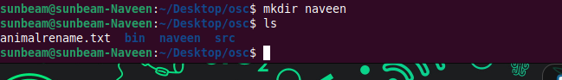

16.cd

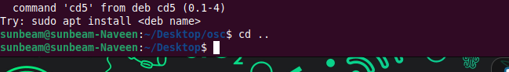

17.rm

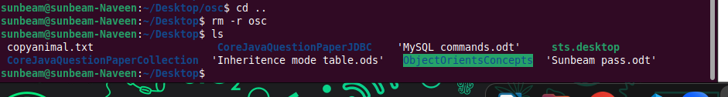

18.rm

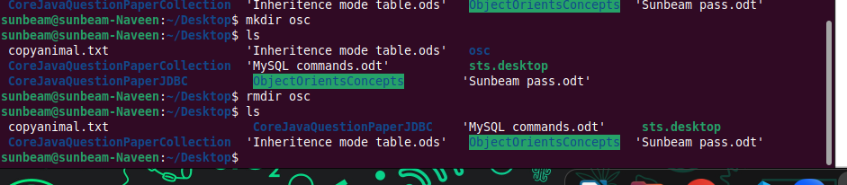
19.touch

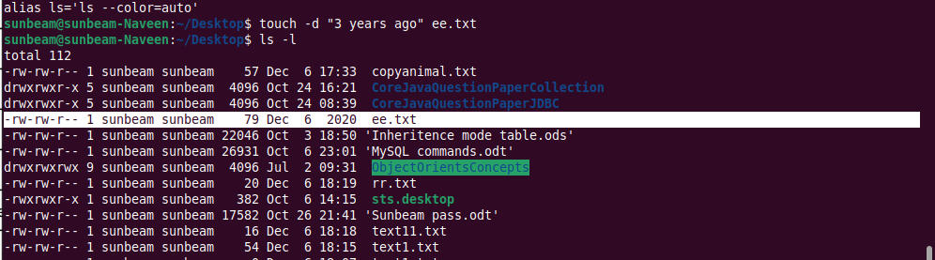

20.sort
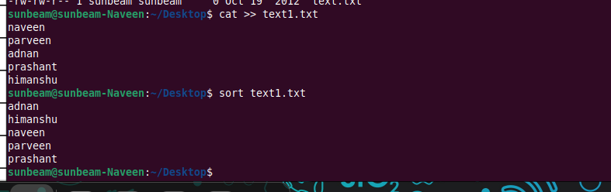
21.uni q

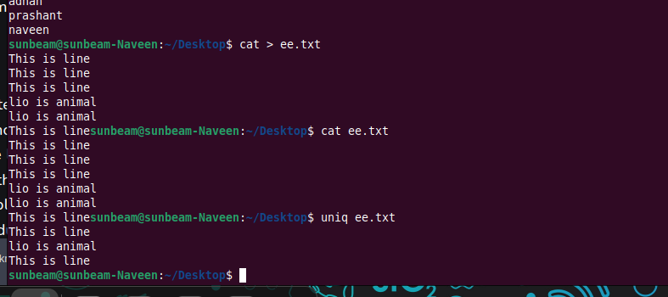

22.head



23.tail

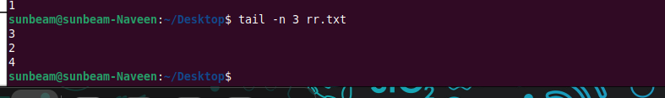

24.factor
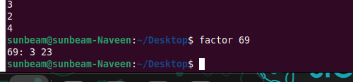
25.alias
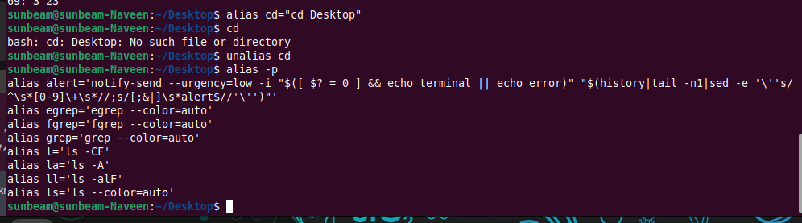
26.unalias

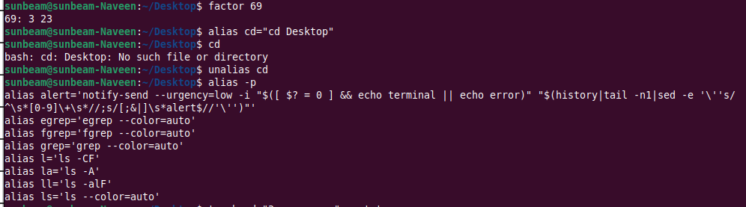
27.echo

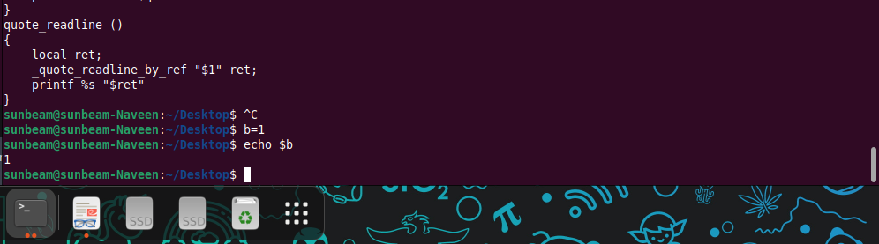

28.ps

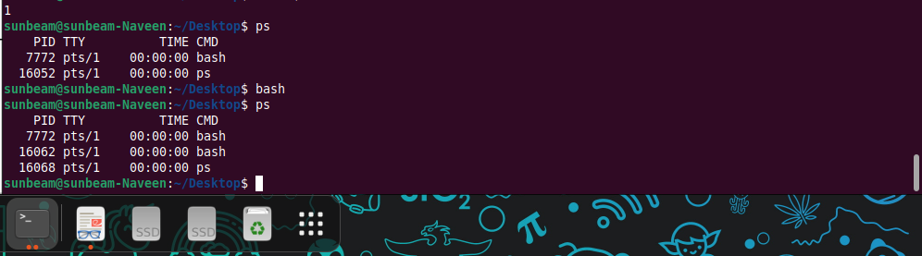
29.kill
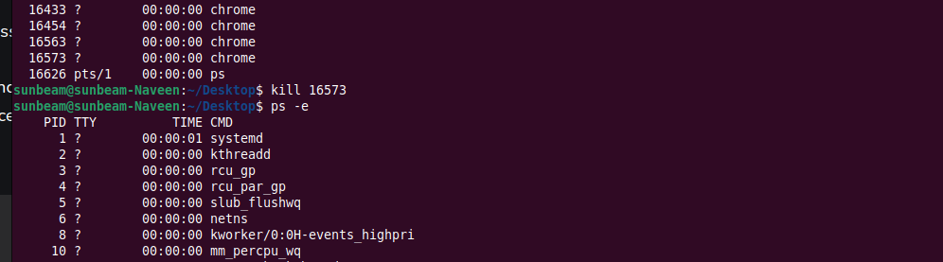
30.env

