|  |
| --- |
| **A**  **PROJECT REPORT ON** |
|  |
|  |
| Web based recruitment system  Get Hired |
|  |
|  |
| SUBMITTED IN  PARTIAL FULFILLMENT OF  **DIPLOMA IN ADVANCED COMPUTING (PG-DAC)** |
|  |
|  |
|  |
|  |
|  |
|  |
|  |
| **BY**  **Arshad Mujawar** |
|  |
|  |
| **UNDER THE GUIDENCE OF**  **Rugveda D Kulkarni** |
|  |
|  |
|  |
| **AT**  **SUNBEAM INSTITUTE OF INFORMATION TECHNOLOGY,**  **PUNE** |

|  |  |
| --- | --- |
|  | |
| **SUNBEAM INSTITUTE OF INFORMATION TECHNOLOGY,**  **PUNE.** | |
|  | |
|  | |
|  | |
|  | |
| **CERTIFICATE** | |
|  | |
| This is to certify that the project | |
|  | |
| Web based recruitment system  Get Hired | |
|  | |
| Has been submitted by | |
|  | |
| **Arshad Mujawar** | |
|  | |
|  | |
| In partial fulfillment of the requirement for the Course of **PG Diploma in Advanced Computing (PG-DAC SEPT 2023)** as prescribed by The **CDAC** ACTS, PUNE. | |
|  | |
|  | |
| Place: Pune | Date: 19-FEB-2024 |
|  | |
|  | |
|  | |
|  | |
|  | |
| **Rugveda D Kulkarni** |  |
| **Project Guide** |  |

**ACKNOWLEDGEMENT**

We extend our heartfelt gratitude to all those who have contributed to the successful completion of our web-based recruitment system project. We would like to express our sincere appreciation to our project coordinator, **Rugveda D Kulkarni**, whose guidance and support were invaluable throughout the duration of this project.

We would also like to thank our team members, **Adnan Khan, Naveen Kumar**, and **Arshad Mujawar**, for their dedication, collaboration, and hard work in bringing this project to fruition.

Furthermore, we acknowledge the collective effort and commitment of all those involved in the development process. The project was executed with the professionalism and diligence required for a final Post graduation diploma project.

The project aimed to design and implement a web-based recruitment system tailored for a company with branches in different cities. The system comprises various roles including admin, HR, and applicant. The admin's responsibilities include account management for HR, analytics monitoring, and account activation/deactivation. HR personnel can post job openings, shortlist applicants, while applicants can create and update their profiles, apply for jobs, and manage their applications.

Lastly, we express our gratitude to our academic institution for providing us with the necessary resources and environment to undertake this project.

Thank you to everyone who contributed to the realization of this endeavor.

Sincerely,

**Arshad Mujawar**

**ABSTRACT**

The Web-Based Recruitment System (WBRS) presented in this project caters to the needs of a company with branches spanning across different cities. Developed by Naveen Kumar, Adnan Khan, and Arshad Mujawar, under the guidance of project coordinator Rugveda D Kulkarni, this system addresses the complexities of managing recruitment processes efficiently.

The system comprises four distinct roles: Admin, HR, and Applicant. Admin privileges include creating HR accounts, overseeing analytics, and managing HR accounts' activation or deactivation. HR personnel can post job openings, review applications, and carry out candidate shortlisting. Applicants, on the other hand, have the ability to create profiles, update information, apply for jobs, and track their applications.

This bachelor's degree final project incorporates essential functionalities such as password recovery while omitting actual company involvement. By simulating real-world recruitment scenarios, the WBRS serves as a practical learning tool for understanding the intricacies of HR processes in a digital environment.

**INDEX**

|  |  |  |
| --- | --- | --- |
|  | **INTRODUCTION** | 1 |
|  | 1.1 Introduction | 7 |
|  | **Product Overview and Summary** |  |
|  | 2.1 Purpose | 9 |
|  | 2.2 Scope | 9 |
|  | 2.3 User Classes and Characteristics | 10 |
|  | 2.4 Design and Implementation Constraints | 12 |
|  | **REQUIREMENTS** | 14 |
|  | 3.1 Functional Requirements | 14 |
|  | 3.1.1 Use case for Administrator. | 14 |
|  | 3.1.2 Use case for Customer. | 17 |
|  | 3.2 Non - Functional Requirements | 21 |
|  | 3.2.1 Usability Requirement | 21 |
|  | 3.2.2 Performance Requirement | 23 |
|  | 3.2.3 Reliability Requirement | 25 |
|  | 3.2.4 Portability Requirement |  |
|  | 3.2.5 Security Techniques | 27 |
|  | **PROJECT DESIGN** | 28 |
|  | 4.1 Data Model | 28 |
|  | 4.1.1 Database Design | 28 |
|  | 4.2 Process Model | 29 |
|  | 4.2.1 Functional Decomposition Diagram | 30 |
|  | 4.2.2 Data Flow Diagram (DFD) |  |
|  | **TEST REPORT** | 39 |
|  | **PROJECT RELATED STATISTICS** |  |
|  | **CONCLUSION** | 41 |

**LIST OF TABLES**

|  |  |  |
| --- | --- | --- |
| **Section** | **Table Title** | **Page** |
| **5** | **Test table** | 39 |
|  |  |  |
|  |  |  |
|  |  |  |
|  |  |  |
|  |  |  |

**LIST OF FIGURES**

|  |  |  |
| --- | --- | --- |
| **Section** | **Figure Title** | **Page** |
| **3.1** | **Admin use case diagram** | 16 |
| **3.1** | **Admin use case diagram** | 20 |
| **4.1** | **Database ER diagram** | 28 |
| **4.2** | **Login page** | 30 |
| **4.2** | **Welcome page** | 31 |
| **4.2** | **HR panel** | 35 |
| **4.2** | **Admin panel** | 37 |
|  |  |  |
|  |  |  |
|  |  |  |
|  |  |  |
|  |  |  |

**Introduction**

In today's dynamic business landscape, efficient recruitment processes are imperative for companies to thrive and expand. With the advent of technology, the traditional methods of recruitment have evolved into more streamlined and automated systems, facilitating seamless communication between employers and job seekers. Our project, the Web-based Recruitment System, aims to address the recruitment needs of a fictitious company operating across multiple cities.

Project Team

This project was developed collaboratively by three dedicated individuals: Naveen Kumar, Adnan Khan, and Arshad Mujawar. Under the astute guidance of our project coordinator, Rugveda D Kulkarni, we embarked on this journey to design and implement a comprehensive recruitment system tailored to the specific requirements of our hypothetical company.

The Web-based Recruitment System caters to the intricate needs of recruitment processes, encompassing various roles and functionalities. It is designed to serve four main user roles: Administrator, Human Resources (HR) Personnel, and Applicants.

- Administrator: The administrator plays a pivotal role in managing the system. They have the authority to create HR accounts, oversee analytics, and activate or deactivate HR accounts as necessary.

- HR Personnel: HR personnel are empowered to create job postings, shortlist candidates, and oversee the recruitment process from start to finish, ensuring a smooth and efficient hiring process.

- Applicants: Applicants are the lifeblood of the recruitment system. They can create accounts, update their profiles, apply for jobs, and keep track of their application status.

Functionality

The system incorporates essential features such as account management, job posting, applicant tracking, and password recovery. These functionalities are meticulously crafted to enhance user experience and streamline the recruitment workflow.

Project Objective

The primary objective of our project is to develop a user-friendly and efficient recruitment system that caters to the specific needs of a multi-city company. By automating and centralizing the recruitment process, we aim to improve efficiency, reduce manual intervention, and provide a seamless experience for both employers and job seekers.

Conclusion

In conclusion, the Web-based Recruitment System is a testament to our dedication and expertise in developing innovative solutions to real-world challenges. While this project is a culmination of our academic journey, its potential applications extend far beyond the confines of the classroom. We believe that our system has the capacity to revolutionize recruitment practices and contribute to the success of businesses in today's competitive environment.

**Project overview and summary**

Purpose

The primary objective of our project is to develop a user-friendly and efficient recruitment system that caters to the specific needs of a multi-city company. By automating and centralizing the recruitment process, we aim to improve efficiency, reduce manual intervention, and provide a seamless experience for both employers and job seekers.

Project scope

The Web-based Recruitment System caters to the intricate needs of recruitment processes, encompassing various roles and functionalities. It is designed to serve four main user roles: Administrator, Human Resources (HR) Personnel, and Applicants.

- Administrator: The administrator plays a pivotal role in managing the system. They have the authority to create HR accounts, oversee analytics, and activate or deactivate HR accounts as necessary.

- HR Personnel: HR personnel are empowered to create job postings, shortlist candidates, and oversee the recruitment process from start to finish, ensuring a smooth and efficient hiring process.

- Applicants: Applicants are the lifeblood of the recruitment system. They can create accounts, update their profiles, apply for jobs, and keep track of their application status.

**User classes and characteristics**

1. Administrator:

- Characteristics:

- Typically, a senior member of the company's management.

- Responsible for overseeing the recruitment process and managing HR activities.

- Has access to sensitive data and system-wide controls.

- Responsibilities:

- Create and manage accounts for HR personnel.

- View system analytics to monitor recruitment performance.

- Activate or deactivate HR accounts as needed.

2. HR Personnel:

- Characteristics:

- Assigned to handle recruitment tasks within the company.

- Often possesses expertise in human resources and hiring processes.

- Requires access to job postings, applicant profiles, and hiring tools.

- Responsibilities:

- Create job postings detailing job descriptions, requirements, and qualifications.

- Review and shortlist applicants based on predefined criteria.

- Manage the hiring pipeline and communicate with applicants.

3. Applicant:

- Characteristics:

- Job seekers interested in employment opportunities within the company.

- May have varying levels of experience and qualifications.

- Seek convenience and efficiency in the job application process.

- Responsibilities:

- Create and maintain a user account/profile.

- Update personal information, including qualifications and work experience.

- Search for job openings based on location, role, and other criteria.

- Apply for positions by submitting resumes and cover letters.

- Track the status of submitted applications and view saved job listings.

Note: The project aims to simulate the functionalities of a recruitment system for a hypothetical company with branches in different cities. Therefore, the user classes and characteristics outlined above are based on typical roles and responsibilities within such a system.

**Design and Implementation Constraints**

1. Security: Given the sensitive nature of HR data and personal information of applicants, stringent security measures must be implemented to protect against unauthorized access, data breaches, and other cybersecurity threats.

2. Compatibility: The system should be compatible with a wide range of web browsers and devices to ensure accessibility for all users, including those using different operating systems and screen sizes.

3. User Interface Design: The user interface must be intuitive and user-friendly for individuals with varying levels of technical proficiency. It should also adhere to accessibility standards to accommodate users with disabilities.

4. Data Integrity: Mechanisms must be in place to ensure the integrity of the data stored in the system, preventing data corruption, loss, or inaccuracies.

5. Regulatory Compliance: The system must comply with relevant laws and regulations pertaining to recruitment processes, data privacy, and employment practices in the jurisdictions where the company operates.

6. Resource Constraints: As a bachelor's degree final project with a limited timeframe and resources, the team needs to prioritize essential features and functionalities while managing time, budget, and technical capabilities effectively.

7. Integration: The system may need to integrate with existing HR systems or third-party services for functionalities such as background checks, payroll integration, or applicant tracking, posing challenges in terms of compatibility and data synchronization.

8. Testing: Comprehensive testing procedures are essential to identify and rectify any bugs, errors, or usability issues before deployment. However, limited resources and time constraints may pose challenges in conducting thorough testing across various devices and scenarios.

9. Documentation: Clear and comprehensive documentation of the system architecture, design decisions, and codebase is crucial for knowledge transfer, maintenance, and future enhancements, but it requires additional time and effort from the development team.

Addressing these constraints requires careful planning, effective communication, and collaboration among team members under the guidance of the project coordinator to ensure the successful design and implementation of the Web-Based Recruitment System.

**Functional Requirements**

Use case for Administrator: -

Role: Administrator (Admin)

Description: This use case outlines the interactions and functionalities available to the Administrator (Admin) within the Web-Based Recruitment System.

Preconditions:

- The admin must be authenticated and logged into the system.

Basic Flow:

1. Create HR Account:

- Role Action: Admin selects the option to create a new HR account.

- System Response: The system presents a form for entering HR details, including username, password, and contact information.

- Role Action: Admin fills in the required information and submits the form.

- System Response: The system creates a new HR account and notifies the admin of successful account creation.

2. View Analytics:

- Role Action: Admin navigates to the analytics section of the dashboard.

- System Response: The system displays various recruitment-related analytics such as the number of job postings, application trends, and hiring metrics.

3. Activate/Deactivate HR Account:

- Role Action: Admin accesses the list of HR accounts.

- System Response: The system presents a list of HR accounts with activation status.

- Role Action: Admin selects a specific HR account to activate or deactivate.

- System Response: The system updates the activation status of the selected HR account accordingly and notifies the admin of the action taken.

Alternative Flow:

- If Admin encounters an error during any of the above actions (e.g., incomplete form submission), the system prompts the admin to correct the error and resubmit the form.

Postconditions:

- The HR account is successfully created or updated.

- The admin has access to analytics data and has managed HR account activations/deactivations effectively.

Exceptions:

- If there are technical issues with the system, the admin may not be able to perform the desired actions.

- If there are validation errors in the form inputs, the admin will be prompted to correct them before proceeding.

- If the HR account creation or activation/deactivation process fails due to database errors or other issues, the admin will be notified and prompted to try again.

Note: This use case focuses specifically on the actions and interactions of the Administrator role within the Web-Based Recruitment System.

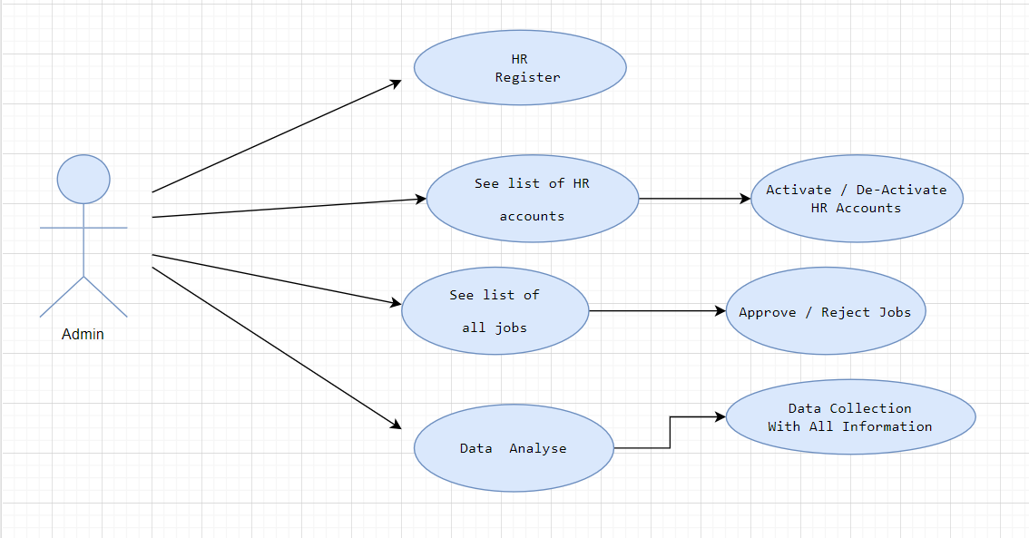

Use case for Applicant: -

Role: Applicant

Goal: To efficiently search for job openings, apply for positions, and manage the application process.

Preconditions:

- The applicant has access to the internet and a compatible device.

- The applicant has registered an account on the Web-Based Recruitment System.

Basic Flow:

1. Create Account:

- The applicant navigates to the registration page of the system.

- The applicant fills out the required registration form with personal details such as name, email, and password.

- The applicant submits the registration form.

- The system validates the information and creates a new applicant account.

2. Update Profile:

- The applicant logs into their account using their credentials.

- The applicant navigates to the profile settings page.

- The applicant updates their profile information, including contact details, education, work experience, and skills.

- The applicant saves the changes.

- The system updates the applicant's profile with the new information.

3. Search for Jobs:

- The applicant logs into their account.

- The applicant accesses the job search functionality.

- The applicant enters search criteria such as job title, location, or keywords.

- The system retrieves and displays a list of relevant job openings.

- The applicant views the job details and requirements.

4. Apply for a Job:

- The applicant selects a job opening they are interested in.

- The applicant reviews the job description and requirements.

- The applicant clicks on the "Apply Now" button.

- The system prompts the applicant to upload a resume and cover letter.

- The applicant uploads the required documents.

- The applicant submits the application.

- The system confirms the successful submission of the application.

5. Manage Applications:

- The applicant logs into their account.

- The applicant accesses the "My Applications" section.

- The applicant views a list of their submitted applications.

- The applicant checks the status of each application (e.g., pending, shortlisted, rejected).

- The applicant may withdraw an application if desired.

Alternative Flows:

- Forgot Password:

- If the applicant forgets their password, they can click on the "Forgot Password" link on the login page.

- The system prompts the applicant to enter their registered email address.

- The system sends a password reset link to the applicant's email.

- The applicant follows the link to reset their password.

Postconditions:

- The applicant has successfully updated their profile, applied for jobs, and managed their applications within the Web-Based Recruitment System.

Note: This use case outlines the primary actions and interactions of an applicant within the system. It ensures a user-friendly experience for job seekers, facilitating efficient navigation, application, and management of job opportunities.

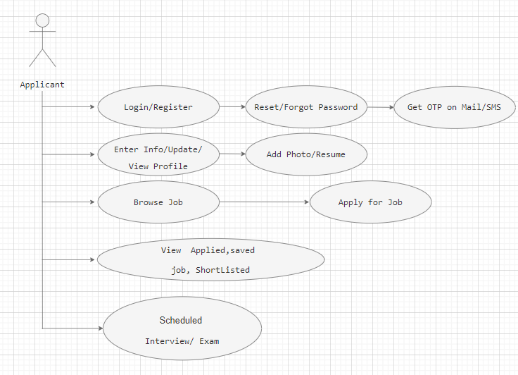

**Non-functional Requirements**

Usability Requirement: -

1. User-Friendly Interface:

- The system must have an intuitive and easy-to-use interface for all user roles (admin, HR, applicant).

- Navigation should be clear and consistent across all pages to facilitate seamless interaction.

2. Accessibility:

- The system must comply with accessibility standards (such as WCAG) to ensure that users with disabilities can navigate and use the platform effectively.

3. Consistent Terminology and Language:

- Maintain consistency in terminology and language throughout the system to avoid confusion and enhance user understanding.

4. Streamlined Registration and Login Process:

- The registration and login process should be straightforward and require minimal steps.

- Include options for social media login or single sign-on to simplify account creation and authentication.

5. Intuitive Profile Management:

- Allow applicants to easily update their profiles, including personal information, work experience, education, and skills.

- Enable HR personnel to manage applicant profiles efficiently, including reviewing, shortlisting, and contacting candidates.

6. Error Handling and Recovery:

- Implement robust error handling mechanisms to gracefully handle unexpected errors and prevent data loss.

- Provide clear instructions and options for users to recover from errors and resume their tasks without disruption.

7. Performance and Loading Speed:

- Optimize system performance and loading speed to ensure swift access to content and functionalities.

- Minimize loading times for pages, forms, and multimedia content to enhance user satisfaction.

**Performance Requirements**

1. Response Time:

- All user interactions should have minimal response times to ensure a smooth user experience.

- Response time for loading pages, submitting forms, and retrieving data should be under 2 seconds under normal load conditions.

2. Availability:

- The system should be available 24/7 with minimal downtime for maintenance or updates.

- Scheduled maintenance windows should be communicated in advance, and downtime should be minimized during these periods.

3. Data Integrity:

- All data entered into the system by users should be stored securely and accurately.

- Data validation checks should be in place to prevent errors and maintain data integrity.

- Backup and recovery mechanisms should be implemented to safeguard against data loss.

4. Security:

- The system should enforce secure authentication and authorization mechanisms for user access.

- User passwords should be stored securely using industry-standard encryption techniques.

- Role-based access control should be implemented to restrict access to sensitive functionalities based on user roles (admin, HR, applicant).

By adhering to these performance requirements, the Web-Based Recruitment System will be able to meet the needs of the hypothetical company with branches in different cities, providing a reliable and efficient platform for recruitment processes.

**Reliability Requirements**

1. System Uptime:

- The system should aim for a minimum uptime of 99% to ensure that it is available for use by administrators, HR personnel, and applicants at all times.

- Scheduled maintenance and updates should be communicated in advance, and downtime should be minimized during non-peak hours.

2. Data Integrity:

- All data stored within the system, including user accounts, job postings, applicant profiles, and application status, must be accurately maintained and protected against unauthorized access or modification.

- Regular data backups should be performed to prevent data loss in case of system failures or errors.

3. User Authentication and Authorization:

- User authentication mechanisms should be robust and secure to prevent unauthorized access to sensitive information.

- Role-based access control (RBAC) should be implemented to ensure that each user can only access functionalities relevant to their role (admin, HR, applicant).

4. Error Handling:

- The system should have comprehensive error handling mechanisms in place to gracefully handle unexpected errors and prevent system crashes.

- All errors and system events should be logged systematically for debugging purposes and to monitor system performance.

6. Cross-Browser Compatibility:

- The system's user interface should be compatible with major web browsers (e.g., Google Chrome, Mozilla Firefox, Safari) to ensure a consistent user experience across different platforms and devices.

**Security Technique**

Security is a paramount concern for any web-based system, especially one handling sensitive data like personal information and job applications. Here are the security techniques implemented in the Web-Based Recruitment System.

1. JWT Token-Based Authentication: Utilizing JSON Web Tokens (JWT) for authentication helps ensure secure login mechanisms. JWT tokens are encrypted and contain user information, which is verified on each request, mitigating the risk of unauthorized access.

2. Role-Based Access Control (RBAC): Implementing RBAC ensures that users can only access functionalities and data appropriate to their roles. In this system, roles such as admin, HR, and applicant have distinct permissions, preventing unauthorized actions.

3. HTTPS Protocol: Employing HTTPS encrypts data transmitted between the server and client, safeguarding against interception and tampering by malicious actors. It ensures data integrity and confidentiality during communication.

4. Data Encryption: Storing sensitive data, such as passwords and personal information, in encrypted formats adds an extra layer of security. Encryption algorithms like bcrypt or AES can be used to protect data at rest.

5. Input Validation: Implementing robust input validation mechanisms helps prevent common vulnerabilities like SQL injection and cross-site scripting (XSS) attacks. Sanitizing and validating user inputs before processing them mitigates the risk of injection attacks.

By incorporating these security techniques, the Web-Based Recruitment System ensures the confidentiality, integrity, and availability of data against various security threats and vulnerabilities.

**Project Design**

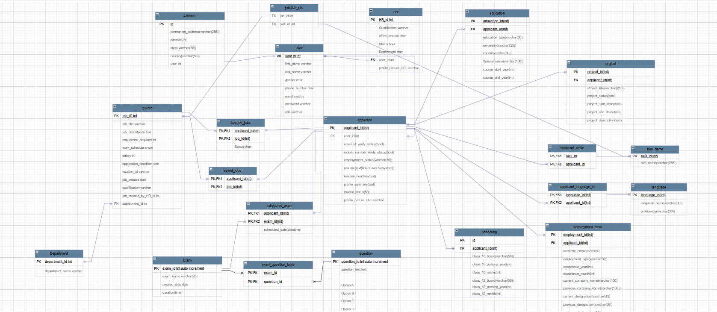Database Design: -

**Process Model**

Agile Development

Project Planning:

- Team Formation: Naveen Kumar, Adnan Khan, and Arshad Mujawar along with Project Coordinator Rugveda D Kulkarni.

- Define Roles: Assign roles of Backend Developer, Frontend Developer, Tester, and Coordinator.

- Identify Requirements: Gather requirements including user stories and features from stakeholders.

- Define Technology Stack: Choose technologies such as Spring Boot for backend development, React.js for frontend, MongoDB for the database, and JWT for secure authentication.

**UI design**

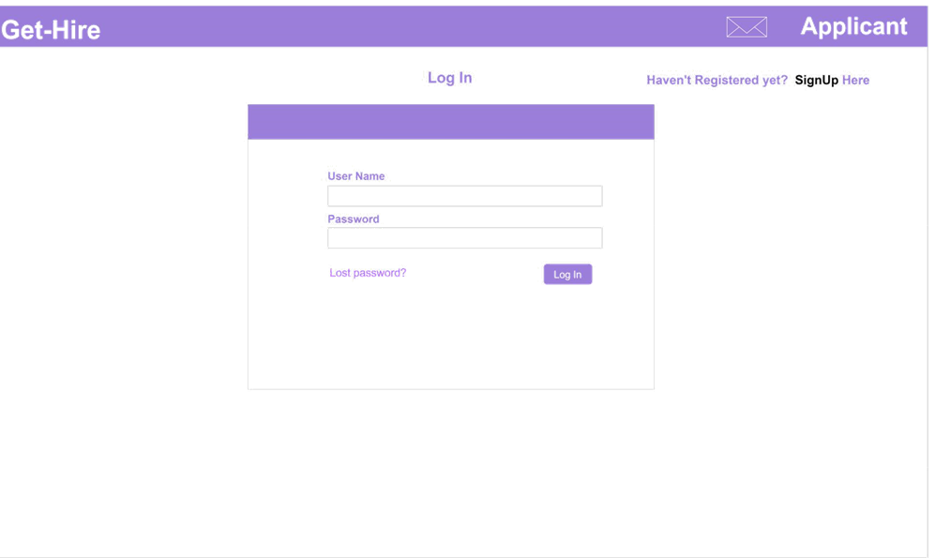

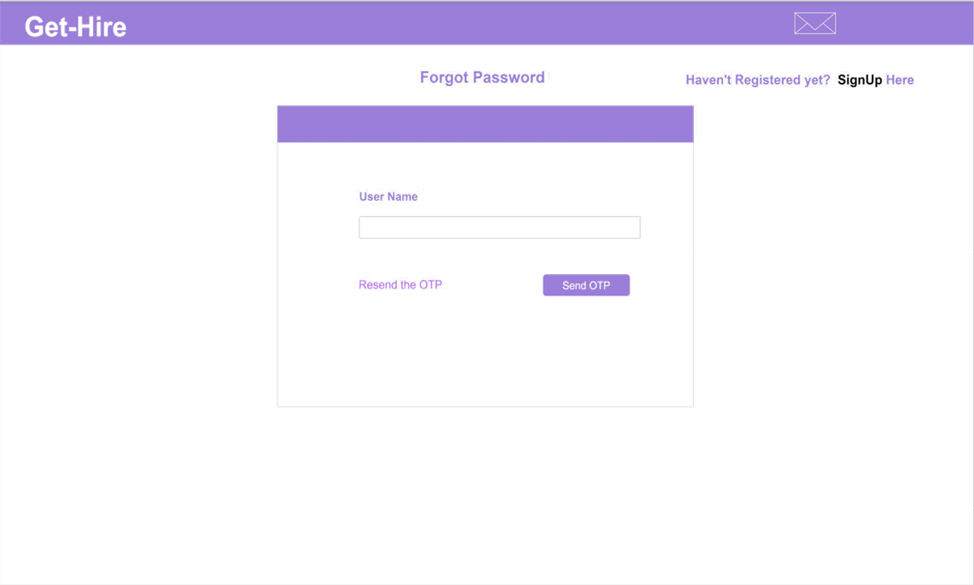

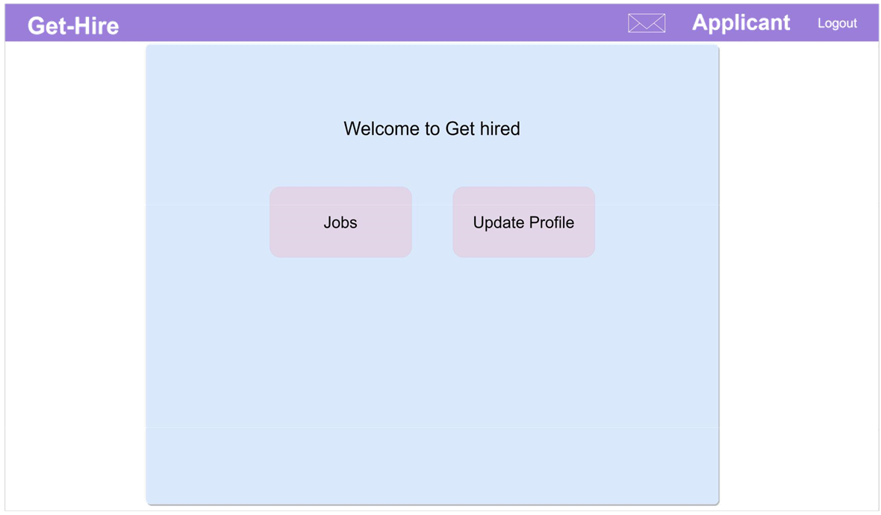

Applicant profile page

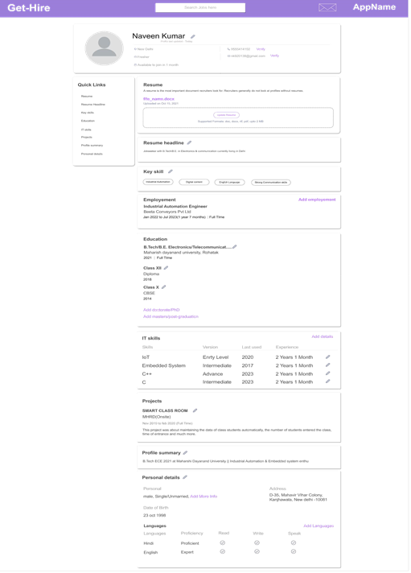

Available Jobs

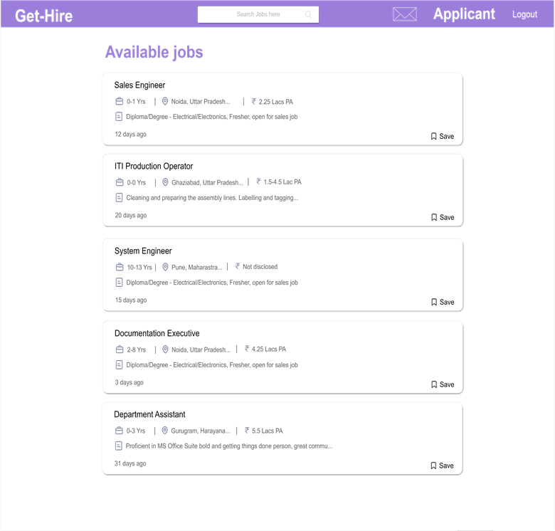

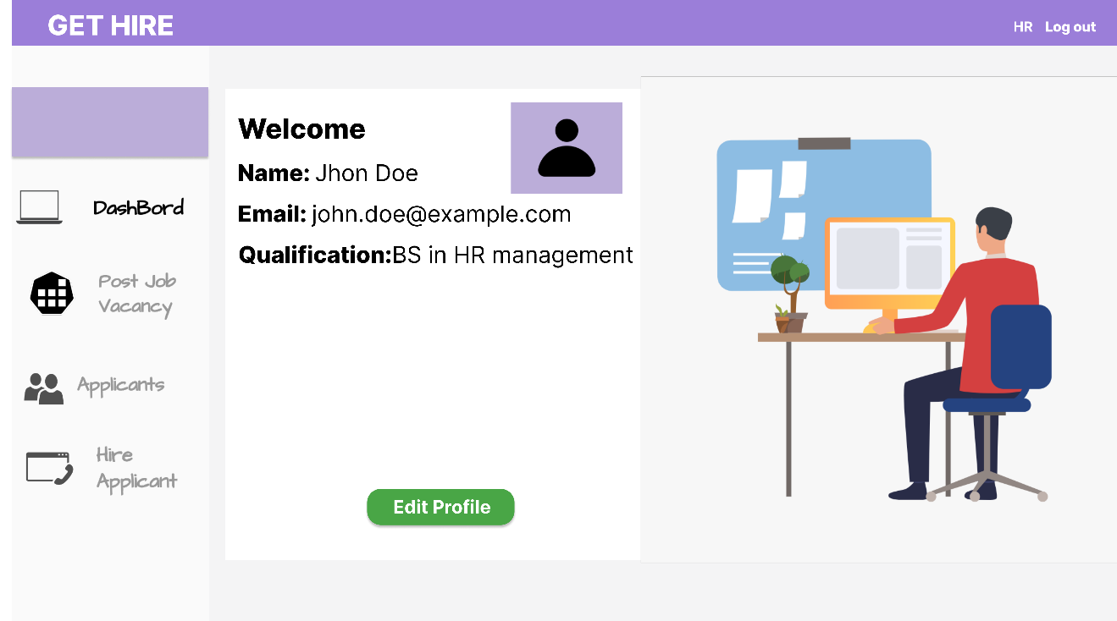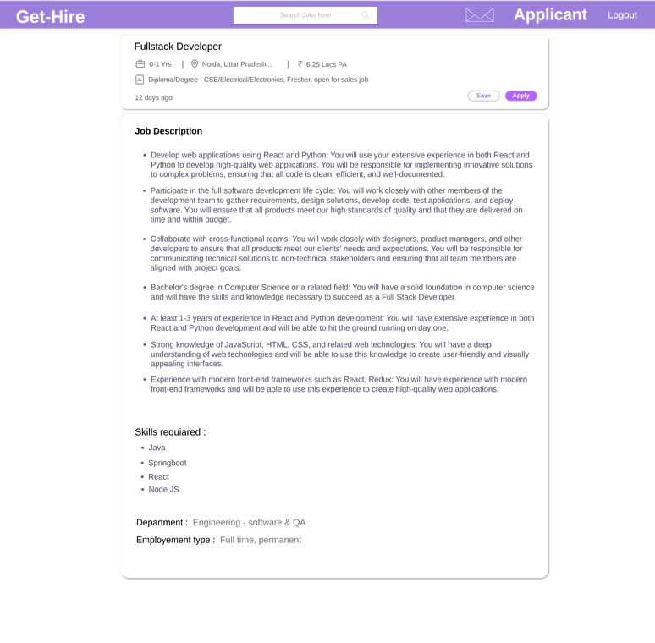

HR Panel

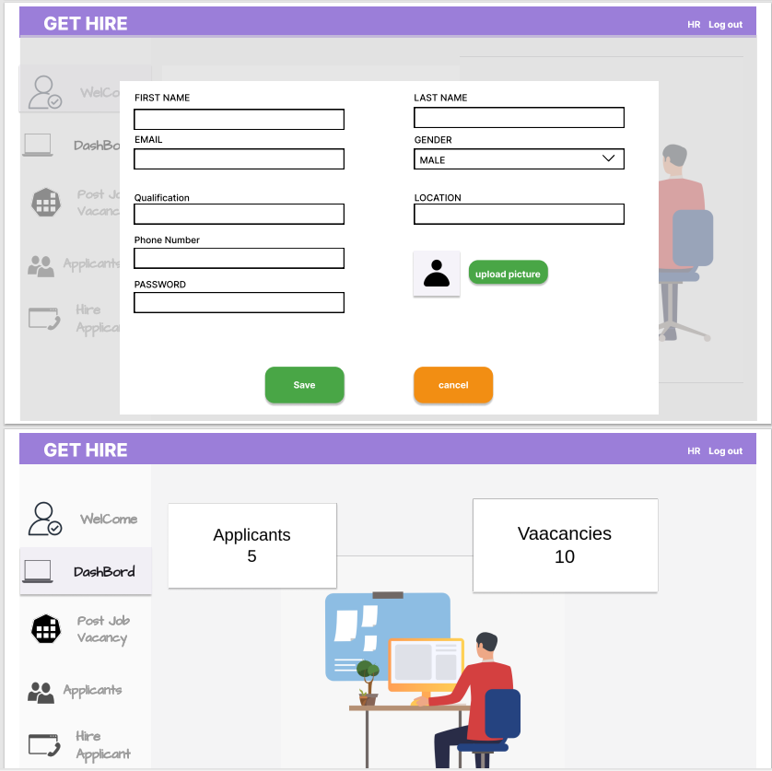

Create Jobs

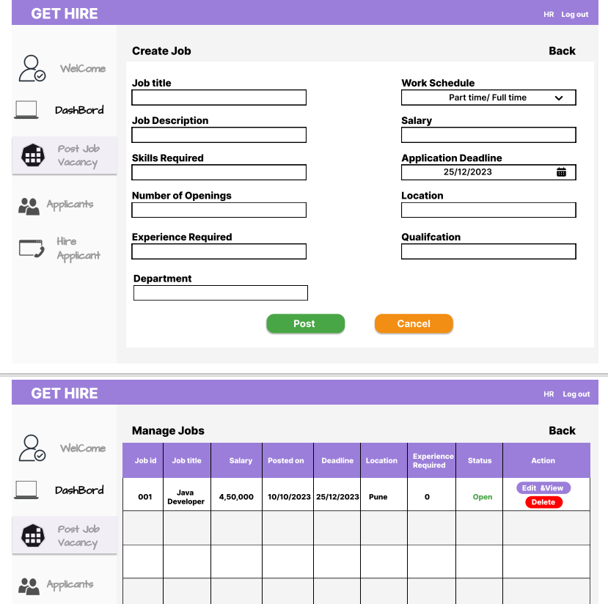

Admin Panel

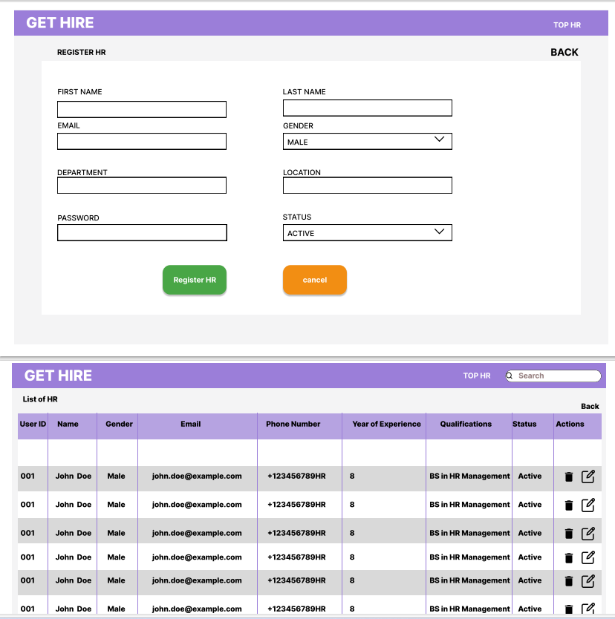

HR List and Analytics

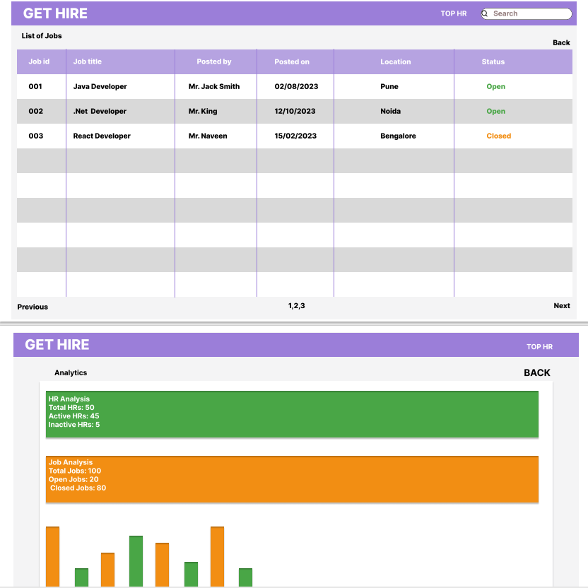

**TEST REPORT**

**We have performed unit testing for testing the application. For performing the unit testing, we individually tested each unit like login, registration, admin/HR/applicant functionality for the application.**

|  |  |  |  |  |  |
| --- | --- | --- | --- | --- | --- |
| Sr.no | Test Case | Expected  Result | Actual Result | Error Message | Type Of  Error |
| 1 | Login For admin, HR, Applicant | Redirection to respective Dashboards | Redirection to respective roles Dashboard pages | Works fine | None |
| 2 | Registration for applicant | Input with validation | Validated data | No error | none |
| 3 | Fetching admin, HR, applicant details | After successful registration redirection to login page | Redirected to Login pages of respective role | No error | minor |
| 4 | Applicant saving, un saving, applying, un applying jobs | Job managing | Works fine | No error | Minor |
| 5 | HR posting jobs | Jobs appear in the available jobs | Runs perfectly find | No error | Minor |
| 6 | Changing status from applied to interview or rejected | Changes in the applicant shortlisted list | Status changed to in the shortlisted job list | No error | Minor |
| 7 | Applicant adding and fetching project, employment details | Data fetching and inserting into database | As expected, | No error | Minor |
| 8 | HR adding and fetching job details | Fetching details | Some errors in the beginning | No error | Minor |
| 9 | Admin adding HR, deactivating HR accounts | Change in database according to test | Some errors in the beginning | No error | Minor |
| 10 | Picture/resume upload | Upload in the AWS S3 bucket | Error sometimes | Sometimes | minor |

Conclusion

The Web-Based Recruitment System project aims to establish hiring process for the company by leveraging modern web technologies. Under the guidance of Project Coordinator Rugveda D Kulkarni, the team comprising **Naveen Kumar**, **Adnan Khan**, and **Arshad Mujawar** has developed a comprehensive solution that caters to the needs of administrators, HR personnel, and job applicants alike. Through efficient management of job postings, applicant profiles, and hiring workflows, the system promises to enhance the efficiency and effectiveness of recruitment processes.