Assignment 03

Q.1 ls -a
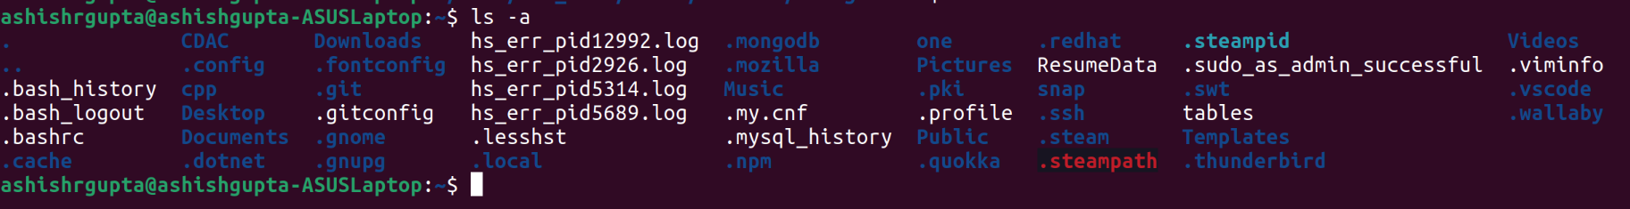

Q.2 rename ‘s/.txt/.htm/’ *.txt

Q.3 ln -s test.txt home/ashishrgupta/Link.txt
ls – l home/ashishrgupta/Link.txt
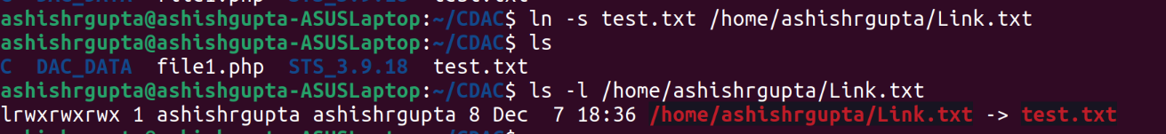

Q.4 ln test.txt home/ashishrgupta/Link.txt


Q.5 stat home/ashishrgupta/Link.txt
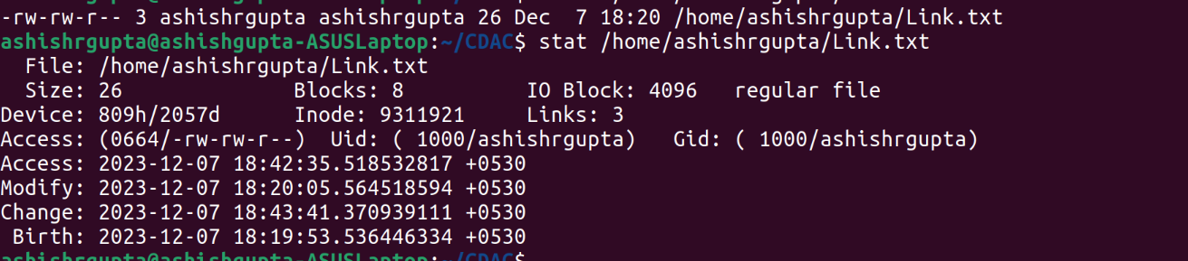

Q.6 touch home/ashishrgupta/Link.txt -t202208180832.23
ls -l home/ashishrgupta/Link.txt

Q.7 touch ashish.txt

Q. 8 tail +5 ashish.txt


Q.9 init 0
poweroff
(Shutdown)

Q.10 init 6
reboot
(restart)

Q.11 whoami

Q.12 tty (current terminal)

Q.13 who am i : deprecated command

Q.15 users

Q.16 who
Q.17 grep “and” ashish.txt

egrep “tha?t” ashish.txt
fgrep “” ashish.txt
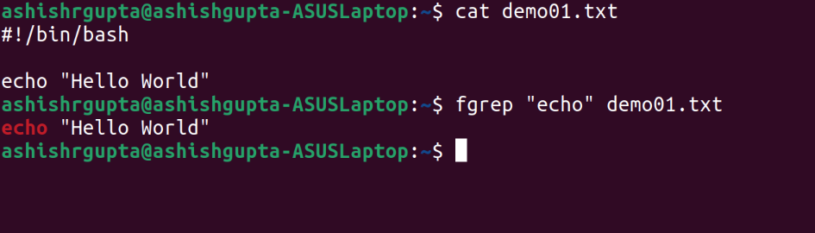

Q. 18 chmod 444 demo01.txt
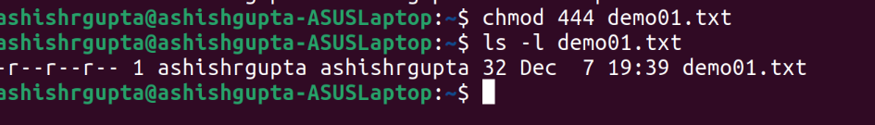

Q.19 chmod 777 demo01.txt
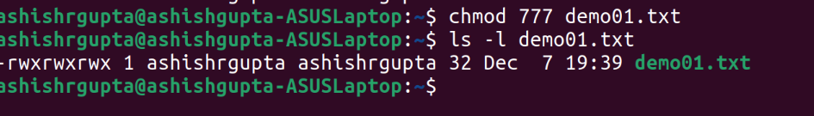

Q.20 wc demo01.txt > text.txt
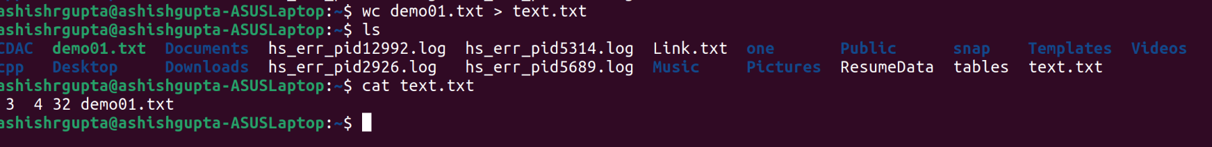

Q.21 who | wc

Q. 22 head +5 text.txt | tail -5


Q. 23 sort text.txt | uniq


Q. 24 who | grep – i “tty[234]”

Q. 25 ls -lhSr
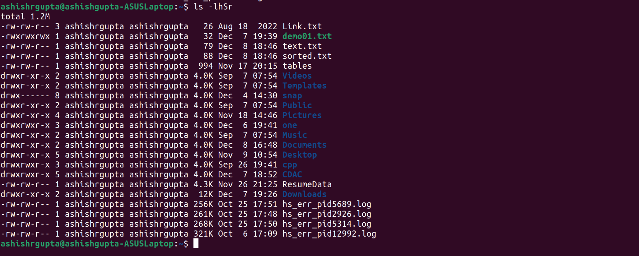

Q. 26 ls | wc -l
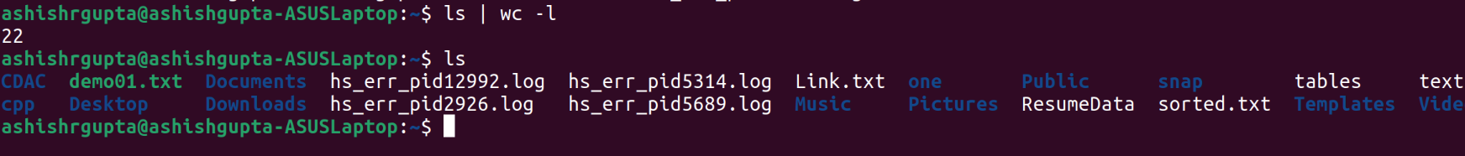

Q. 27 ls -a | grep “^\.”
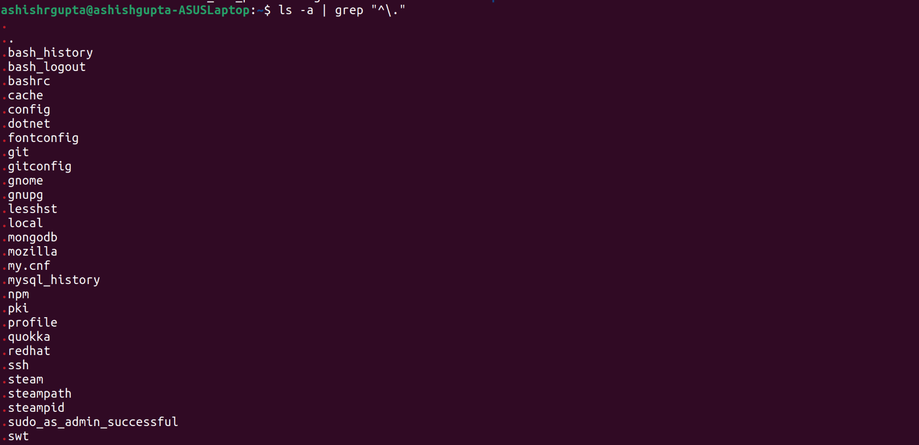

Q.28 cat text.txt | tr “a-z” “A-Z”
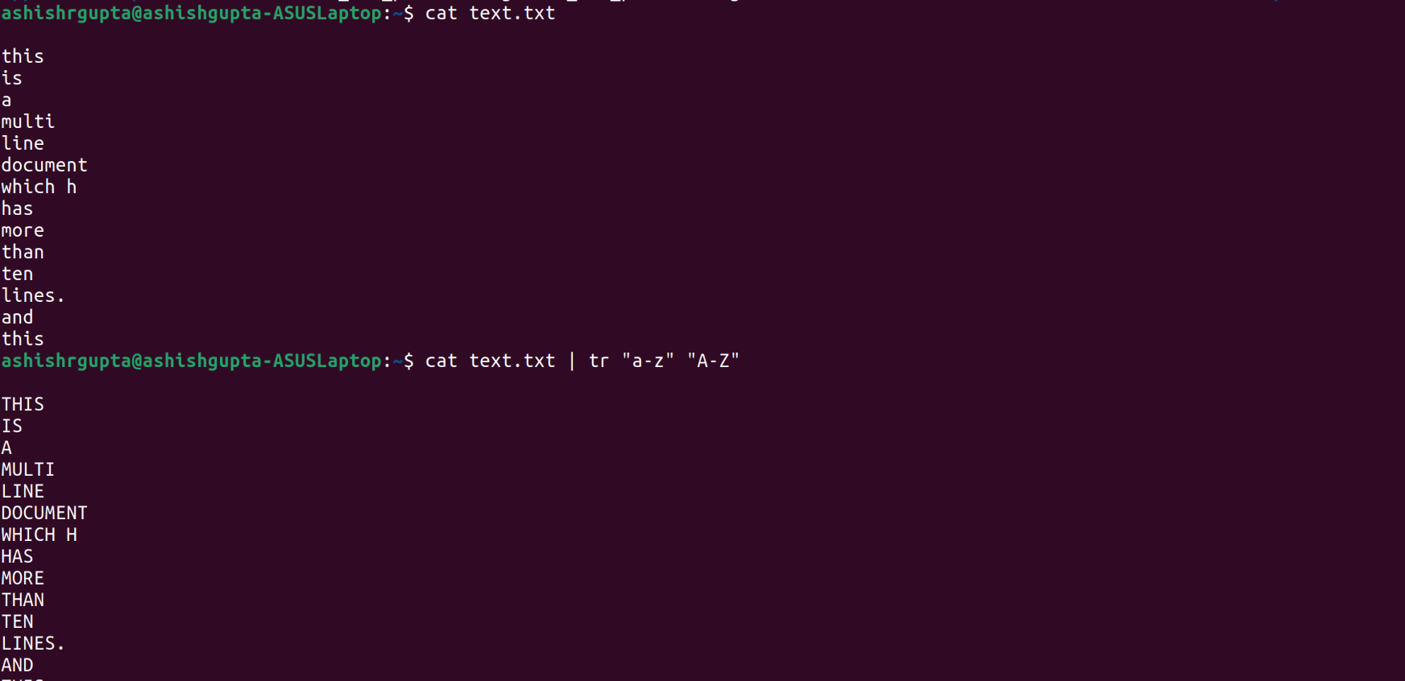

Q. 29 echo “Split Content” | cut -d “ “ -f1

