Assignment 01

Q.1) man

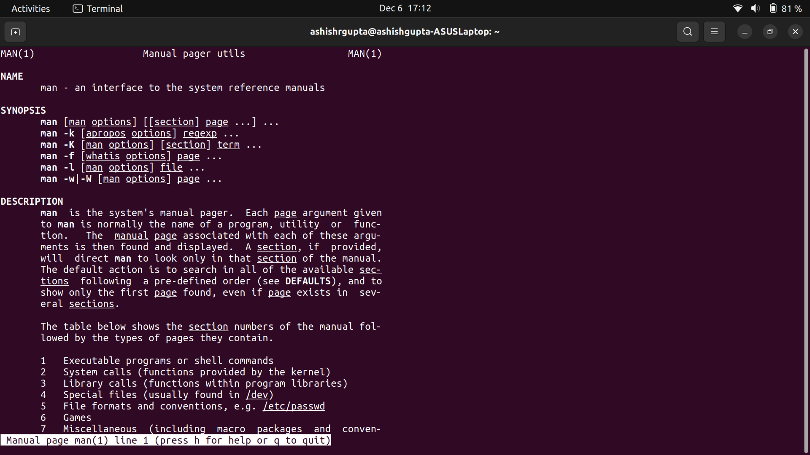

Q.2 uname

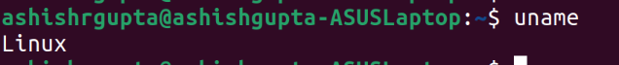

Q.3 pwd



Q.4 hostname

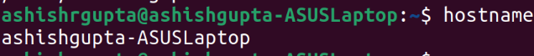

Q.5 date

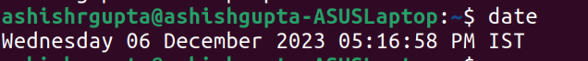

Q.6 cal

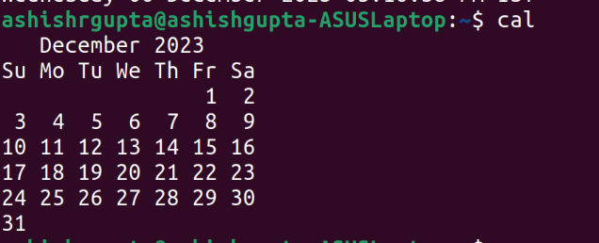

Q.7 ls

dir

Q.8 cat > ashish.txt

Q.9 cat >> ashish.txt

Q.10 cp ashish.txt CDAC
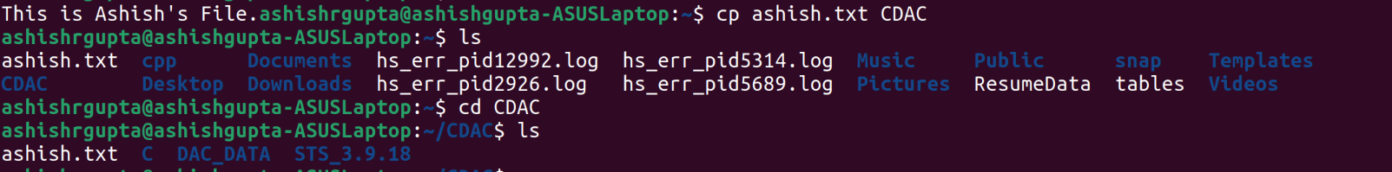

cp -r “Single assignment” Practice

Q.11 mv “Single assignment” bin

Q.12 mv ashish.txt ashishcopy.txt

Q.13 tac ashish.txt
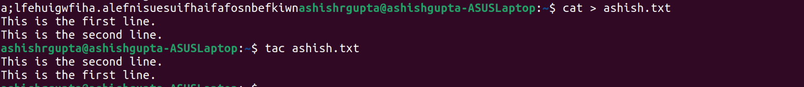

rev ashish.txt

Q.14 wc ashish.txt

Q.15 mkdir sampledir

Q.16 cd CDAC

Q.17 rm ashish.txt
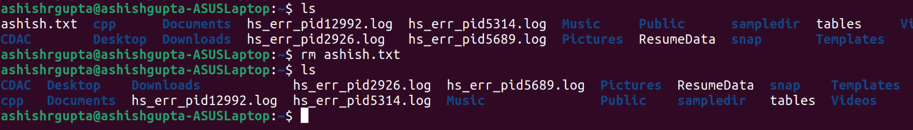

rm -r sampledir
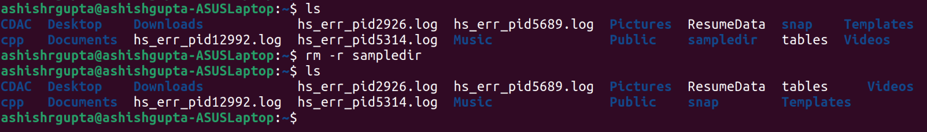

Q. 18 rm
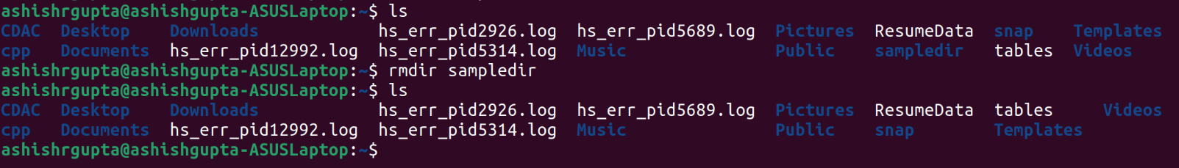

Q.19 touch -m ashish.txt
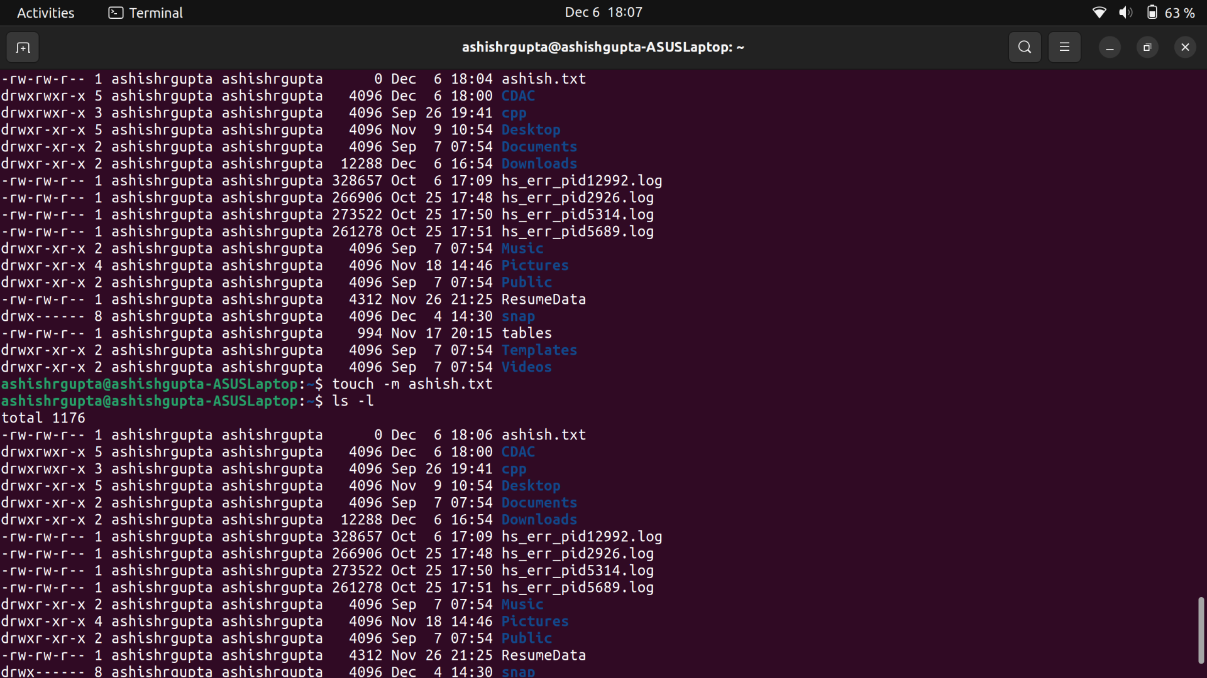
touch ash1.txt ash2.txt ash3.txt
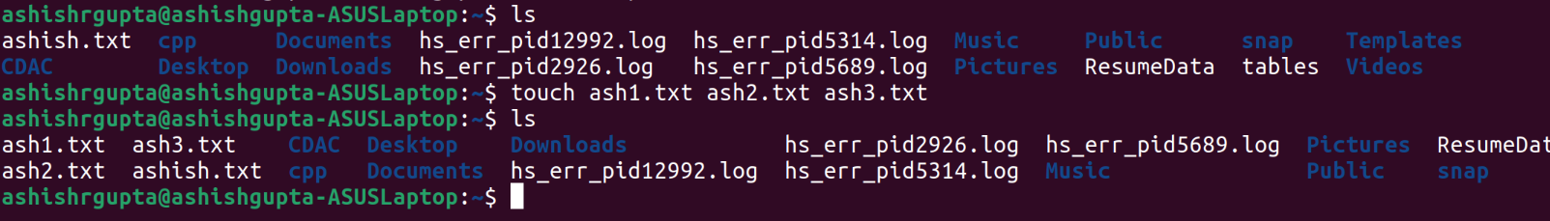

Q.20 sort ashish.txt


Q.21 uniq ashish.txt

Q.22 head -2 ashish.txt
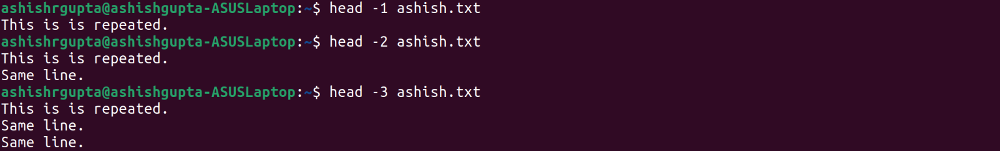

Q.23 tail -2 ashish.txt


Q.24 factor 108
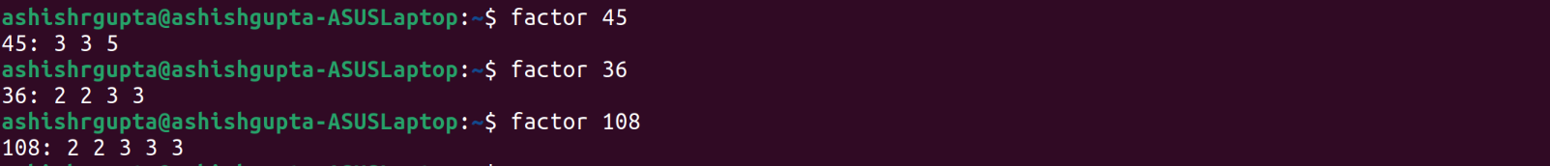

Q.25 alias fact=“factor 20”
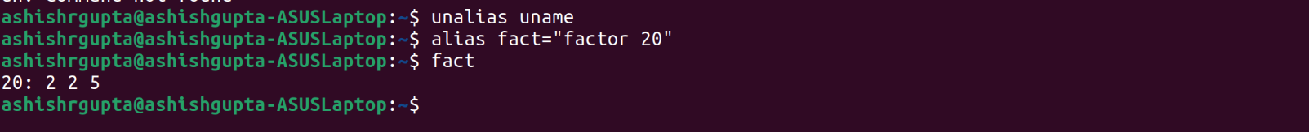

Q.26 unalias fact
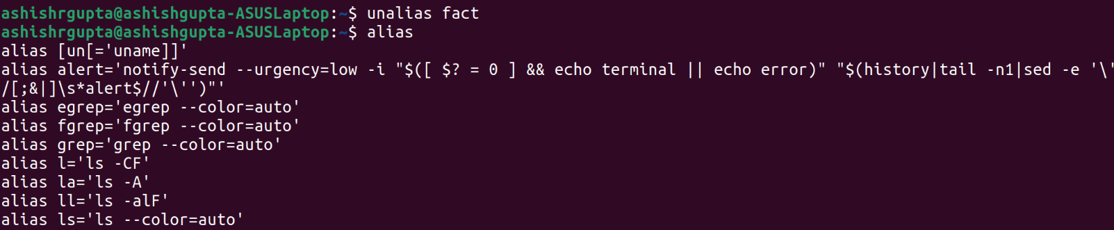

Q.27 echo $SHELL

Q.28 ps

Q.29 kill 6859
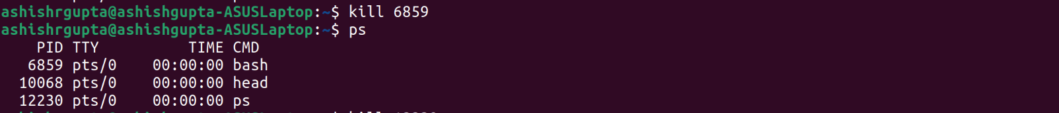

Q.30 env
