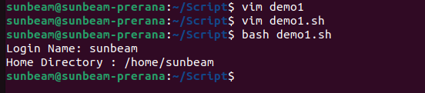
1. Write a shell script to display your LOGIN NAME and HOME directory.

2.Write a shell script to display menu like “1. Date, 2. Cal, 3. Ls, 4. Pwd, 5. Exit” and
execute the commands depending on user choice.

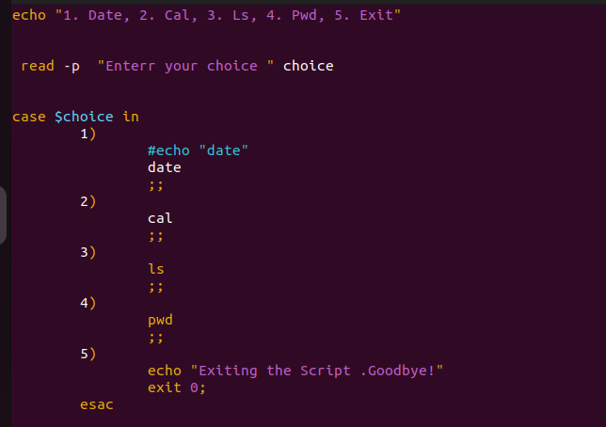

4

.
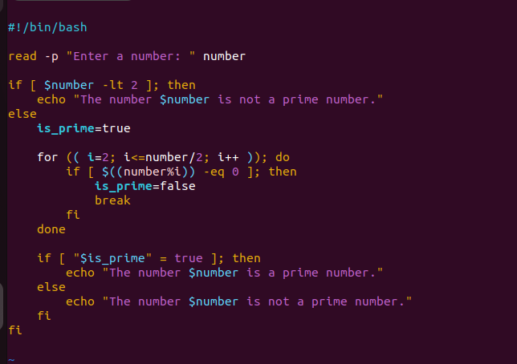

5

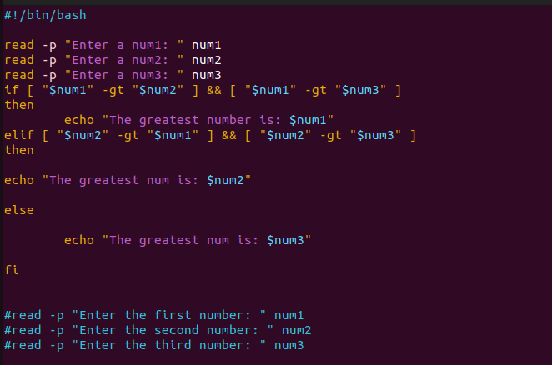

6.Write a Program to find whether a given year is a leap year or no
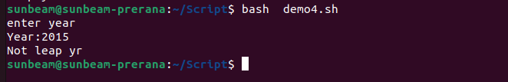
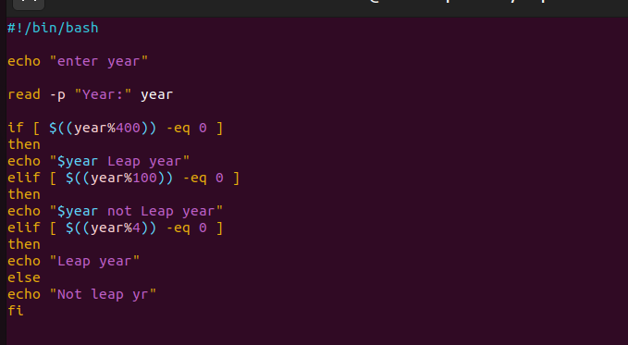
7.
7. Write a Program to find whether a given number is positive or negative
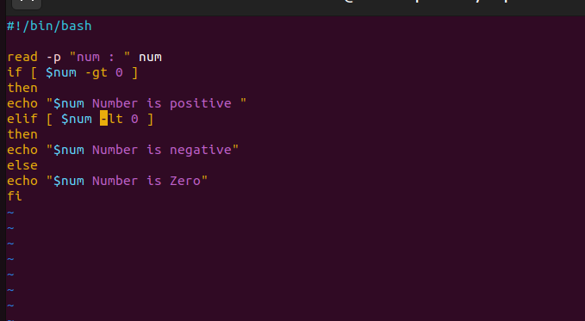
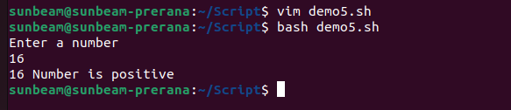

8. Write a program to print the table of a given number.

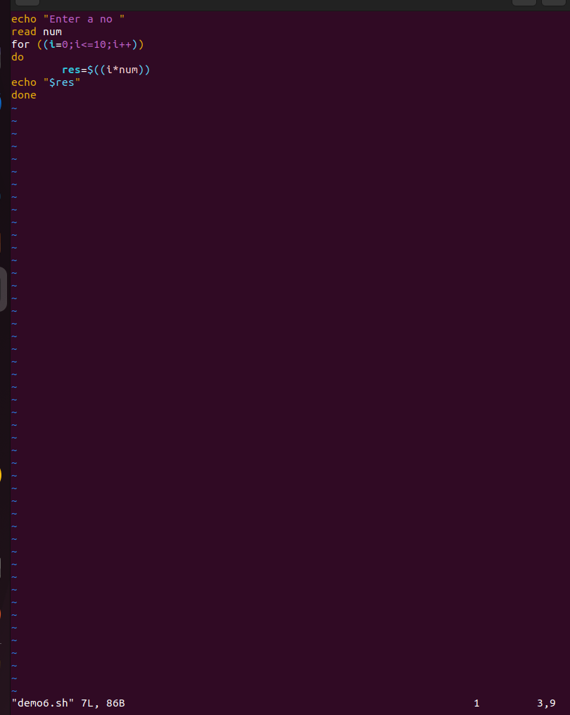

9. Write a program to find the factorial of given number.

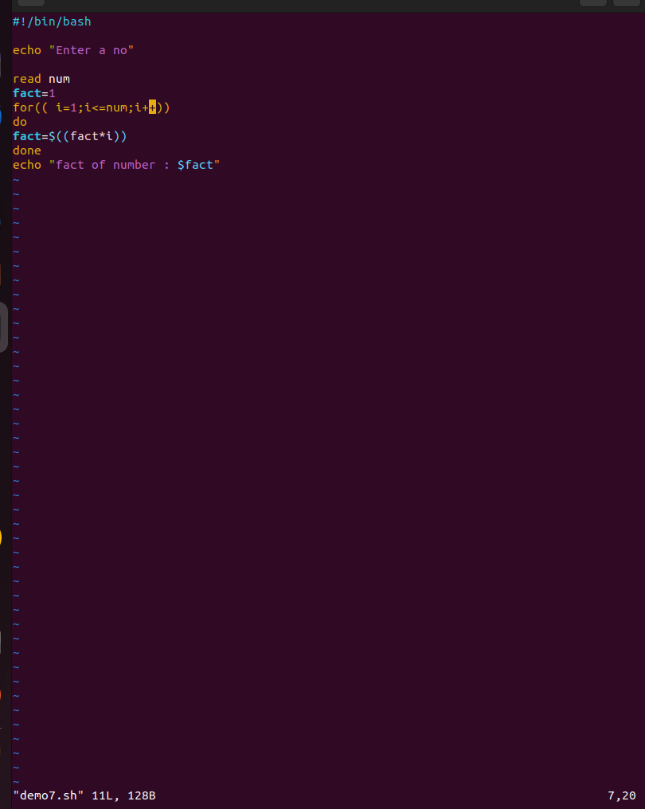
10. Write a program to find given number of terms in the Fibonacci series

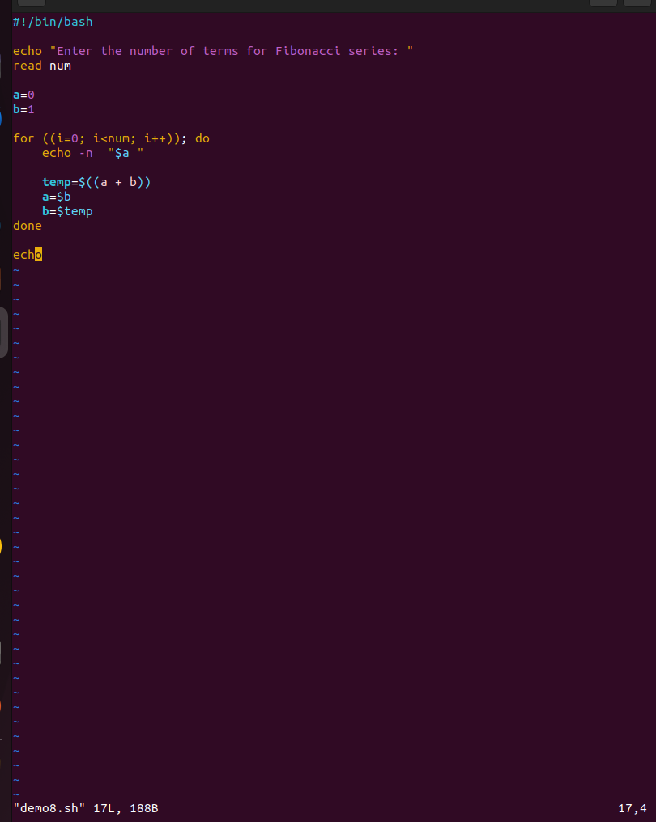

17
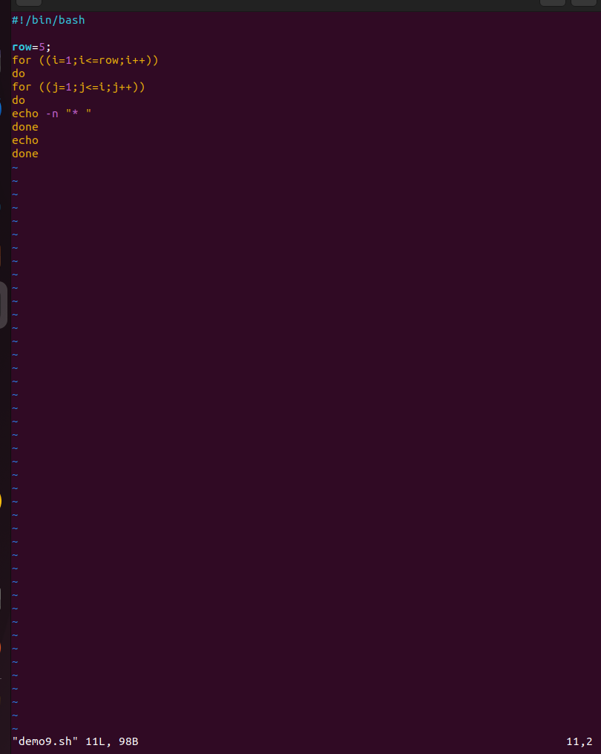
11
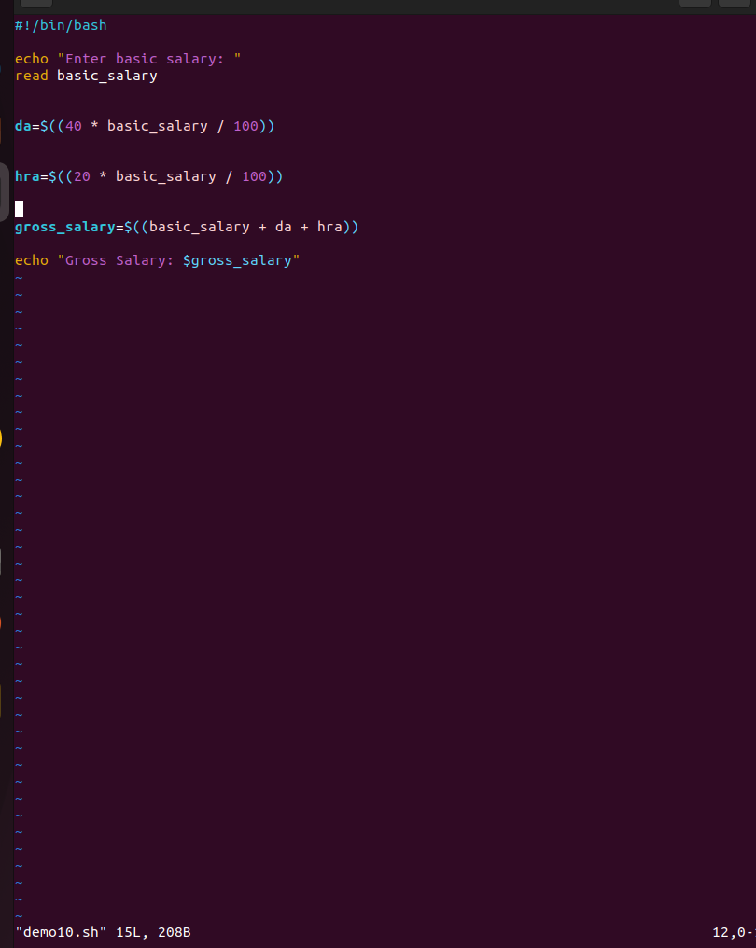
3. Write a shell script to accept the name from the user and check whether user entered
name is file or directory. If name is file display its size and if it is directory display its
contents.
