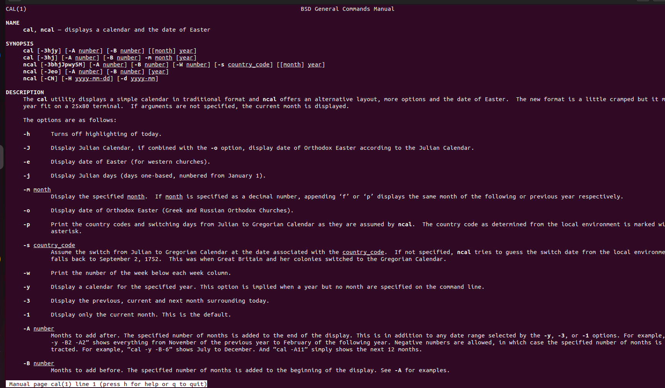
1.man cal

2.uname
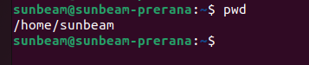
3.pwd

4.Hostname
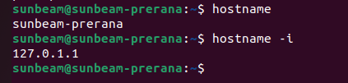

5.Date
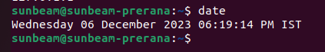

6.Cal
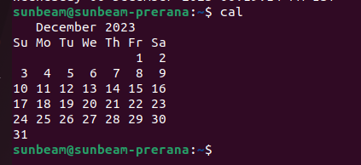

7.ls,dir

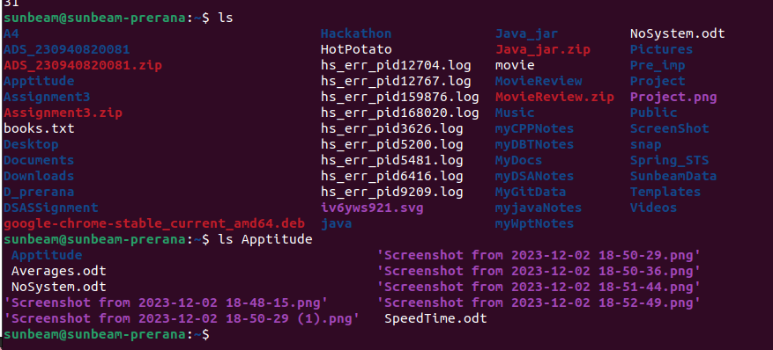
8.
9.
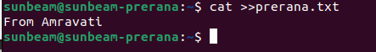

10

11.mv,moving


12 mv ,rename

13tac ,rev

14.wc

15.mkdir


16 cd

17rm

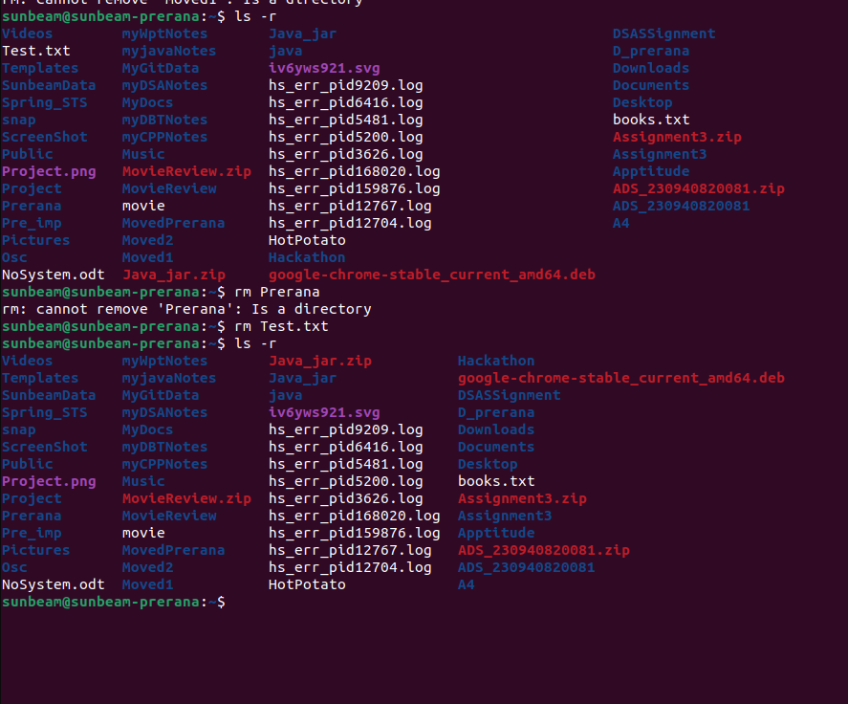
For Diresctory
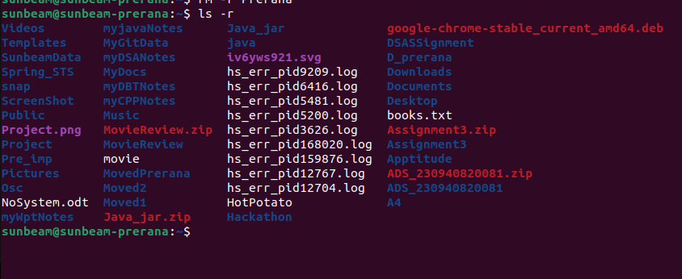

19 touch
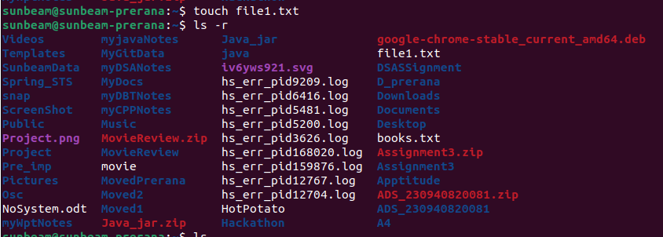


20.Sort

21.Uniq
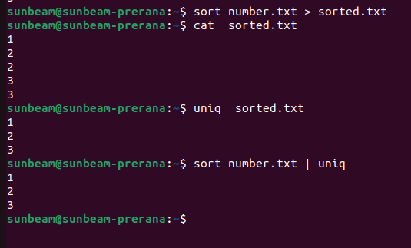

22.head
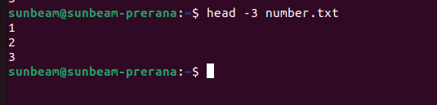
23
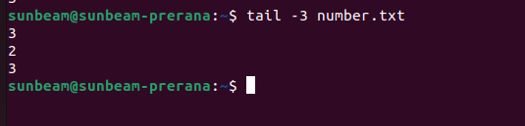
24

25

26
27

28.


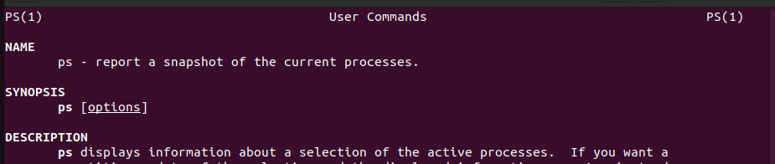

29

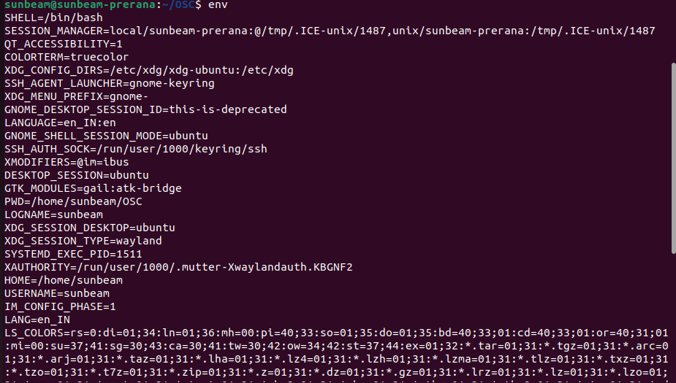
30

