11. List the directory contents date wise sorted. ( man ls)
2. List the directory contents size wise sorted.(man ls)
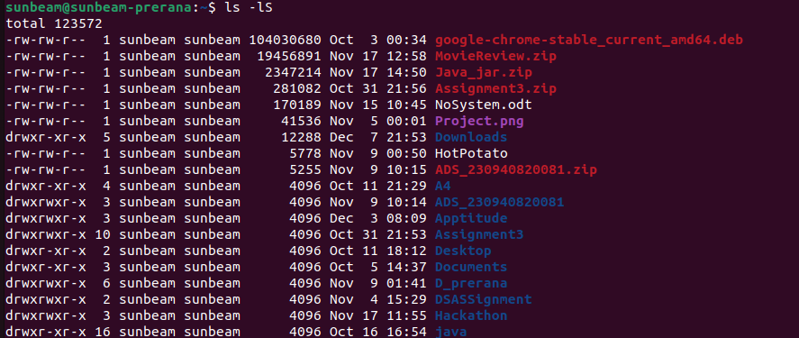
3. List directory contents along with their inode no.
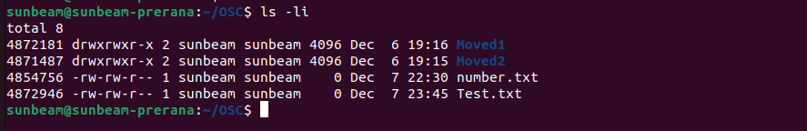
4. List the contents of the subdirectory.
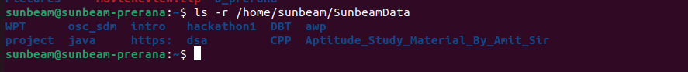
5.5. Create a file, write your surname and name in it and
save.

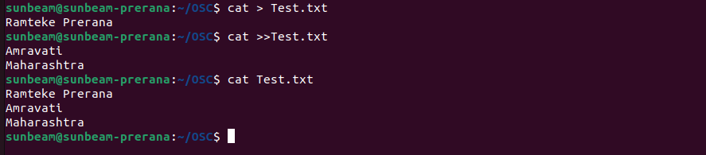

6. how to change the time stamp of file (man touch)

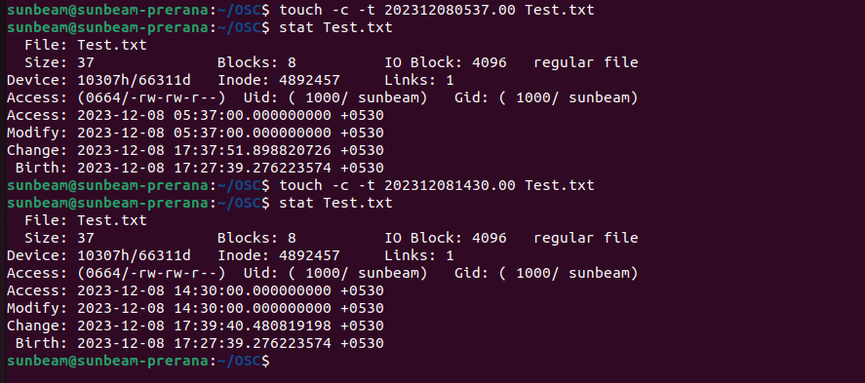
7. Create directory structure : Give following commands ,
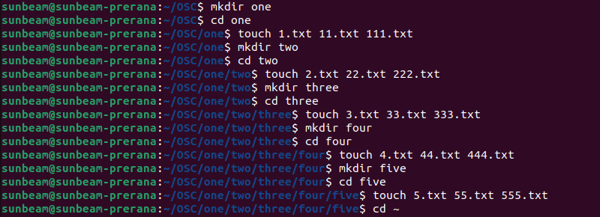

8.
i. list the directory contents of directory named
"five" from current directory

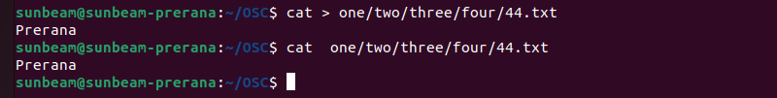
ii. write your name in a file named "44.txt" of
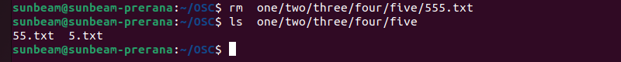
directory "four" from current directory. iii. remove the file named "555.txt" from directory "five" from current directory.
iv. change directory to five v. write your course name in file named "3.txt" which
resides in directory "three" from current directory (i.e.
five).also read the same file.

vi. list the contents of directory "two" from current
directory
vii. remove file named "222.txt" which belongs to
directory "two" from current directory
viii. now change the directory to "one"
ix. remove all files only from directory named "five"
from current directory

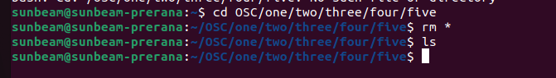
x. remove directory named "five" from current directory
xi. remove whole directory named "four" from current
directory

xii. change to your home directory.

9. change the time stamp of file named "3.txt" which resides
in directory named "three".(man touch)
