1.ls

2.rename
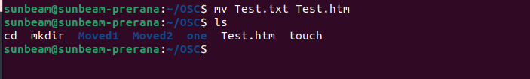
3ln -s

4ln

5.stat
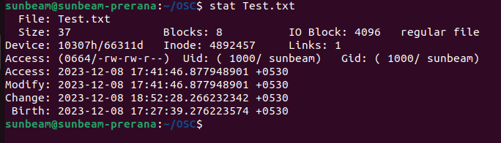
6
touch
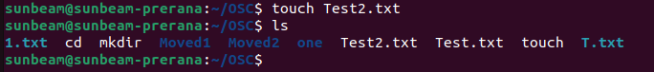
7.touch Create empty file

8 .tail Print all lines in a file from fifth line onwards



9.init 0, poweroffShutdown (Only for super-user)
10.init 6, rebootReboot (Only for super-user)
12.whoami Find current user
13.tty Find current terminal
15
16
17grep, egrep, fgrepFind a given word/pattern from the file

18 chmod Make a file as read-only
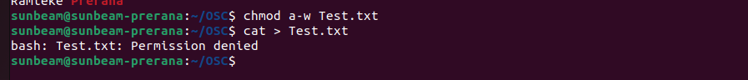
19 chmod Make a file as write, read and execute

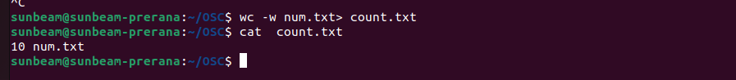
20.wc (using redirection)Take input from the file, count words and store output to other file

21who | wc (using pipe)Count words in output of “who” command

22.head, tail (using pipe)Print lines 5 to 10 from the given file


23
sort , uniq (using pipe)Print the uniq values from the unsorted file


24

25
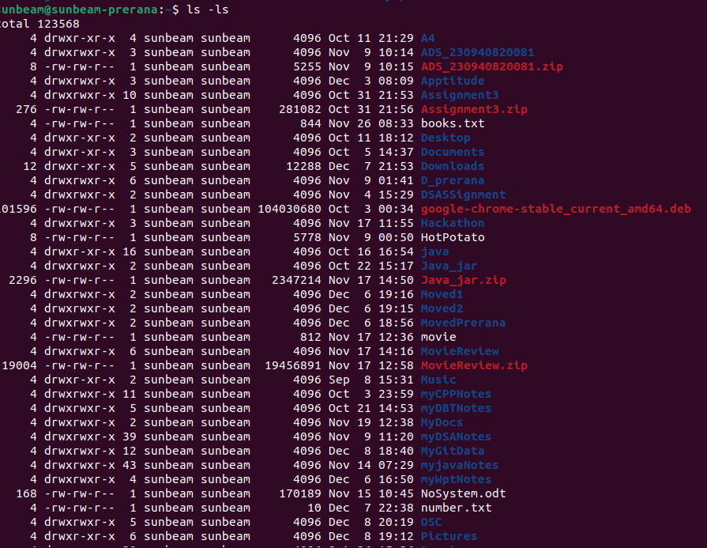
26ls, grep (using pipe)Count number of files and directories from current directory
27ls, grep (using pipe)Display only hidden files in a directory

28.tr Convert file contents into uppercase , also learn "-s" option of this command
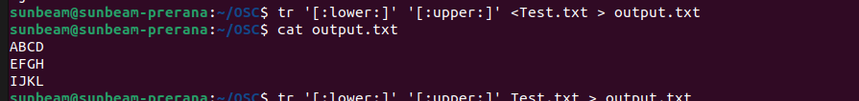

29.cut Split the file contents using delimiter and print required fields
