Assignment – 8

Formatting Query output.

1) Assume each salesperson has a 12% commission. Write a query on the orders table that will produce the order number,the salesperson number, and the amount of the salespersons commission for that order.

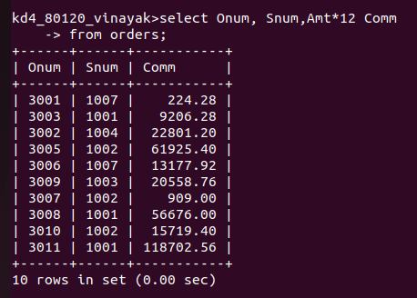

2) Write a query on the customers table that customers table that will find the highest rating in each city. Put the output in this form:
For the city (city), the highest rating is : (rating).
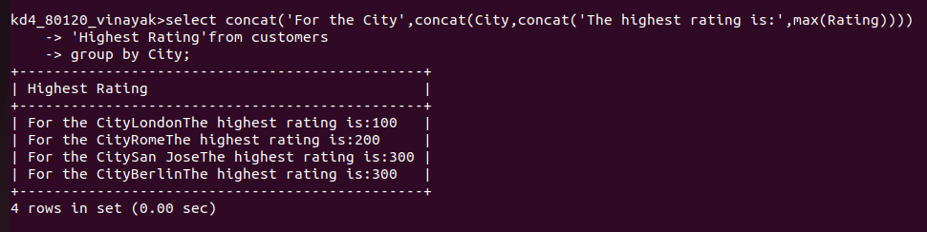

3) Write a query that lists customers in descending order of rating. Output the rating field first, followed by the customers name and number.
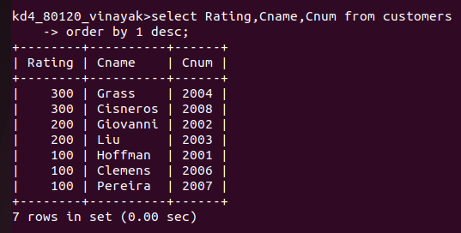

4) Write a query that totals the orders the orders for each day and places the results in descending order.

