ASSIGNMENT – 1

Q. Create the following tables with the given structures and insert sample data as specified.

1) SALESPEOPLE
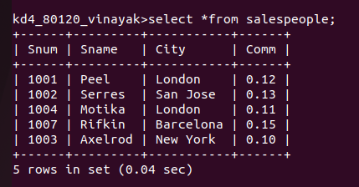

2) CUSTOMERS
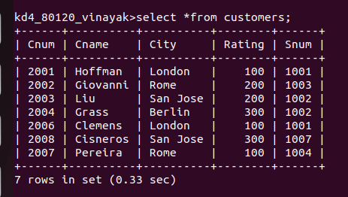

3) ORDERS
