ASSIGNMENT – 5

Q. Relational and Logical Operators.

1) Write a query that will give you all orders for more than Rs. 1000.

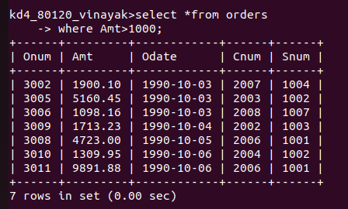

2) Write a query that will give you the names and cities of all SALESPEOPLE in london with a comission above .10.

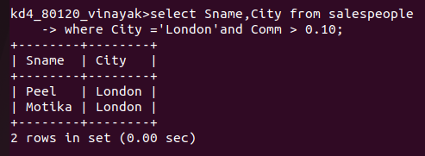

3) Write a query on the CUSTOMERS table whose o/p will exclude all customers with a rating <=100, unless they are located in Rome.

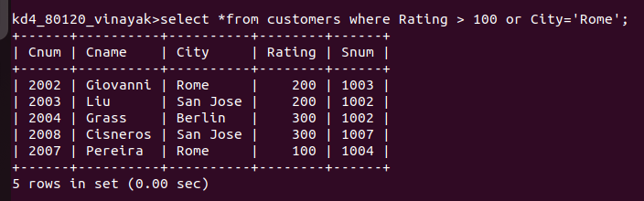

4) What will be the output from the following query ?

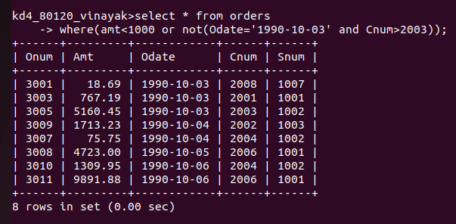

5) What will be the output from the following query ?

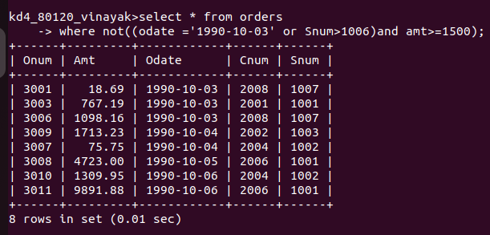

6)What is a simpler way to write this query?

