ASSIGNMENT – 6

Using Special Operators in Conditions.

1)Write two different queries that would produce all orders taken on October 3rd or 4th,1990.

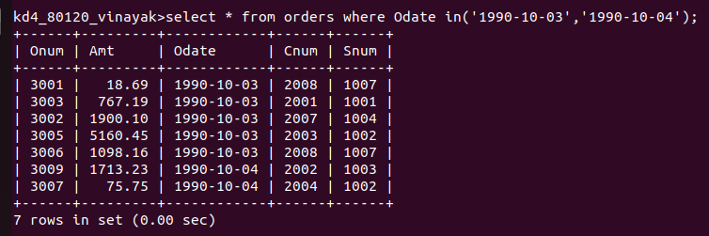

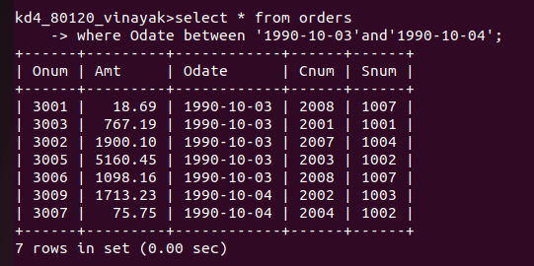

2)Write a query that selects all of the customers serviced by Peel or Motika. (Hint: the snum field relates the two tables to one another).

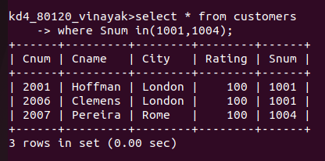

3)Write a query that will produce all customers whose names begin with a letter from ‘A’ to ‘G’.

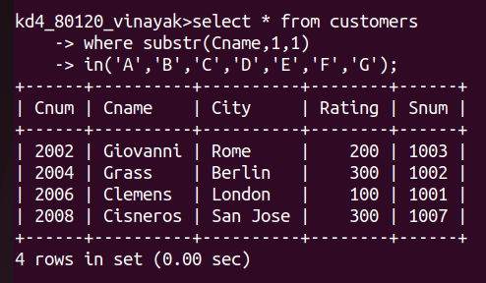

4)Write a query that selects all customers whose names begin with the letter ‘C’.

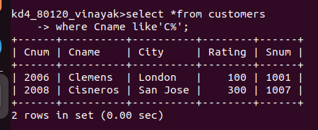

5)Write a query that selects all orders except those with zeroes or NULLs in the amt field.

