ASSIGNMENT – 7

Summarizing Data with Aggregate Functions.

1)Write a query that counts all orders for october 3.

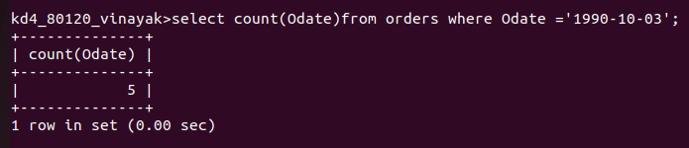

2)Write a query that counts the number of different non-NULL city values in the Customers table.

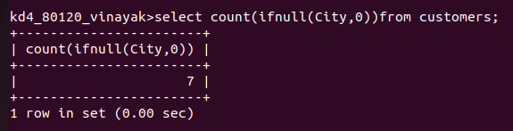

3)Write a query that selects each customer’s smallest order.
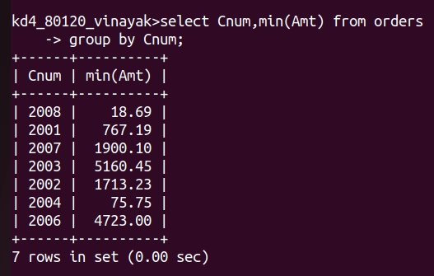

4)Write a query that selects the first customer in alphabetical order, whose name begins with G.
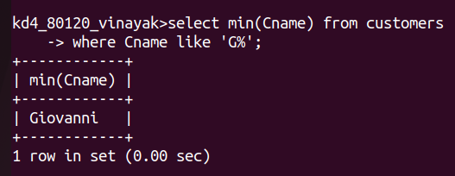
5)Write a query that selects the highest rating in each city.

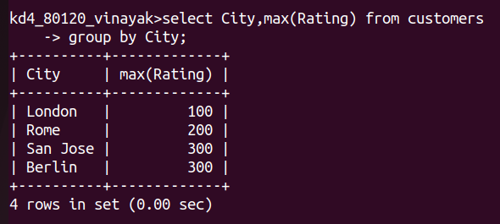
6)Write a query that counts the number of salespeople registering orders for each day.(Ifa salesperson has more than one order on a givenday,he or she should be counted only once.).
