ASSIGNMENT :-12

Using the operators ANY, ALL and SOME.

1) Write a query that selects all customers whose ratings are equal to or greater than ANY of Serres’.

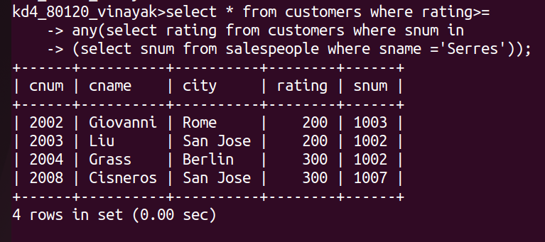

2)Write a query using ANY or ALL that will find all salespeople who have no
customers located in their city.

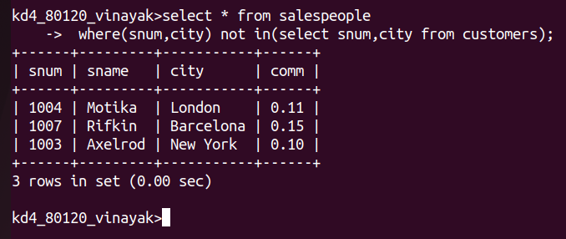

3) Write a query that selects all orders for amounts greater than any for the customers in London.

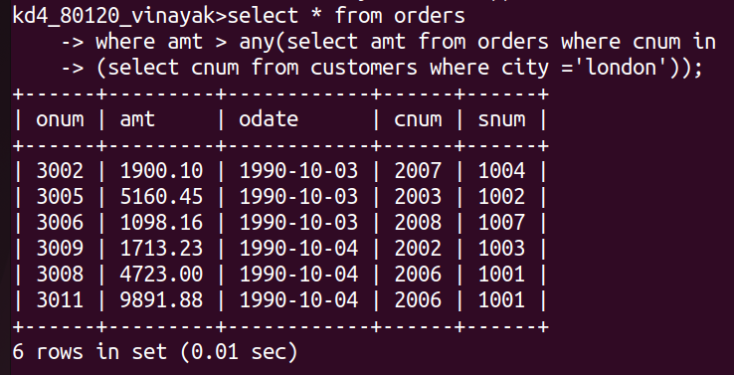

4) Write the above query using MIN or MAX.

