SQL ASSIGNMENT – 9

QUERYING MULTIPLE TABLES AT ONCE.

1) Write a query that list each other number followed by the name of the customer who made the order.

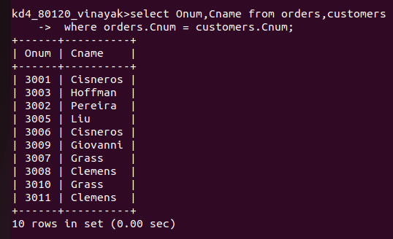

2) Write a query that gives the names of both the salesperson and the customer for each order along with the order number.
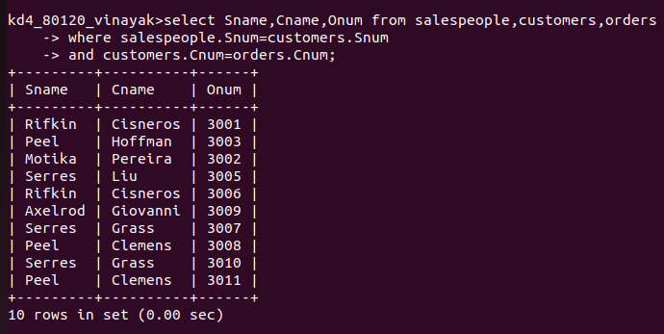
3) Write a query that produces all customers serviced by salespeople with a commision above 12%. output the customer’s name, the salesperson’s name, and the salesperson’s rate of commision.
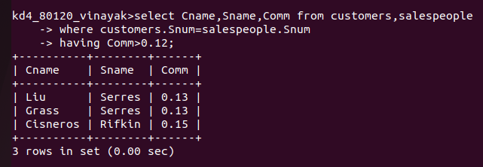

4) Write a query that calculates the amount of the salesperson’s commision on each order by a customer with a rating above 100.

