Wordpress三欄文字排版

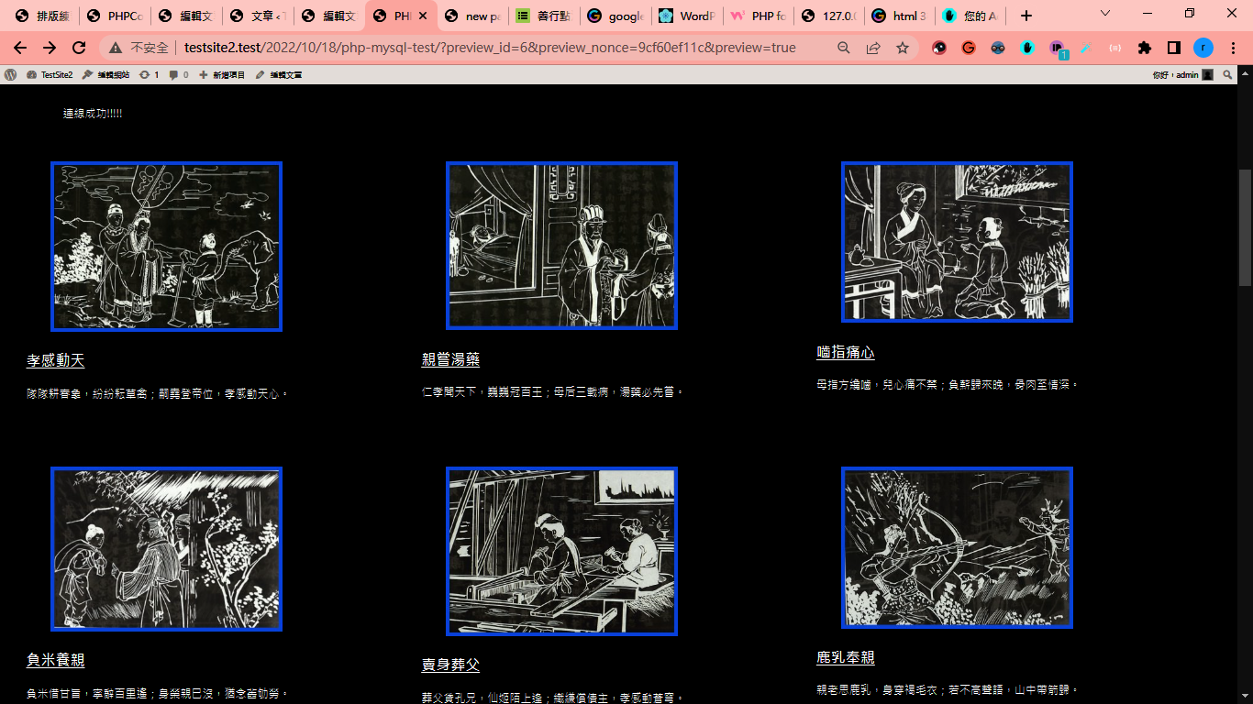

以20221019/文章/排版練習.html為例



可以發現每一橫列(1,1)+(1,2)+(1,3)其實是一個叫columns區塊，只要把以下html code插入，就可以產生一個橫列

|  |
| --- |
| <!-- wp:columns {"align":"full","style":{"color":{"text":"#000000","background":"#ffffff"}}} -->  <div class="wp-block-columns alignfull has-text-color has-background" style="background-color:#ffffff;color:#000000"><!-- wp:column -->  <div class="wp-block-column"><!-- wp:image {"sizeSlug":"large"} -->  <figure class="wp-block-image size-large"><img src="https://drive.google.com/uc?export=view&amp;id=1ka6EJwunWYDf2lFGGVgIDoIx2Uyt_lmN" alt=""/><figcaption><gwmw style="display:none;"></figcaption></figure>  <!-- /wp:image -->  <!-- wp:heading {"level":3,"style":{"typography":{"fontSize":"24px","lineHeight":"1.3"}}} -->  <h3 style="font-size:24px;line-height:1.3"><strong><a href="http://wordpress.org">1,1標題文字↗</a></strong></h3>  <!-- /wp:heading -->  <!-- wp:paragraph -->  <p>1,1摘要文字</p>  <!-- /wp:paragraph --></div>  <!-- /wp:column -->  <!-- wp:column -->  <div class="wp-block-column"><!-- wp:image {"sizeSlug":"large"} -->  <figure class="wp-block-image size-large"><img src="https://drive.google.com/uc?export=view&amp;id=16QoMPJz1oWgqW7_WaitVw7-Ho3YVKH7t" alt=""/><figcaption><gwmw style="display:none;"></figcaption></figure>  <!-- /wp:image -->  <!-- wp:heading {"level":3,"style":{"typography":{"fontSize":"24px","lineHeight":"1.3"}}} -->  <h3 style="font-size:24px;line-height:1.3"><strong><a href="https://wordpress.org">1,2標題文字 ↗</a></strong></h3>  <!-- /wp:heading -->  <!-- wp:paragraph -->  <p>1,2摘要文字</p>  <!-- /wp:paragraph --></div>  <!-- /wp:column -->  <!-- wp:column -->  <div class="wp-block-column"><!-- wp:image {"sizeSlug":"large"} -->  <figure class="wp-block-image size-large"><img src="https://drive.google.com/uc?export=view&amp;id=1VxEQb6EQ7vPlfVNIBFJ7j1_3QixnzCSV" alt=""/><figcaption><gwmw style="display:none;"></figcaption></figure>  <!-- /wp:image -->  <!-- wp:heading {"level":3,"style":{"typography":{"fontSize":"24px","lineHeight":"1.3"}}} -->  <h3 style="font-size:24px;line-height:1.3"><strong><a href="https://wordpress.org">1,3標題文字 ↗</a></strong></h3>  <!-- /wp:heading -->  <!-- wp:paragraph -->  <p>1,3摘要文字</p>  <!-- /wp:paragraph --></div>  <!-- /wp:column --></div>  <!-- /wp:columns --> |

在php中，我們把以上的code拆成4個部分，part0, part1, part2, endline

再把每一筆資料加上一個column_idx=0,1,2

然後根據現在的column_idx=0,1,2 印出 part0, part1, part2，等loop結束後，插入endline

即完成排版

In php-show-db snippet(內容：20221019/php_snippets/php-show-db.php)

|  |
| --- |
| <?php  $db_host = "127.0.0.1";  $db_username = "root";  $db_password = "";  $database = "testsite"; //因為是本地測試，改這一段就好(輸入你指定的資料庫名稱，我指定test_2021，如下圖)  $con = mysqli_connect("$db_host", "$db_username", "$db_password", "$database");  if(!$con)  {  die("連線失敗!!!!!");  echo("連線失敗!!!!!");  $ssql = "set names utf8";  mysqli_query($con,$ssql);  }  else echo("連線成功!!!!!");  ?>  <?php  $query = "SELECT * FROM bwtest ORDER BY timestamp"; //搜尋 *(全部欄位) ，從 表staff  //mysqli_query << PHP 有很多種...指令(?) ，這是其中一個，我現在還都是學到甚麼用什麼，沒辦法自己看手冊，然後實驗+學習使用。  $query_run = mysqli_query($con,$query); //$con <<此變數來自引入的 db_cn.php  ?>  <?php  if(mysqli_num_rows($query_run) > 0)  {  $column_idx=0;  foreach($query_run as $row)  {  if($column_idx == 0)  {  ?>  <!-- wp:columns {"align":"full","style":{"color":{"text":"#000000","background":"#ffffff"}}} -->  <div class="wp-block-columns alignfull has-text-color has-background" style="background-color:#ffffff;color:#000000"><!-- wp:column -->  <div class="wp-block-column"><!-- wp:image {"sizeSlug":"large"} -->  <figure class="wp-block-image size-large"><img src="https://drive.google.com/uc?export=view&amp;id=<?php echo $row["pic_url"]; ?>" alt=""/><figcaption><gwmw style="display:none;"></figcaption></figure>  <!-- /wp:image -->  <!-- wp:heading {"level":3,"style":{"typography":{"fontSize":"24px","lineHeight":"1.3"}}} -->  <h3 style="font-size:24px;line-height:1.3"><strong><a href="http://testsite2.test/2022/10/18/new-page/?title=<?php echo $row['title']; ?>"><?php echo $row["title"]; ?></a></strong></h3>  <!-- /wp:heading -->  <!-- wp:paragraph -->  <p><?php echo $row["short_description"]; ?></p>  <!-- /wp:paragraph --></div>  <!-- /wp:column -->  <?php  }  else if($column_idx == 1)  {  ?>  <!-- wp:column -->  <div class="wp-block-column"><!-- wp:image {"sizeSlug":"large"} -->  <figure class="wp-block-image size-large"><img src="https://drive.google.com/uc?export=view&amp;id=<?php echo $row["pic_url"]; ?>" alt=""/><figcaption><gwmw style="display:none;"></figcaption></figure>  <!-- /wp:image -->  <!-- wp:heading {"level":3,"style":{"typography":{"fontSize":"24px","lineHeight":"1.3"}}} -->  <h3 style="font-size:24px;line-height:1.3"><strong><a href="http://testsite2.test/2022/10/18/new-page/?title=<?php echo $row['title']; ?>"><?php echo $row["title"]; ?></a></strong></h3>  <!-- /wp:heading -->  <!-- wp:paragraph -->  <p><?php echo $row["short_description"]; ?></p>  <!-- /wp:paragraph --></div>  <!-- /wp:column -->  <?php  }  else if($column_idx == 2)  {  ?>  <!-- wp:column -->  <div class="wp-block-column"><!-- wp:image {"sizeSlug":"large"} -->  <figure class="wp-block-image size-large"><img src="https://drive.google.com/uc?export=view&amp;id=<?php echo $row["pic_url"]; ?>" alt=""/><figcaption><gwmw style="display:none;"></figcaption></figure>  <!-- /wp:image -->  <!-- wp:heading {"level":3,"style":{"typography":{"fontSize":"24px","lineHeight":"1.3"}}} -->  <h3 style="font-size:24px;line-height:1.3"><strong><a href="http://testsite2.test/2022/10/18/new-page/?title=<?php echo $row['title']; ?>"><?php echo $row["title"]; ?></a></strong></h3>  <!-- /wp:heading -->  <!-- wp:paragraph -->  <p><?php echo $row["short_description"]; ?></p>  <!-- /wp:paragraph --></div>  <!-- /wp:column --></div>  <?php  }  if($column_idx<2) $column_idx++;  else $column_idx=0;  }  if($column_idx == 2) //加這段是因為如果只有該橫列只有2個column，排版會歪掉，所以要在右邊增加一個隱形的column  {  ?>  <div style="visibility:hidden">  <!-- wp:column -->  <div class="wp-block-column"><!-- wp:image {"sizeSlug":"large"} -->  <figure class="wp-block-image size-large"><img src="https://drive.google.com/uc?export=view&amp;id=<?php echo $row["pic_url"]; ?>" alt=""/><figcaption><gwmw style="display:none;"></figcaption></figure>  <!-- /wp:image -->  <!-- wp:heading {"level":3,"style":{"typography":{"fontSize":"24px","lineHeight":"1.3"}}} -->  <h3 style="font-size:24px;line-height:1.3"><strong><a href="http://testsite2.test/2022/10/18/new-page/?title=<?php echo $row['title']; ?>"><?php echo $row["title"]; ?></a></strong></h3>  <!-- /wp:heading -->  <!-- wp:paragraph -->  <p><?php echo $row["short_description"]; ?></p>  <!-- /wp:paragraph --></div>  <!-- /wp:column --></div>  </div>  <?php  }  ?>  <!-- /wp:columns -->  <?php  }  ?>  <?php mysqli_close($con);?> |

文章

PHP MYSQL Test(內容：20221019/文章/ PHP MYSQL Test.html)

把

<p>[xyz-ips snippet="php-show-db"]</p>

移到最底端即可，因為原位置有js的table要印，會影響排版