**TASK-2**

**NumPy Exercises**

1. Import NumPy as np
2. Make an array of 10 zeros
3. Make an array of 10 ones
4. Make an array of 10 fives
5. Create an array of the integers from 10 to 50
6. Create an array of all even integers from 10 to 50
7. Create a 3x3 matrix with values ranging from 0 to 8

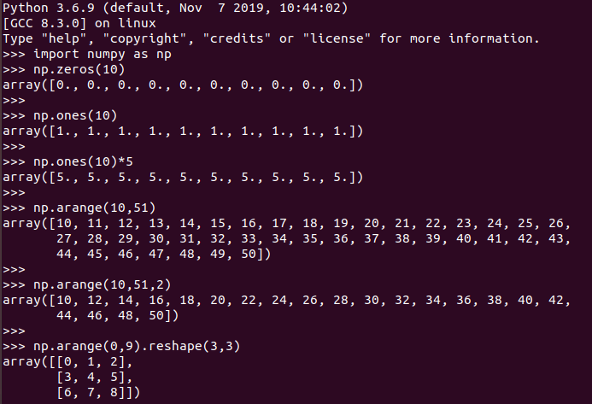

1. Create a 3x3 identity matrix
2. Use NumPy to generate a random number between 0 to 1

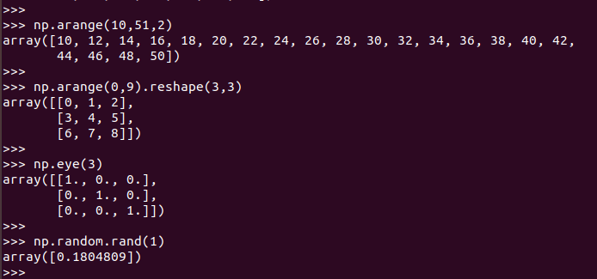

1. Use NumPy to generate an array of 25 random numbers sampled from a standard normal distribution
2. Create the following matrix:

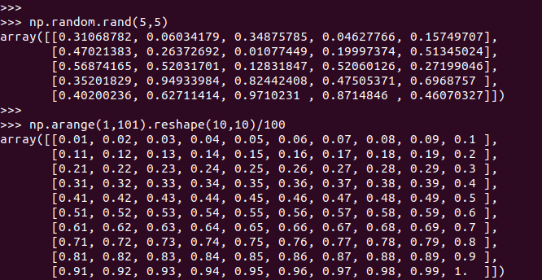

1. Create an array of 20 linearly spaced points between 0 and 1

NumPy Indexing and Selection: -

1. Replicate the resulting matrix outputs:

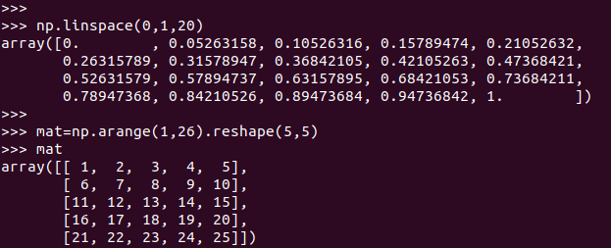

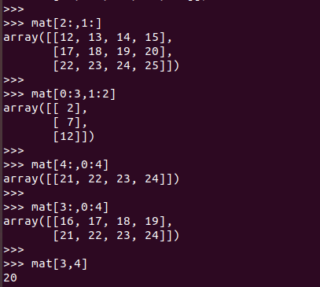

Now do the following: -

1. Get the sum of all the values in mat



1. Get the standard deviation of the values in mat



1. Get the sum of all the columns in mat

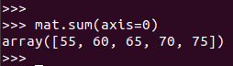

**Matplotlib Exercises**

Exercise 1

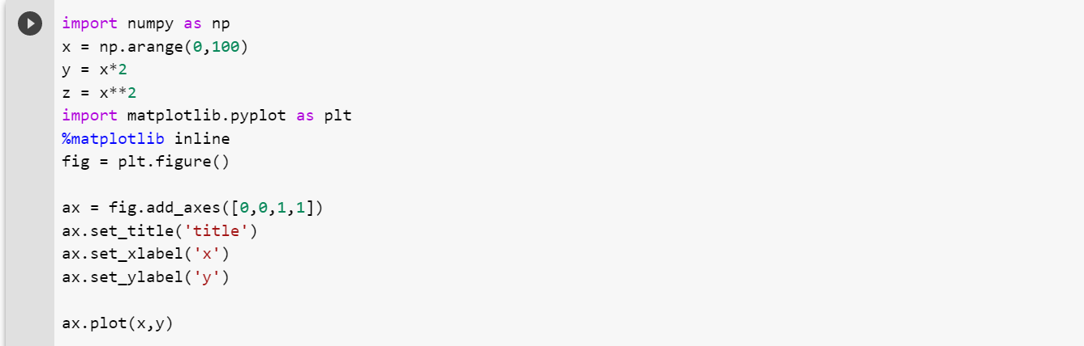

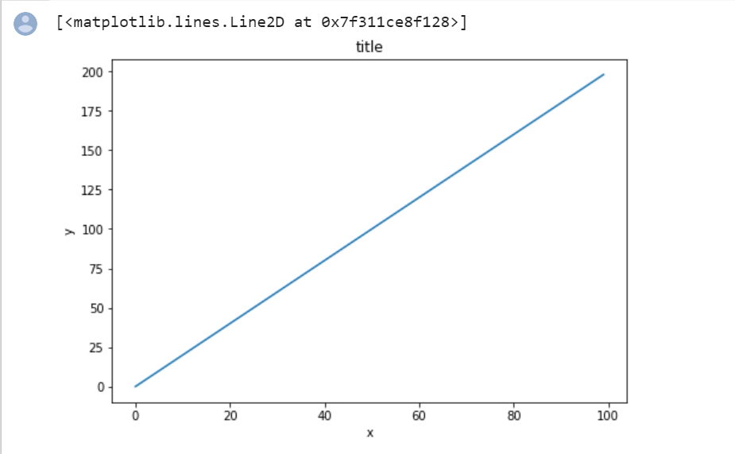

Exercise 2

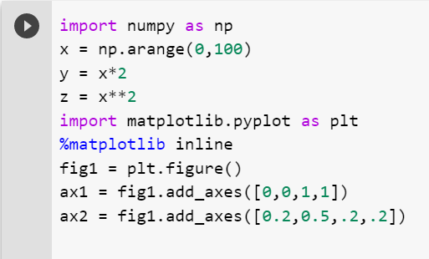

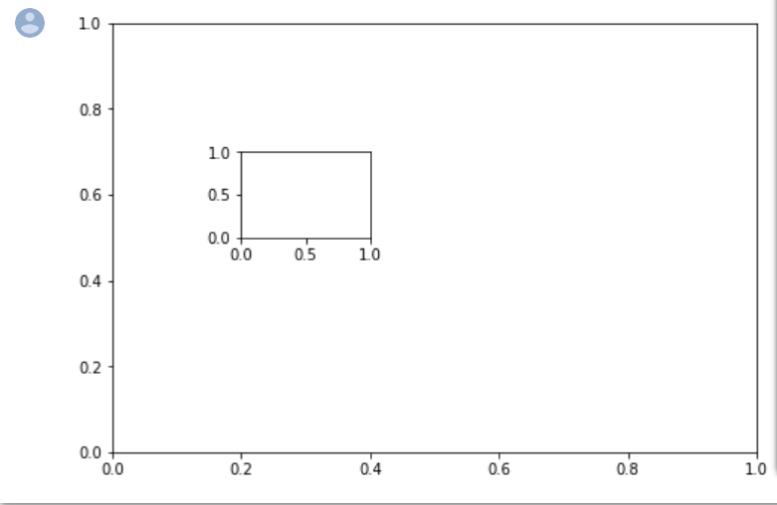

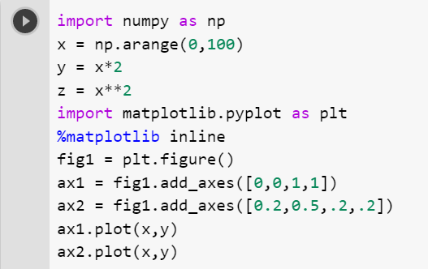

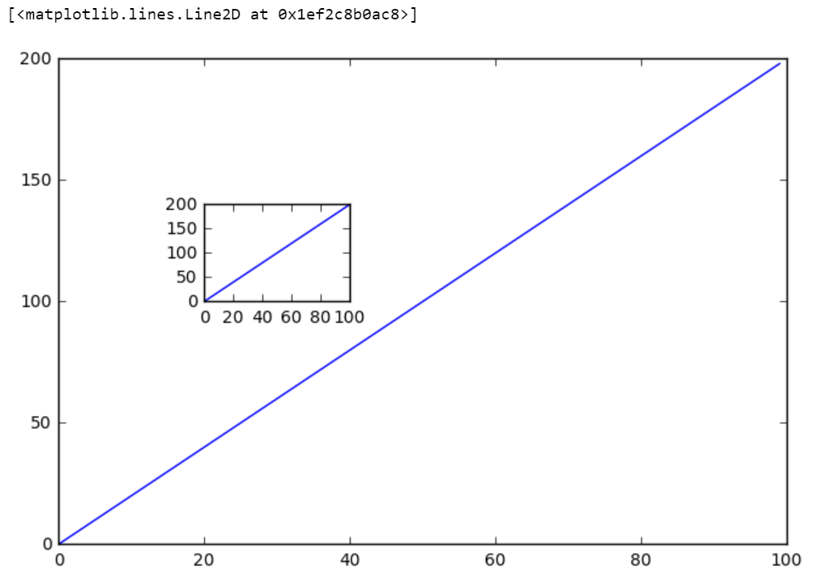

Exercise 3

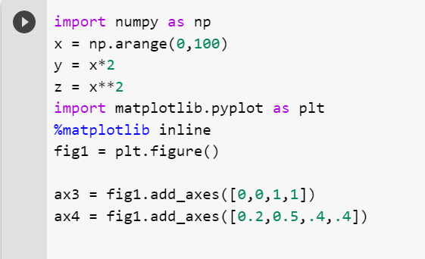

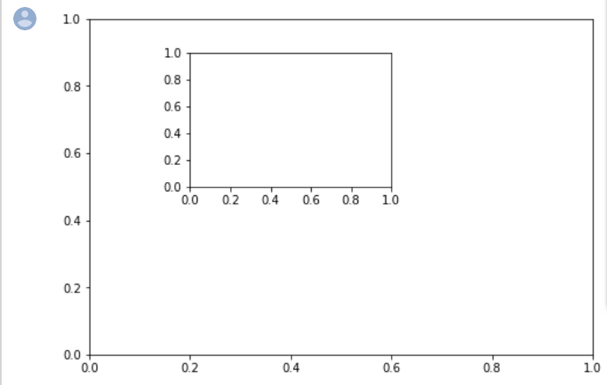

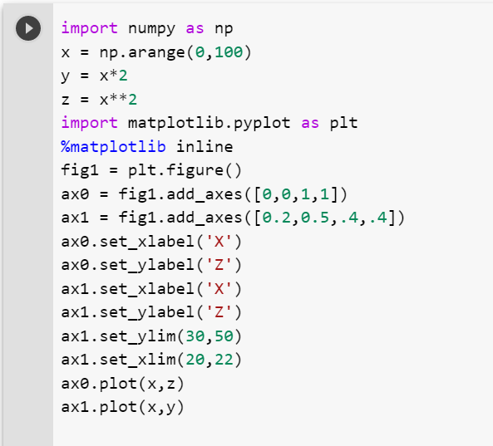

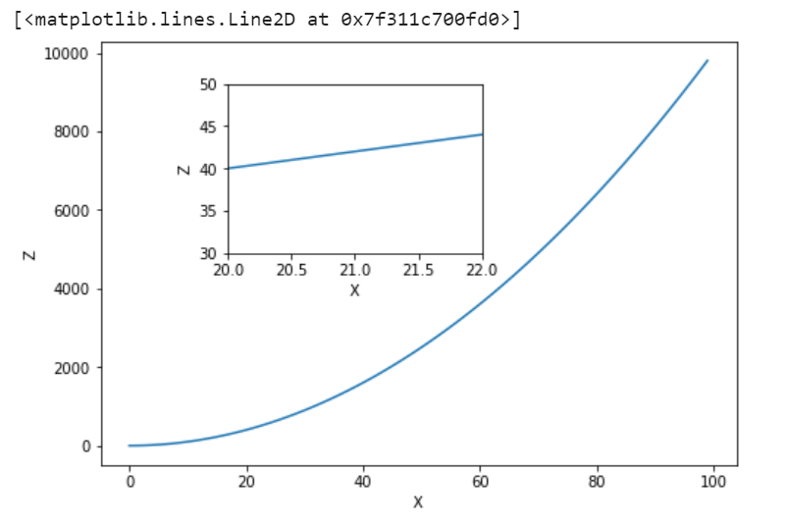

Exercise 4

