Coin Change Problem

This Algorithm has been implemented in C#, This approach takes two values from the user (i.e.) the bill amount and the change given by the user. This algorithm considers the quarters, pennies, nickels and pennies as the denominations given to the user. Under all the cases, this approach gives the least denomination possible to the user as change. A sample output of this approach can be seen below.

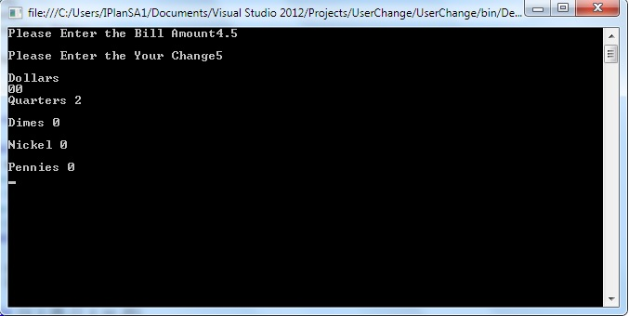

Please let me know if you have any issues with my code I will try my level best to solve them at the earliest.