SQL Assignment 5

1. Write a query that will give you all orders for more than Rs. 1000.
ans:

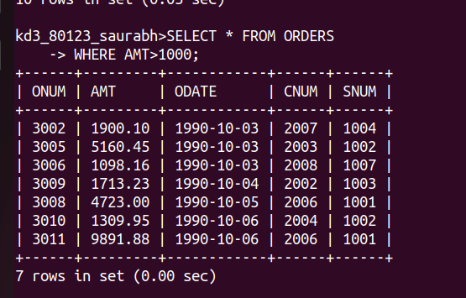
2. Write a query that will give you the names and cities of all salespeople in London with a commission above 0.10.
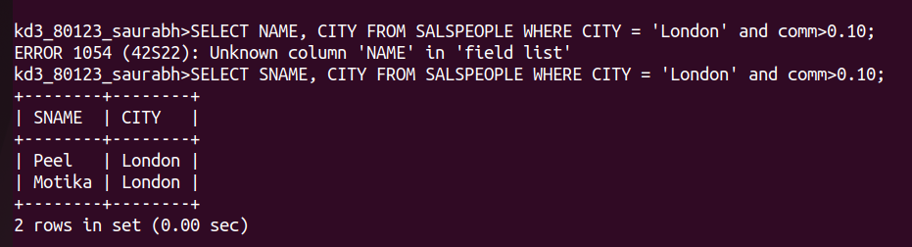

3. Write a query on the customer tables whoes output will exclude customers with a rating <=100 , unless they are located in rome.
Ans;
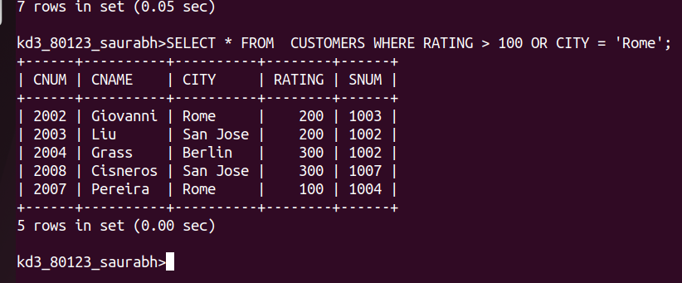

4. What will be the output form the following query

select * from orders
where ( amt<1000 OR NOT ( odate =’1990-10-03’ AND cnum>2003));

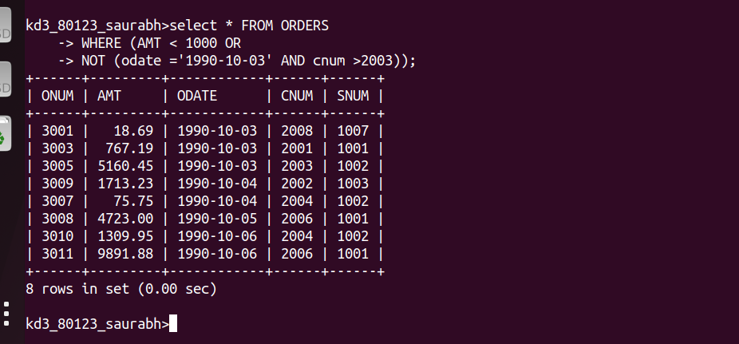

5. What will be the output of the following query ?

Select * from Orders
where NOT (( odate =’ 1990-10-03’ OR snum >1006) AMD amt >=1500);

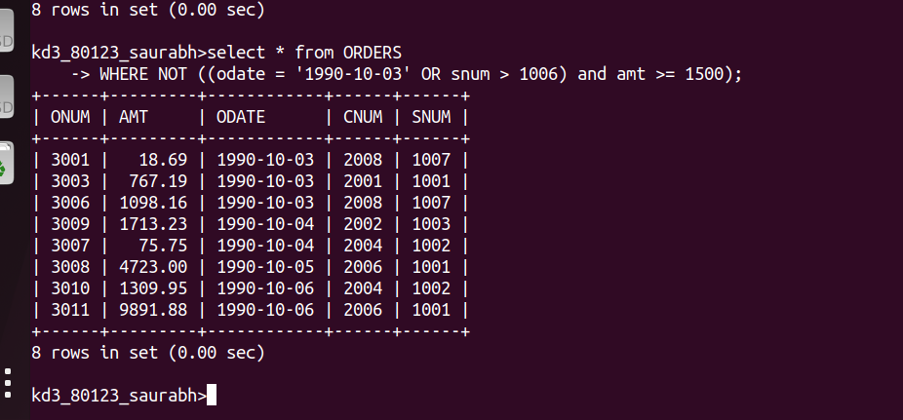

6. what is a simpler way to write this query?
Select snum, sname, city , comm from salespeople where ( comm> 0.12 or comm < 0.14);

