Assignment no 09
Q1. Write a query that listes each oders number followed by the name of the customers who made the order
ANS---

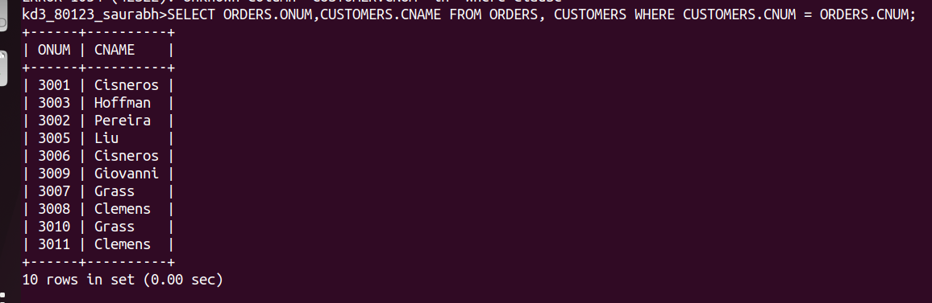

Q2.Write a query that gives the name of both the salesperson and the customers for each oders along with the order number
ANS--
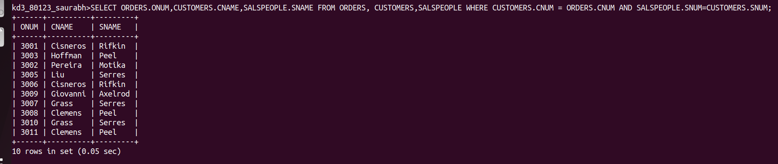

Q3.Write a query that produces all of both customers serviced by salespeople whith a comission above 12%. Output the customers name, the salesperson name, and the salesperon rate of comission
ANS----
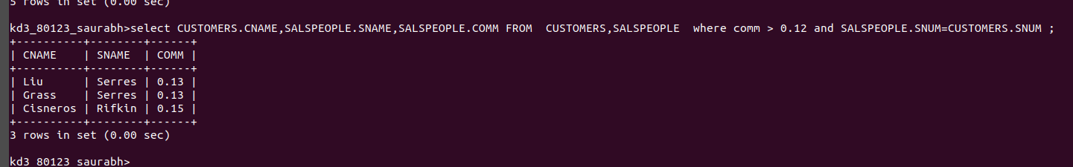

Q4.Write a query that calculate the amount of the salesperson comission on each oders by a customer with a rating above 100.
ANS--
