View the of aviablecollection in cdac database
ans---


Create a database named as cdac and connect to it


Create a new collection by the the name of library
ANS


Insert the following documents in the library collection
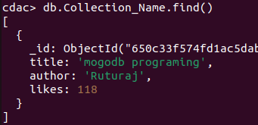

view the recently inserted document and note the _id filed
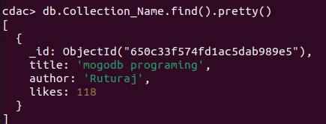

show database


12

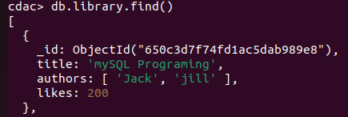
db

13.

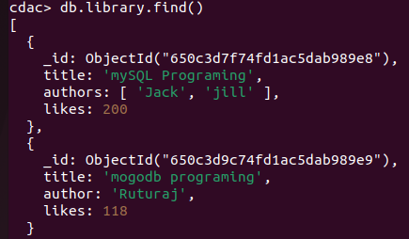

14.
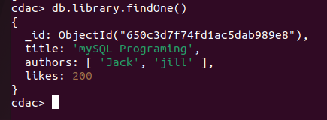

15

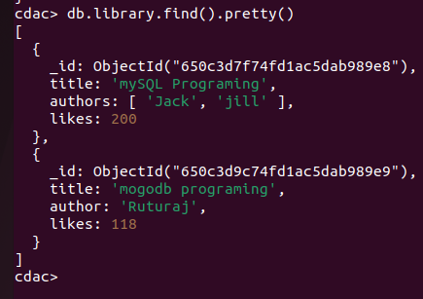

16
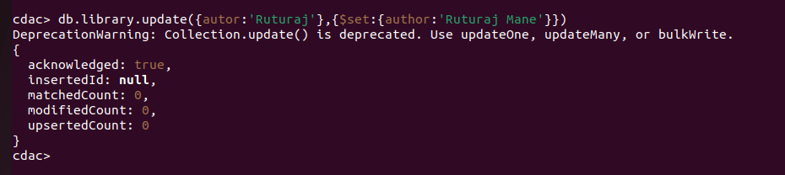

17
18.

19.
20

21.

press clr + C

