SQL ASSignment

Q1.Assume each salesperson has 12% commission write a query on the orders table that will produce the oders number the salesperon number and the amount of the salesperson commission for that order.
ANS---
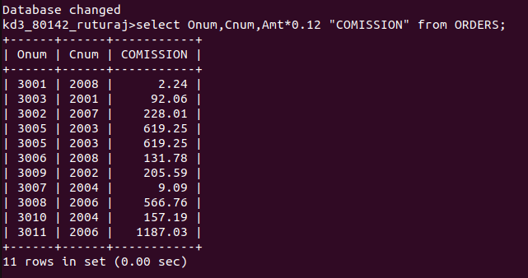

Q2. write a query in the customer table that will find higest rating in each city.
ANS--
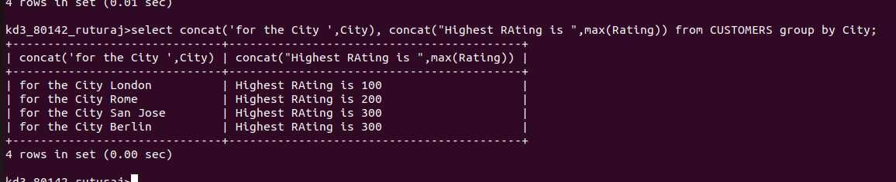

Q3.write a query that lists cutomers in descending orders of rating.Output the rating field first follwed by the cutomers name and number
ANS--
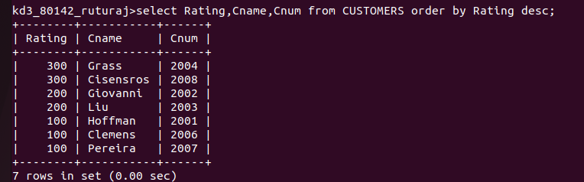

Q4 write a query that total the orders for orders for each day palces the result in desceding order
ANS---

